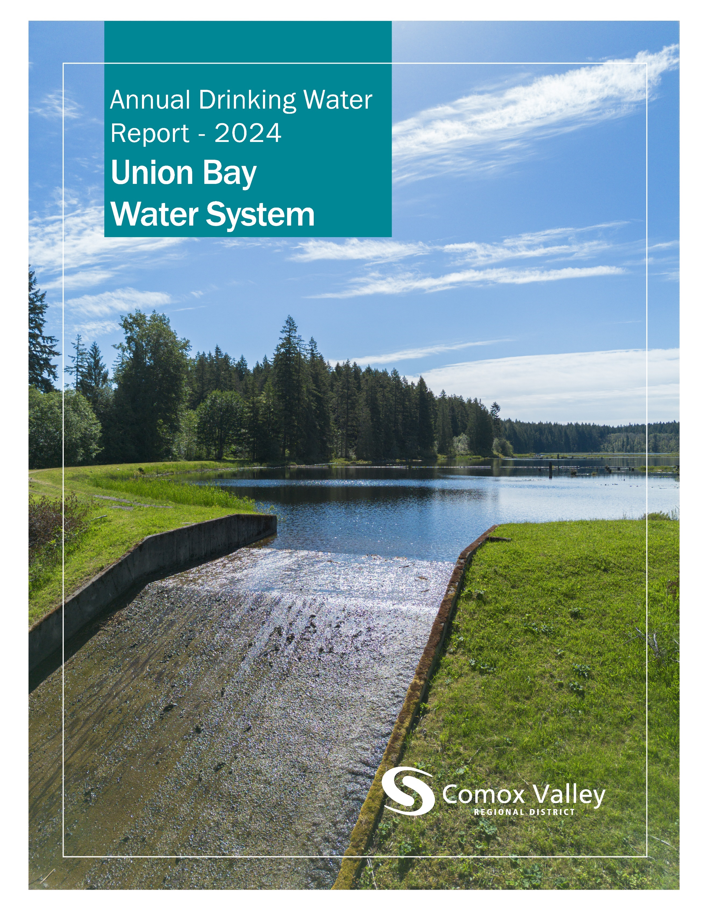

Table of Contents
Introduction 2
Source Water 2
Water Treatment 3
Water Distribution 4
Water Quality 4
Water Quality Summary 5
Distribution Water – Data by Sample Site 6
Consumption Metrics and Water Rates 8
Conservation 9
Operations 10
2024 Achievements 10
2025 Objectives 10

The Comox Valley Regional District respectfully acknowledges that the land on which it operates is the unceded territory of the K’ómoks First Nation, the traditional keepers of this land.

Introduction
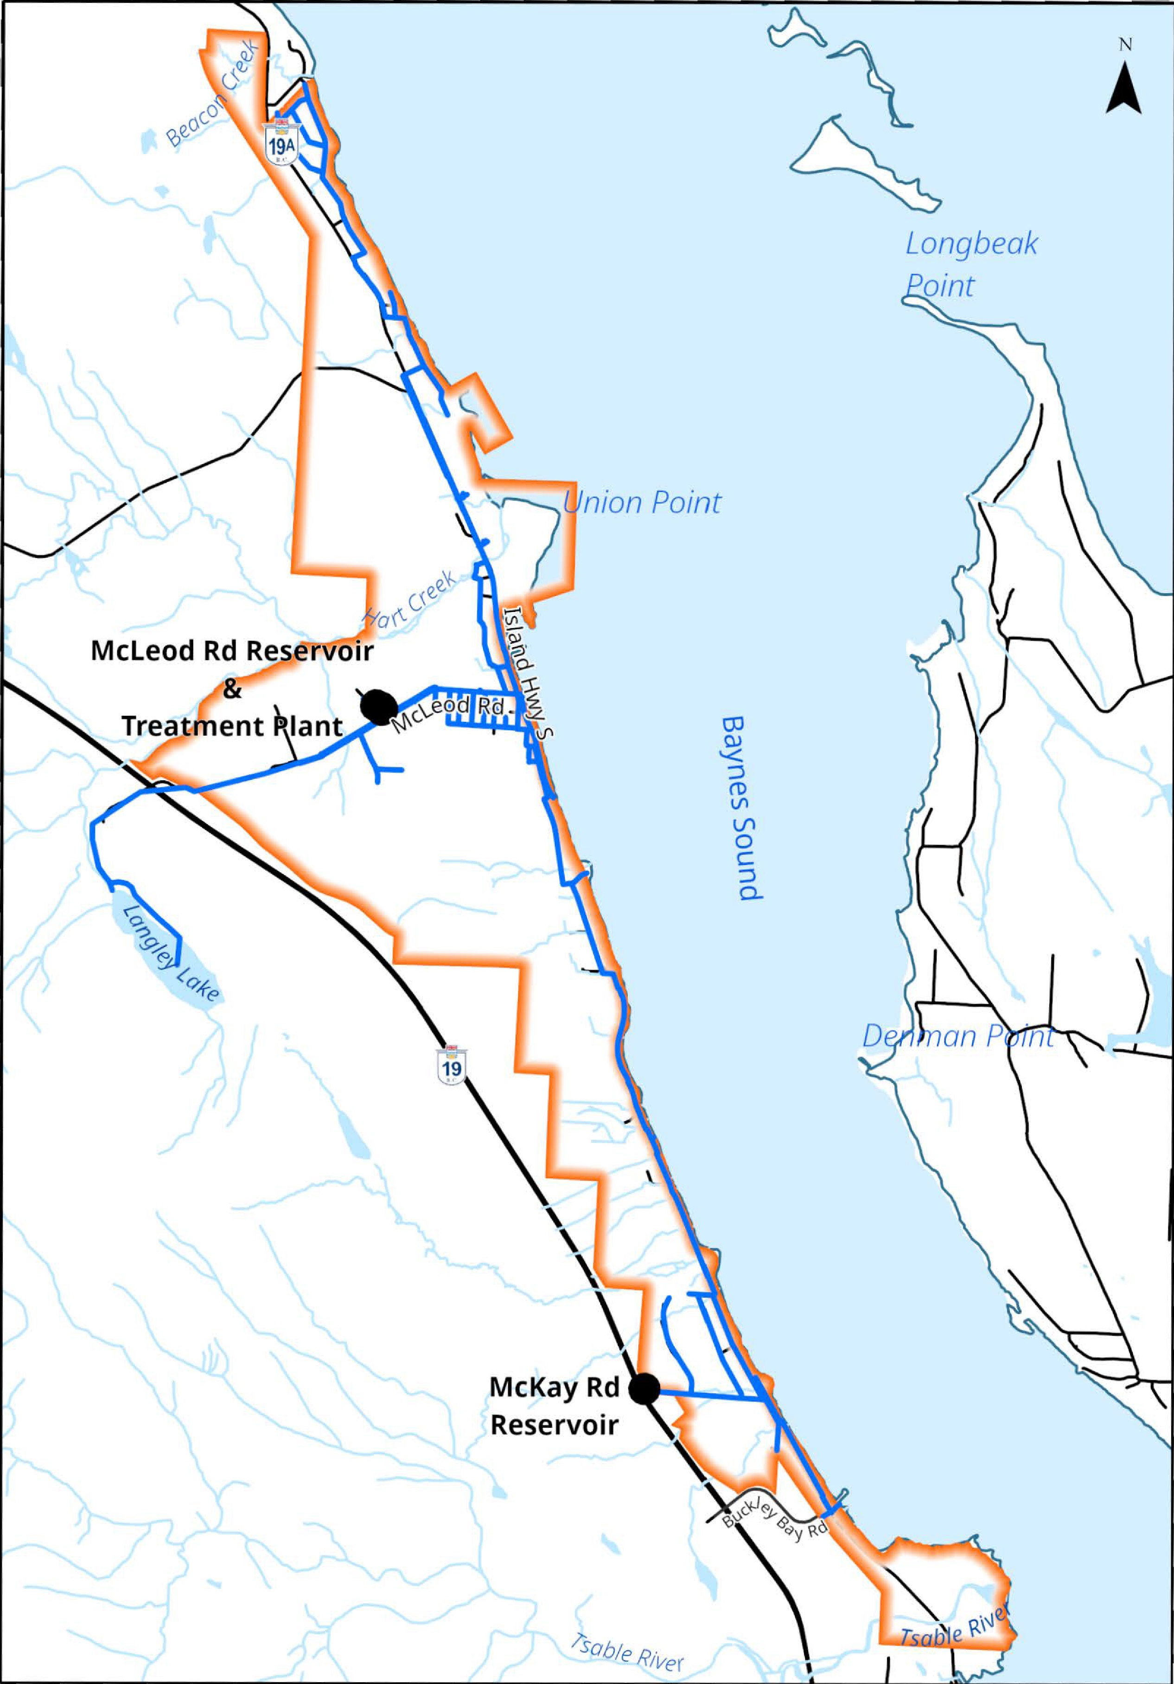
The Comox Valley Regional District strives to provide high-quality drinking water through responsible operation and management of the water system. The CVRD is regulated by Island Health for its activities as a potable water supplier and is required under the Drinking Water Protection Act to report annually on the Union Bay Water System. This report includes information on water quality, consumption, maintenance, and capital projects.
The CVRD provides water to roughly 1800 residents in the Union Bay Service Area.

Source Water
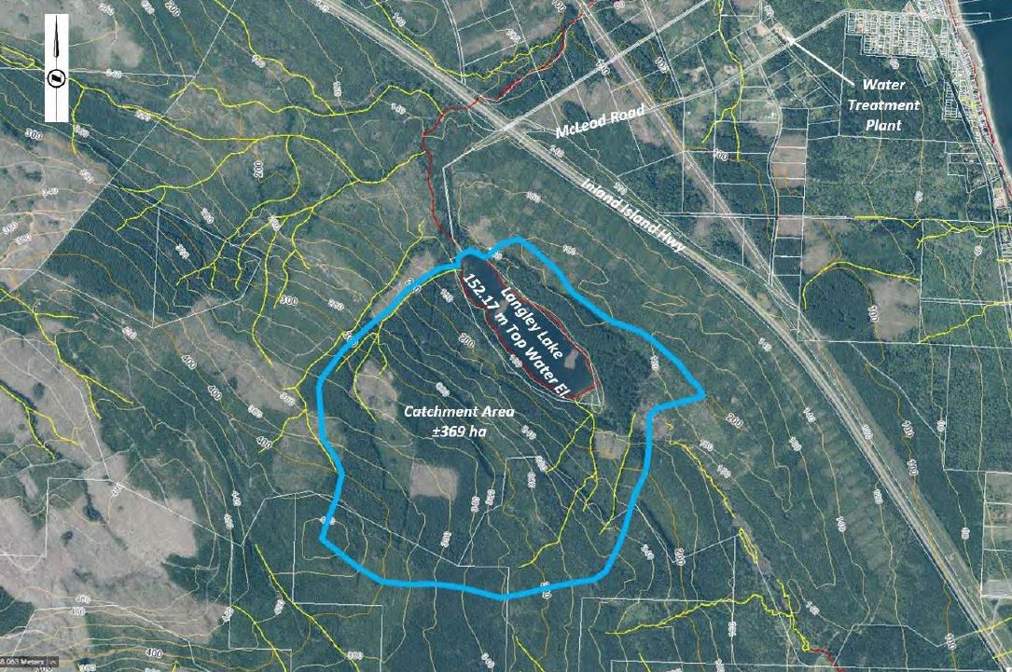
Water for the Union Bay Service Area is sourced from Langley Lake, a spring and creek fed lake with several small tributaries.
The lake watershed is 369 hectares of drainage basin and is much of it is privately owned and managed for timber supply.
Langley Lake watershed.

Water Treatment
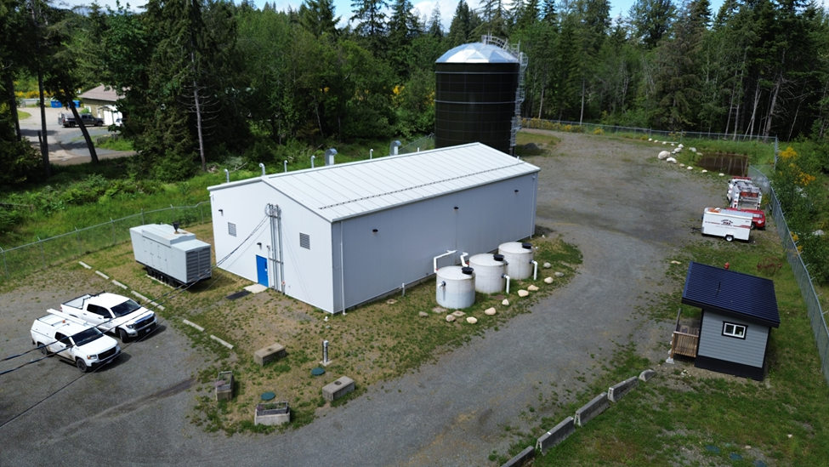
All water supply systems using surface water are governed by Island Health and are required to adhere to provincial “4-3-2-1-0” treatment objectives to ensure effective elimination of disease-causing viruses, bacteria, and parasites.
The “4-3-2-1-0” objectives are as follows:
Union Bay Water Treatment Plant
- 4-log (99.99 per cent) removal/inactivation of viruses
- 3-log (99.9 per cent) removal/inactivation of Giardia and Cryptosporidium
- 2 types of treatment processes
- 1 maximum Nephelometric Turbidity Units in treated water
- 0 detectable E. Coli, fecal coliforms and total coliforms in treated water
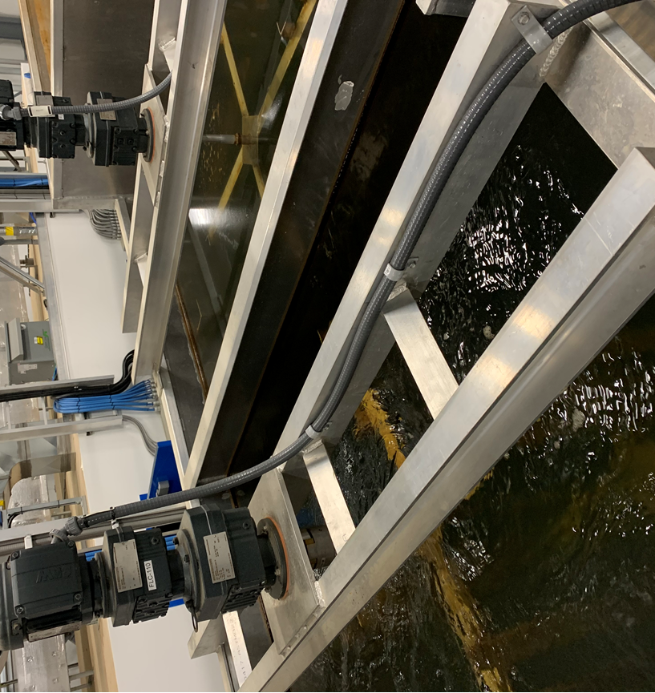
The journey from source to tap begins at the intake suspended above the bed of Langley Lake. Water enters the intake and flows along the dam on the NE side of the lake before travelling 3.8km to the water treatment plant.
When it arrives, it begins treatment by passing through a dissolved air flotation process that introduces a cloud of very small bubbles that carry particles to the surface where they are skimmed off.
Flocculation tank mixers.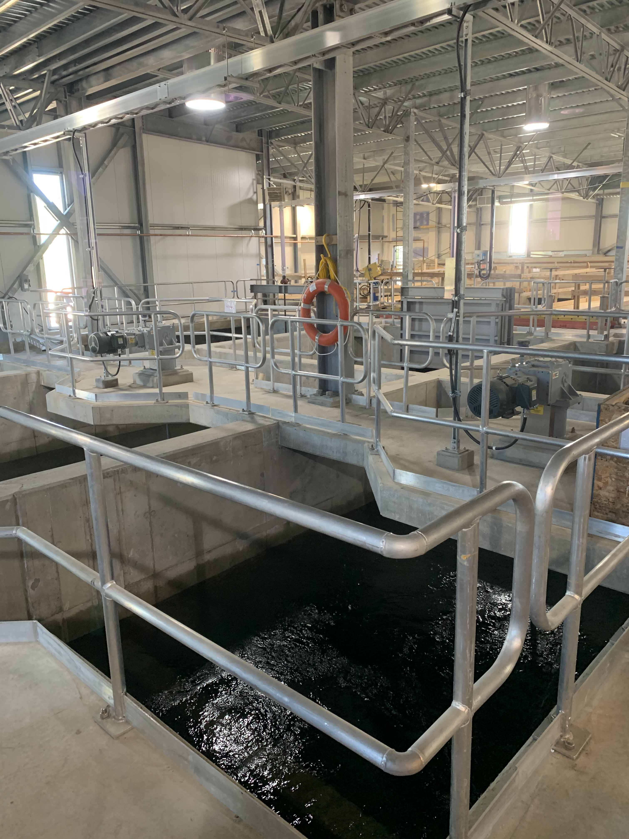
After this process, the water passes through a rapid gravity filtration media consisting of anthracite and sand to filter out any remaining particulate.
Finally, sodium hypochlorite is added for two purposes: to provide a final form of treatment, and to establish a residual disinfectant that persists in small amounts throughout the distribution network.
After disinfection, the water enters McLeod Reservoir which provides contact time for the sodium hypochlorite to disinfect any remaining bacteria.

Water Distribution
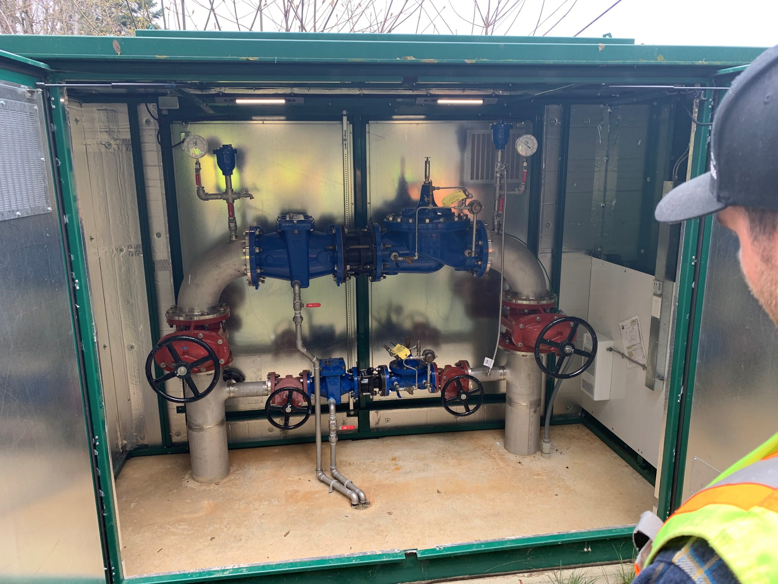
Water leaves the reservoir at the treatment plant and some water is pumped to pressurize the upper zone of Green Avenue and Musgrave Road, and some water and flows downhill, passing through two pressure reducing valves as it makes its way into the community.
The system extends along the coast to Kilmarnock Drive in the north, and to Buckley Bay Road in the south. Some water travels to McKay Reservoir which provides fire protection and storage capacity to the southern extremities of Union Bay. There are 80 fire hydrants and 736 service connections in the distribution system.
Nelson pressure reducing valve.

Water Quality
The Ministry of Health, through its regional body Island Health, regulates municipal drinking water quality through the Drinking Water Protection Act and the Drinking Water Protection Regulation. Both documents set out certain requirements for drinking water purveyors to ensure the provision of safe drinking water to their customers.
The Guidelines for Canadian Drinking Water Quality are developed by the Federal-Provincial-Territorial Committee on Drinking Water and they provide a limit on microbial, chemical, physical, radiological substances called a “maximum acceptable concentration”. The guidelines also assign aesthetic objectives to substances that do not cause risk to human health but influence consumer acceptance of the water based on factors such as taste, odour and colour.
The CVRD collects and analyzes weekly water quality samples from Langley Lake, at the treatment facility, McLeod and McKay Reservoirs, as well as from various other strategic points within the network to ensure that water meets regulatory objectives. Additionally, beyond the scope of this document, water from select locations is tested periodically throughout the year for over 200 different analytes to confirm the effectiveness of treatment processes, the quality of our source water, and the integrity of the distribution system.

Water Quality Summary
Source Water | 2023 | 2024
Turbidity (Average, NTU) | 0.94 | 1.15
pH (Average) | 6.5 | 6.8
Distribution Water | 2023 | 2024 | Target
Turbidity (Average, NTU) | 0.22 | 0.25 | <1
Temperature (Average, ℃) | 11.7 | 12.7 | <15
pH (Average) | 7.4 | 9.4 | 7-10.5
Chlorine Residual (Average, mg/L) | 0.46 | 0.61 | 0.4≥≤2.0
Total Coliforms (Positive Samples) | 0 | 0 | 0
E. Coli (Positive Samples) | 0 | 0 | 0
Trihalomethanes* (Average, mg/L) | 0.02 | 0.03 | <0.1

Distribution Water – Other Analytes
Parameter | Units | Matrix | Q1 | Q2 | Q3 | Q4
Nitrite (N) | mg/L | Result | <0.0050 | <0.0050 | <0.0050 | <0.0050
Nitrite (N) | mg/L | DL | 0.005 | 0.005 | 0.005 | 0.005
Nitrate (N) | mg/L | Result | <0.020 | <0.020 | <0.020 | 0.08
Nitrate (N) | mg/L | DL | 0.02 | 0.02 | 0.02 | 0.02
Conductivity | uS/cm | Result | 8.8 | 10.3 | 9.3 | 9.5
Conductivity | uS/cm | DL | 2 | 2 | 2 | 2
pH | pH | Result | 8.6 | 14.7 | 19.1 | 8.5
pH | pH | DL | N/A | N/A | N/A | N/A
Alkalinity (PP as CaCO3) | mg/L | Result | 0.13 | 0.39 | 0.37 | 0.1
Alkalinity (PP as CaCO3) | mg/L | DL | 1 | 1 | 1 | 1
Alkalinity (CaCO3) | mg/L | Result | 0.88 | 0.73 | 0.3 | 0.55
Alkalinity (CaCO3) | mg/L | DL | 1 | 1 | 1 | 1
Bicarbonate (HCO3) | mg/L | Result | 64 | 69 | 74 | 77
Bicarbonate (HCO3) | mg/L | DL | 1 | 1 | 1 | 1
Carbonate (CO3) | mg/L | Result | 7.05 | 6.79 | 6.92 | 7.13
Carbonate (CO3) | mg/L | DL | 1 | 1 | 1 | 1
Hydroxide (OH) | mg/L | Result | <1.0 | <1.0 | <1.0 | <1.0
Hydroxide (OH) | mg/L | DL | 1 | 1 | 1 | 1
Chloride (Cl) | mg/L | Result | 14 | 17 | 25 | 21
Chloride (Cl) | mg/L | DL | 1 | 1 | 1 | 1
Sulphate (SO4) | mg/L | Result | 17 | 21 | 30 | 25
Sulphate (SO4) | mg/L | DL | 1 | 1 | 1 | 1
True Colour | Col. Unit | Result | <1.0 | <1.0 | <1.0 | <1.0
True Colour | Col. Unit | DL | 2 | 2 | 2 | 2
Orthophosphate (P) | mg/L | Result | <1.0 | <1.0 | <1.0 | <1.0
Orthophosphate (P) | mg/L | DL | 0.003 | 0.003 | 0.003 | 0.003
Nitrate plus Nitrite (N) | mg/L | Result | 6.6 | 5 | 4.8 | 10
Nitrate plus Nitrite (N) | mg/L | DL | 0.02 | 0.02 | 0.02 | 0.02
Dissolved Fluoride (F) | mg/L | Result | 3.7 | 3.4 | 3.7 | 3.7
Dissolved Fluoride (F) | mg/L | DL | 0.05 | 0.05 | 0.05 | 0.05
Total Dissolved Solids | mg/L | Result | <2.0 | <2.0 | <2.0 | 2.6
Total Dissolved Solids | mg/L | DL | 10 | 10 | 10 | 10
Turbidity | NTU | Result | <0.0030 | 0.0079 | 0.14 | 0.0073
Turbidity | NTU | DL | 0.1 | 0.1 | 0.1 | 0.1
Bromide (Br) | mg/L | Result | <0.020 | <0.020 | <0.020 | 0.08
Bromide (Br) | mg/L | DL | 0.01 | 0.01 | 0.01 | 0.01
Total Hardness (CaCO3) | mg/L | Result | <0.050 | <0.050 | <0.050 | <0.050
Total Hardness (CaCO3) | mg/L | DL | 0.5 | 0.5 | 0.5 | 0.5
Total Aluminum (Al) | ug/L | Result | 42 | 34 | 38 | 40
Total Aluminum (Al) | ug/L | DL | 3 | 3 | 3 | 3
Total Antimony (Sb) | ug/L | Result | <0.10 | <0.10 | 0.13 | 0.26
Total Antimony (Sb) | ug/L | DL | 0.5 | 0.5 | 0.5 | 0.5
Total Arsenic (As) | ug/L | Result | 0.114 | 0.037 | 0.024 | 0.031
Total Arsenic (As) | ug/L | DL | 0.1 | 0.1 | 0.1 | 0.1
Total Barium (Ba) | ug/L | Result | 0 | 0 | 0 | 0
Total Barium (Ba) | ug/L | DL | 1 | 1 | 1 | 1
Total Beryllium (Be) | ug/L | Result | 0 | 0 | 0 | 0
Total Beryllium (Be) | ug/L | DL | 0.1 | 0.1 | 0.1 | 0.1
Total Bismuth (Bi) | ug/L | Result | 10.7 | 11.6 | 14.9 | 16.1
Total Bismuth (Bi) | ug/L | DL | 1 | 1 | 1 | 1
Total Boron (B) | ug/L | Result | 33.6 | 40.8 | 67.4 | 47.3
Total Boron (B) | ug/L | DL | 50 | 50 | 50 | 50
Total Cadmium (Cd) | ug/L | Result | <0.50 | <0.50 | <0.50 | <0.50
Total Cadmium (Cd) | ug/L | DL | 0.01 | 0.01 | 0.01 | 0.01
Total Chromium (Cr) | ug/L | Result | <0.10 | <0.10 | <0.10 | 0.11
Total Chromium (Cr) | ug/L | DL | 1 | 1 | 1 | 1
Total Cobalt (Co) | ug/L | Result | 1.6 | 2 | 2.7 | 2.4
Total Cobalt (Co) | ug/L | DL | 0.2 | 0.2 | 0.2 | 0.2
Total Copper (Cu) | ug/L | Result | <0.10 | <0.10 | <0.10 | <0.10
Total Copper (Cu) | ug/L | DL | 0.2 | 0.2 | 0.2 | 0.2
Total Iron (Fe) | ug/L | Result | <1.0 | <1.0 | <1.0 | <1.0
Total Iron (Fe) | ug/L | DL | 5 | 5 | 5 | 5
Total Lead (Pb) | ug/L | Result | <50 | <50 | <50 | <50
Total Lead (Pb) | ug/L | DL | 0.2 | 0.2 | 0.2 | 0.2
Total Manganese (Mn) | ug/L | Result | <0.010 | <0.010 | <0.010 | <0.010
Total Manganese (Mn) | ug/L | DL | 1 | 1 | 1 | 1
Total Molybdenum (Mo) | ug/L | Result | <1.0 | <1.0 | <1.0 | <1.0
Total Molybdenum (Mo) | ug/L | DL | 1 | 1 | 1 | 1
Total Nickel (Ni) | ug/L | Result | <0.20 | <0.20 | <0.20 | <0.20
Total Nickel (Ni) | ug/L | DL | 1 | 1 | 1 | 1
Total Selenium (Se) | ug/L | Result | 0.34 | 0.68 | 0.59 | 0.27
Total Selenium (Se) | ug/L | DL | 0.1 | 0.1 | 0.1 | 0.1
Total Silicon (Si) | ug/L | Result | 14.7 | 14.8 | 11 | 19
Total Silicon (Si) | ug/L | DL | 100 | 100 | 100 | 100
Total Silver (Ag) | ug/L | Result | <0.20 | <0.20 | <0.20 | <0.20
Total Silver (Ag) | ug/L | DL | 0.02 | 0.02 | 0.02 | 0.02
Total Strontium (Sr) | ug/L | Result | <1.0 | <1.0 | <1.0 | <1.0
Total Strontium (Sr) | ug/L | DL | 1 | 1 | 1 | 1
Total Thallium (Tl) | ug/L | Result | <1.0 | <1.0 | <1.0 | <1.0
Total Thallium (Tl) | ug/L | DL | 0.01 | 0.01 | 0.01 | 0.01
Total Tin (Sn) | ug/L | Result | <1.0 | <1.0 | <1.0 | <1.0
Total Tin (Sn) | ug/L | DL | 5 | 5 | 5 | 5
Total Titanium (Ti) | ug/L | Result | <0.10 | <0.10 | <0.10 | <0.10
Total Titanium (Ti) | ug/L | DL | 5 | 5 | 5 | 5
Total Uranium (U) | ug/L | Result | 2310 | 2450 | 1990 | 1990
Total Uranium (U) | ug/L | DL | 0.1 | 0.1 | 0.1 | 0.1
Total Vanadium (V) | ug/L | Result | <0.020 | <0.020 | <0.020 | <0.020
Total Vanadium (V) | ug/L | DL | 5 | 5 | 5 | 5
Total Zinc (Zn) | ug/L | Result | 14.2 | 17.7 | 21.7 | 21.8
Total Zinc (Zn) | ug/L | DL | 5 | 5 | 5 | 5
Total Zirconium (Zr) | ug/L | Result | <0.010 | <0.010 | <0.010 | <0.010
Total Zirconium (Zr) | ug/L | DL | 0.1 | 0.1 | 0.1 | 0.1
Total Calcium (Ca) | mg/L | Result | <5.0 | <5.0 | <5.0 | <5.0
Total Calcium (Ca) | mg/L | DL | 0.05 | 0.05 | 0.05 | 0.05
Total Magnesium (Mg) | mg/L | Result | <5.0 | <5.0 | <5.0 | <5.0
Total Magnesium (Mg) | mg/L | DL | 0.05 | 0.05 | 0.05 | 0.05
Total Potassium (K) | mg/L | Result | <0.10 | <0.10 | <0.10 | <0.10
Total Potassium (K) | mg/L | DL | 0.05 | 0.05 | 0.05 | 0.05
Total Sodium (Na) | mg/L | Result | <5.0 | <5.0 | <5.0 | <5.0
Total Sodium (Na) | mg/L | DL | 0.05 | 0.05 | 0.05 | 0.05
Total Sulphur (S) | mg/L | Result | <5.0 | <5.0 | <5.0 | <5.0
Total Sulphur (S) | mg/L | DL | 3 | 3 | 3 | 3
Total Mercury (Hg) | ug/L | Result | <0.10 | <0.10 | <0.10 | <0.10
Total Mercury (Hg) | ug/L | DL | 0.0019 | 0.0019 | 0.0019 | 0.0019
Total Trihalomethanes | ug/L | Result | 4.08 | 4.47 | 5.76 | 6.18
Total Trihalomethanes | ug/L | DL | 1 | 1 | 1 | 1
Bromodichloromethane | ug/L | Result | 0.131 | 0.115 | 0.116 | 0.167
Bromodichloromethane | ug/L | DL | 1 | 1 | 1 | 1
Bromoform | ug/L | Result | 0.195 | 0.24 | 0.263 | 0.215
Bromoform | ug/L | DL | 1 | 1 | 1 | 1
Dibromochloromethane | ug/L | Result | 7.72 | 8.49 | 8.62 | 11
Dibromochloromethane | ug/L | DL | 1 | 1 | 1 | 1
Chloroform | ug/L | Result | <3.0 | <3.0 | <3.0 | <3.0
Chloroform | ug/L | DL | 1 | 1 | 1 | 1

Consumption Metrics and Water Rates
The average daily water production in 2024 was 655m³ per day. Demand is highest during the summer months - approximately twice as much as during the winter. System demand reached its highest point on May 15th with 1392m³ of water being produced.

 |  | 2024 | 2025
Residential | Minimum charge up to 10m³ | $66.74 | $68.41
Residential | 10m³ to 25m³ | $1.73/m³ | $1.77/m³
Residential | 25m³ to 37.5m³ | $2.35/m³ | $2.41/m³
Residential | 37.5³ to 50m³ | $3.09/m³ | $3.17/m³
Residential | Over 50m³ | $4.64/m³ | $4.75/m³
Commercial | Minimum charge | $46.25 | $47.40
Commercial | Cost per m³ | $1.98/m³ | $2.03/m³

Conservation
Water conservation is an increasingly important initiative and while it seems as if there is an abundance of water available, our supply is truly a limited resource, particularly during the summer months.
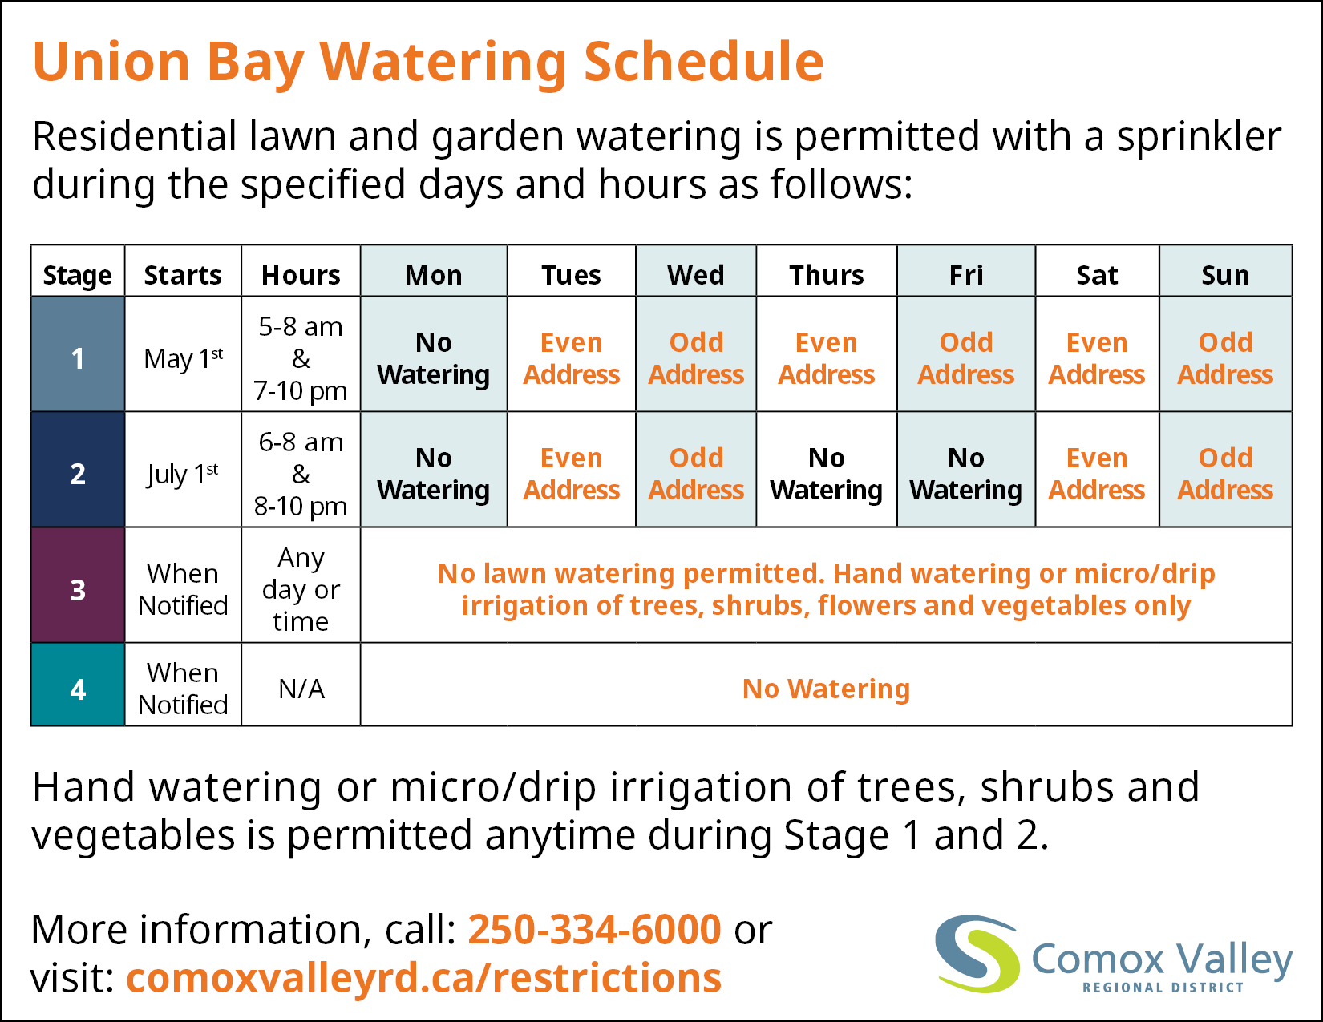
The CVRD has a four-stage system in place for managing water consumption. Stage one is the least restrictive and comes into effect annually on May 1st until September 30th unless otherwise noted. Stage 2 is implemented when the water level in Langley Lake drops to elevation 151.53 m (0.64 m below the spillway crest). Stage 3 is implemented when the water level in Langley Lake drops to elevation 150.95 m (1.22 m below the spillway crest) and stage 4 is designed to accommodate emergency infrastructure repairs where the ability to deliver water is compromised and water use needs to be reduced to ‘basic needs’ only.

Operations
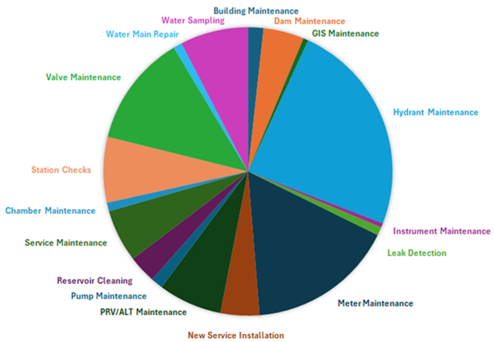
Water treatment facilities and distribution systems are operated by 15 qualified operators. In 2024, several ongoing and annual maintenance activities were carried out, as well as improvements to work order tracking, data collection, and map improvements.
Additionally, many non-annual projects were completed such as reservoir cleaning, and hydrant painting.

2024 Achievements
- Langley Lake dam upgrades and development of a preventative maintenance plan
- HWY 19-A 100mm watermain disconnects
- Installed 2 new sample stations in the distribution system
- Completed a thorough Leak Detection project where 6 leaks were identified and repaired
- Completed water audit and developed residential metering replacement strategy

2025 Objectives
- Procure and install Water Treatment Plant outflow meter
- Complete construction on the ‘Nelson Loop Project’ which will increase the robustness of water delivery into the distribution system
- Obtain board approval and begin implementation of a residential meter replacement program
- Water Treatment Plant upgrades to include controls and automation system as well as electronic actuators on filter valves

