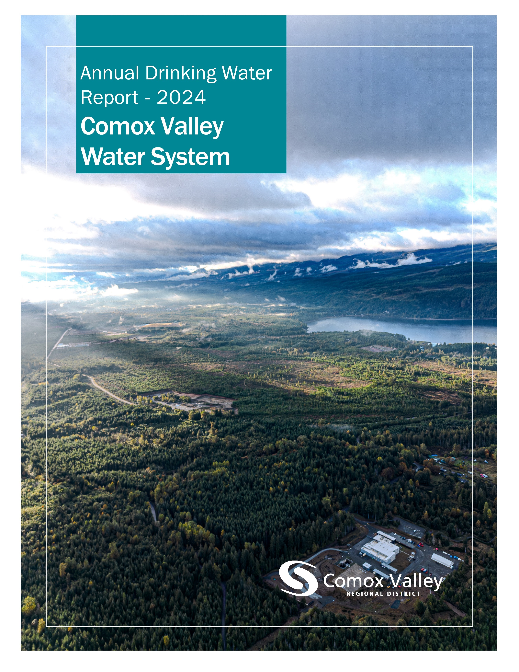

Table of Contents
Introduction 2
Source Water 3
Water Treatment 4
Water Distribution 6
Water Quality 7
Water Quality Summary 7
Source Water – Turbidity 8
Source Water – Temperature 9
Source Water – pH 10
Source Water – PFAs 11
Distribution Water – Turbidity 12
Distribution Water – Temperature 13
Distribution Water – pH 14
Distribution Water – Chlorine Residual 15
Distribution Water – Total Coliforms 16
Distribution Water – E. Coli 17
Distribution Water – Trihalomethanes 18
Distribution Water – Field Data by Sample Site 19
Distribution Water – Other Analytes 20
Watershed Protection Plan 22
Consumption Metrics and Water Rates 23
Conservation 24
Operations 25
2024 Achievements 25
2025 Objectives 25
The Comox Valley Regional District respectfully acknowledges that the land on which it operates is the unceded territory of the K'ómoks First Nation, the traditional keepers of this land.

Introduction
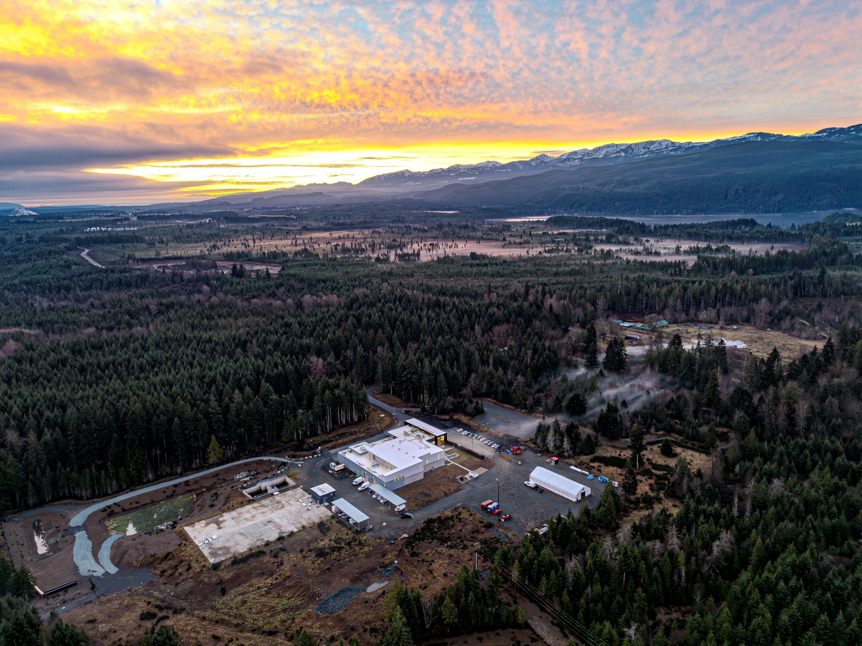
The Comox Valley Regional District strives to provide high-quality drinking water through responsible operation and management of the water system. The CVRD is regulated by Island Health for its activities as a potable water supplier and is required under the Drinking Water Protection Act to report annually on the Comox Valley Water System. This report includes information on water quality, consumption, maintenance, and capital projects.
Above: Comox Valley Water Treatment Plant at daybreak
The CVRD provides water to roughly 55,000 residents: the Town of Comox, the City of Courtenay, K’ómoks First Nation, and the Comox Valley Water Local Service Area.
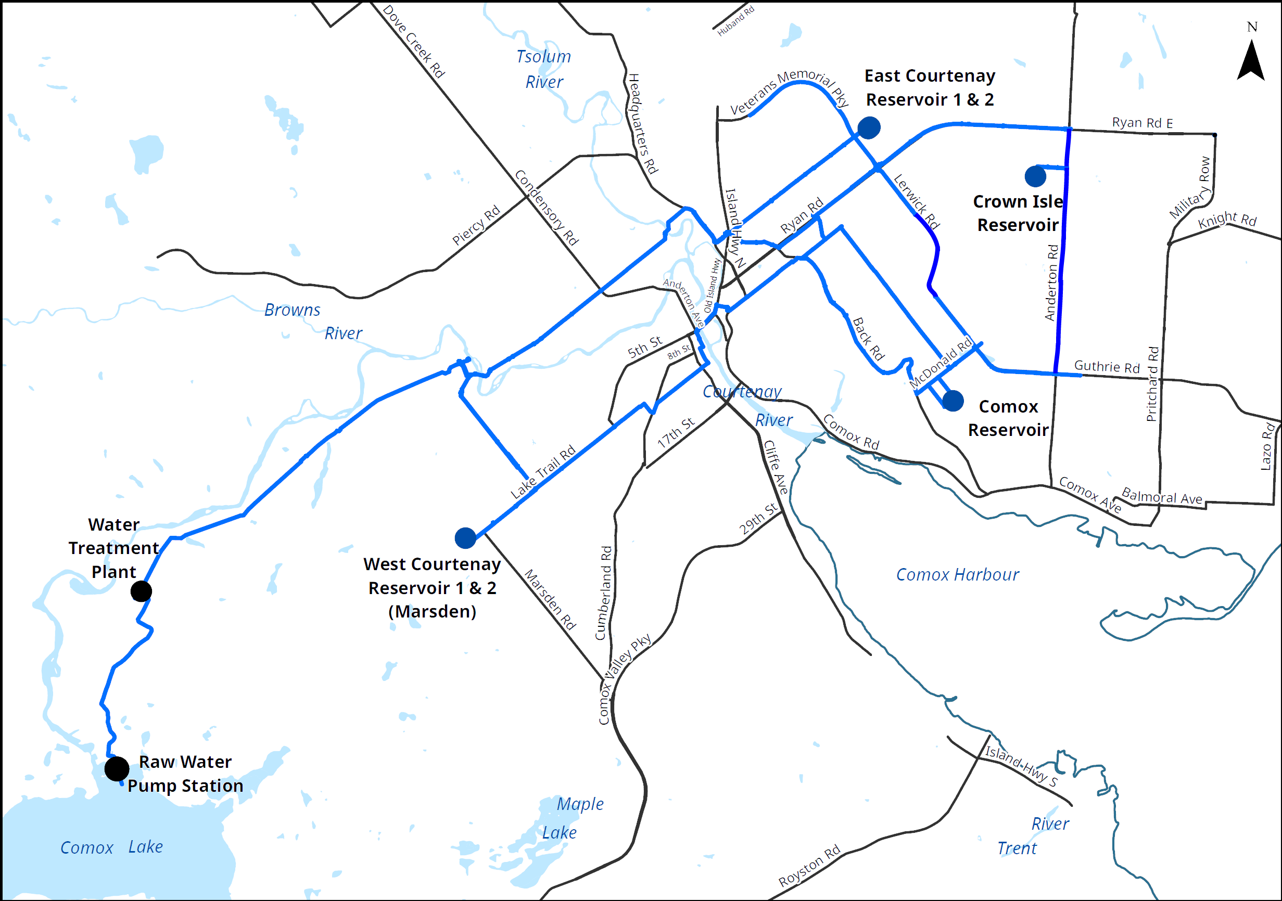

Source Water
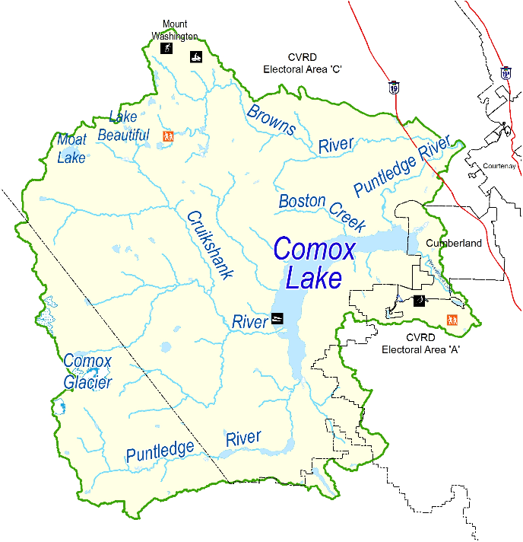
Water for the Comox Valley Water Service Area is sourced from Comox Lake, a glacier-fed lake with several tributaries – including the Puntledge, Perseverance, and Cruikshank rivers.
The lake watershed is 461 square kilometres of drainage basin and much of it is privately owned and managed for timber supply.
The lake itself is a reservoir not only for drinking water but is controlled by BC Hydro for power generation and fish flows into the Puntledge River.
Above: Map of the Comox Lake watershed.
Below: Comox Lake
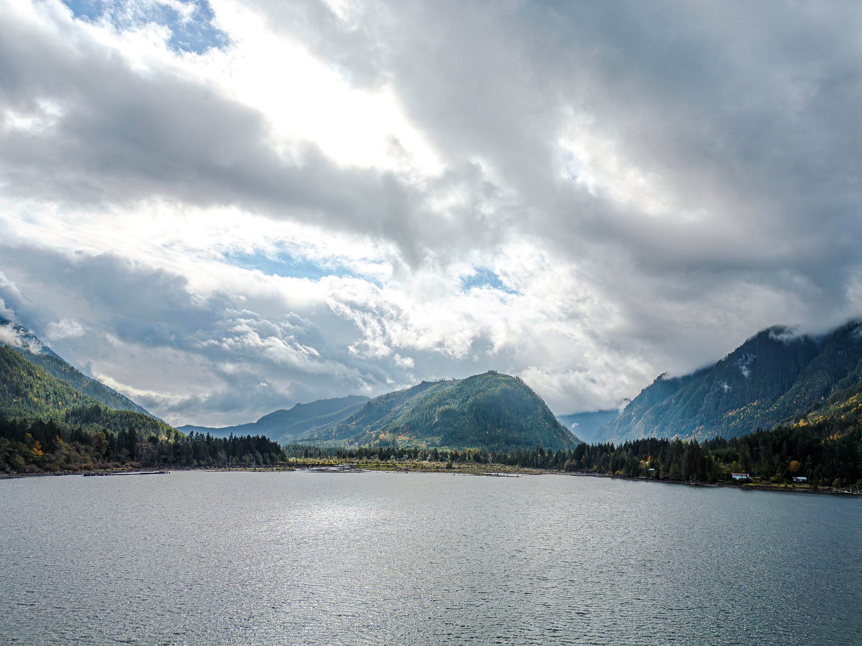
In 2016, the CVRD partnered in a multi-stakeholder effort to create the Watershed Protection Plan. This plan identifies the various activities within the watershed, their risks, and aims to reduce incidents by facility upgrades, emergency preparedness, public education initiatives, land protection, water quality monitoring, and signage.

Water Treatment
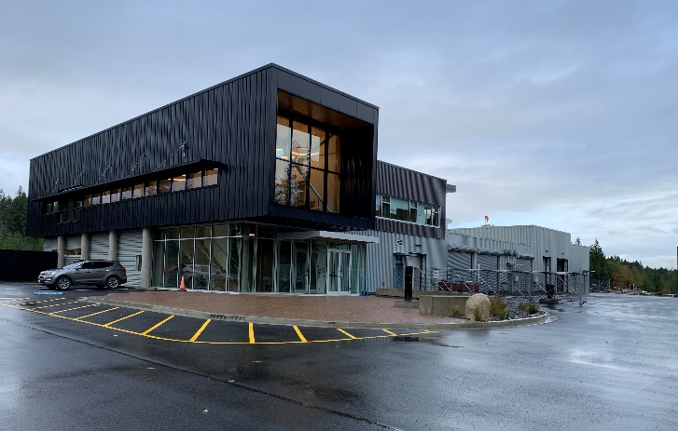
All water supply systems using surface water are governed by Island Health and are required to adhere to provincial “4-3-2-1-0” treatment objectives to ensure effective elimination of disease-causing viruses, bacteria, and parasites.
The “4-3-2-1-0” treatment objectives are as follows:
Comox Valley Water Treatment Plant
- 4-log (99.99 per cent) removal/inactivation of viruses
- 3-log (99.9 per cent) removal/inactivation of Giardia and Cryptosporidium
- 2 types of treatment processes
- 1 maximum Nephelometric Turbidity Units (NTU) in treated water
- 0 detectable E. Coli, fecal coliforms and total coliforms in treated water
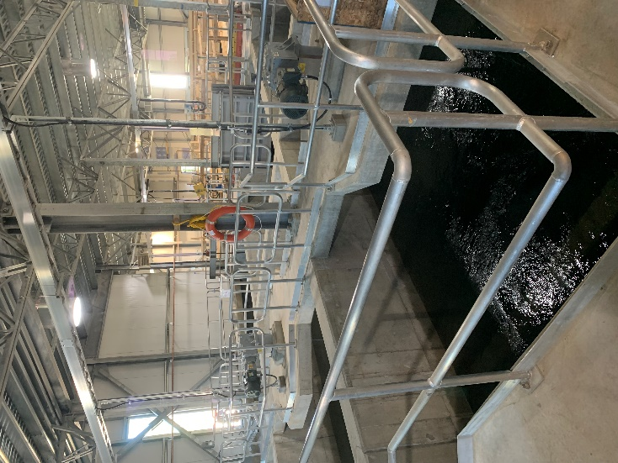
The journey from source to tap begins at the intake suspended above the bed of Comox Lake. Water enters the screened intake and flows to the underground wet well located on the shore; from there it is pumped 2.7 km to the water treatment plant.
When it arrives, a coagulant is added; this causes particulate to clump together into ‘floc’, and large, slow-moving mixers gently agitate the water to aid in this process. It then flows into sand and anthracite filter beds where the water passes through the media but the ‘floc’ becomes caught.

Flocculation tanks and mixing motors.
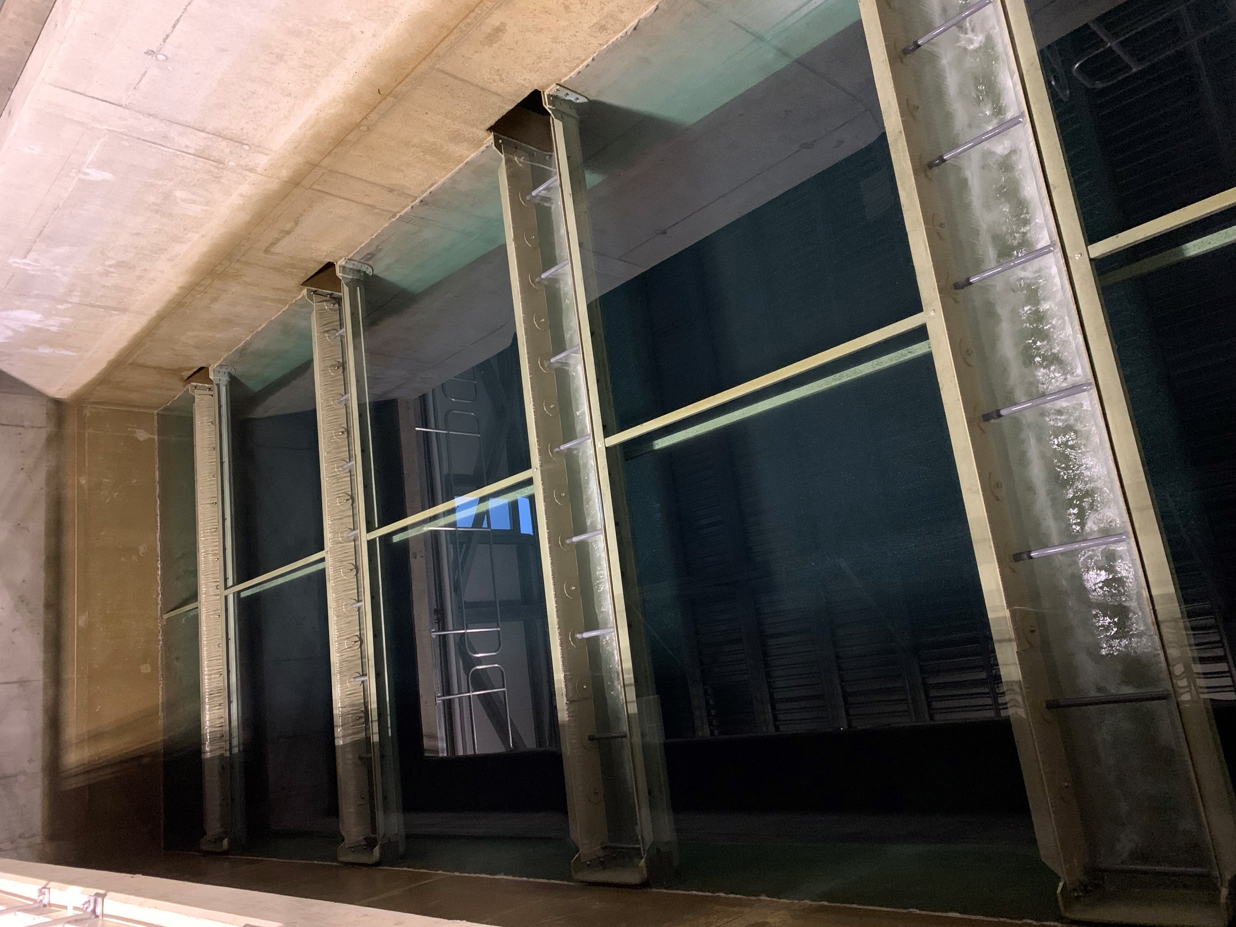
The filtered water is disinfected by passing though ultra-violet light reactors (UV) – this inactivates pathogens such as viruses, bacteria, and protozoa.
Then sodium hypochlorite is added for two purposes: to provide a final form of treatment, and to establish a residual disinfectant that persists in small amounts throughout the distribution network.
After disinfection, the water enters a large reservoir divided by a maze of channels called a ‘clear well’ that provides contact time for the sodium hypochlorite to disinfect any remaining bacteria.
One of five filter beds at the treatment plant.
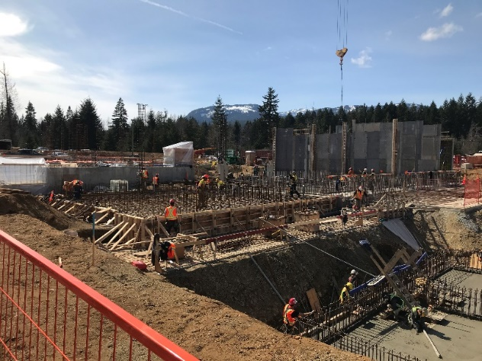
The finished water then travels through two transmission mains: one to West Courtenay and Marsden Reservoirs, and the other crosses underneath the Puntledge and Tsolum Rivers on its way to East Courtenay Reservoirs.
Planning of the water treatment plant began in 2015, construction started in 2019, and the facility began treating water in October of 2021.
Construction of the water treatment plant in 2020.

Water Distribution
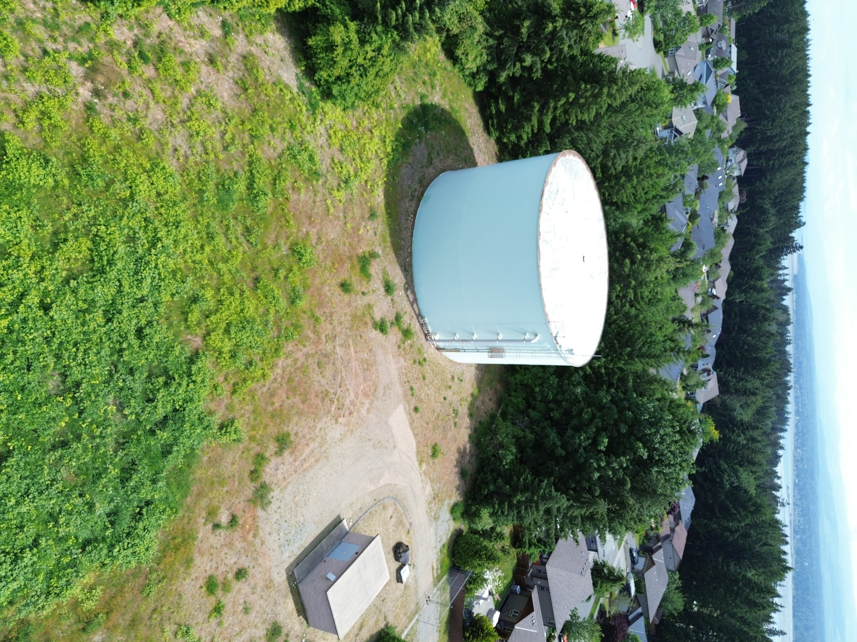
Water leaves the treatment plant clear well and flows to reservoirs located at high points throughout the service area. These reservoirs act as storage for fire protection, and their elevation provides head pressure for distribution. At these facilities, water is managed by automated valves and pumps, and is monitored for basic water quality parameters as it leaves in pipes to supply the distribution network. Altitude valves manage the fill needs of reservoirs, and respond to changing demands.
As water flows to lower elevations, the water pressure builds. Pressure reducing valves in kiosks or underground chambers serve to reduce the pressure to a manageable level.
Comox Reservoir and valve house.

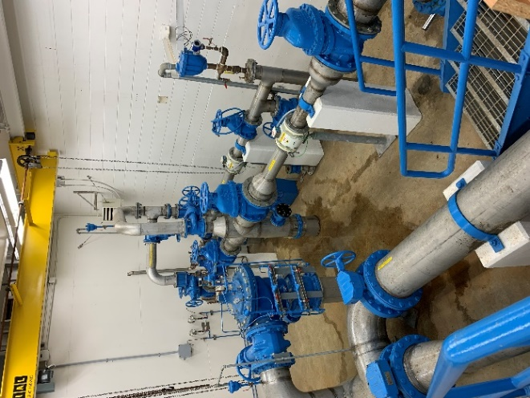
Variations in the topography of the service area create high points in the distribution mains where air becomes trapped. Air valves operate autonomously at these sites to release the air and prevent lockup.
Water flows through the distribution mains branching off again and again to create a vast network of pipes that supply fire hydrants, businesses, and households.

West Courtenay and Marsden control room.

Water Quality
The Ministry of Health, through its regional body Island Health, regulates municipal drinking water quality through the Drinking Water Protection Act and the Drinking Water Protection Regulation. Both documents set out certain requirements for drinking water purveyors to ensure the provision of safe drinking water to their customers.
The Guidelines for Canadian Drinking Water Quality are developed by the Federal-Provincial-Territorial Committee on Drinking Water, and they provide a limit on microbial, chemical, physical, radiological substances called a “maximum acceptable concentration”. The guidelines also assign aesthetic objectives to substances that do not cause risk to human health, but influence consumer acceptance of the water based on factors such as taste, odour and colour.
The CVRD collects and analyzes weekly water samples at the water treatment plant, Comox Lake, six reservoirs, and from various other strategic points within the distribution system to ensure that water is meeting regulatory objectives. Additionally, water from select locations is tested periodically throughout the year for over 200 different analytes to confirm the effectiveness of treatment processes, the quality of our source water, and the integrity of the distribution system.

Water Quality Summary
Source Water | 2023 | 2024
Turbidity (Average, NTU) | 0.64 | 0.83
Temperature (Average, ℃) | 12.9 | 12.2
pH (Average) | 7.5 | 7.4
Distribution Water | 2023 | 2024 | Target
Turbidity (Average, NTU) | 0.12 | 0.09 | <1
Temperature (Average, ℃) | 11.7 | 12.3 | <15
pH (Average) | 7.8 | 7.9 | 7-10.5
Chlorine Residual (Average, mg/L) | 0.70 | 0.75 | 0.4≥≤2.0
Total Coliforms (Positive Samples) | 0 | 0 | 0
E. Coli (Positive Samples) | 0 | 0 | 0
Trihalomethanes (Average, mg/L) | 0.01 | 0.01 | <0.1
- More information regarding each parameter is available later on in the report.

Source Water – Turbidity
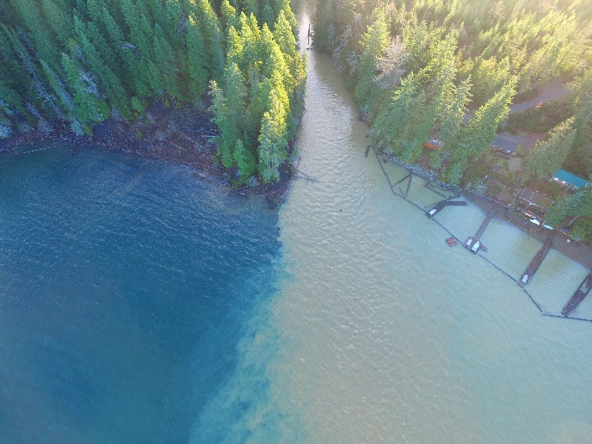
Turbidity is a measure of the clarity of water in nephelometric turbidity units, or NTUs. Heavy rainfall and washouts can cause turbidity events on Comox Lake, but the intake and dual-media filtration at the Water Treatment Plant has mitigated the need for turbidity-related boil-water notices. The average turbidity of the lake in 2024 was 0.83 NTU, with a peak of 4.2 NTU in February.
Turbid water entering Comox Lake from Perseverance Creek.

Source Water – Temperature
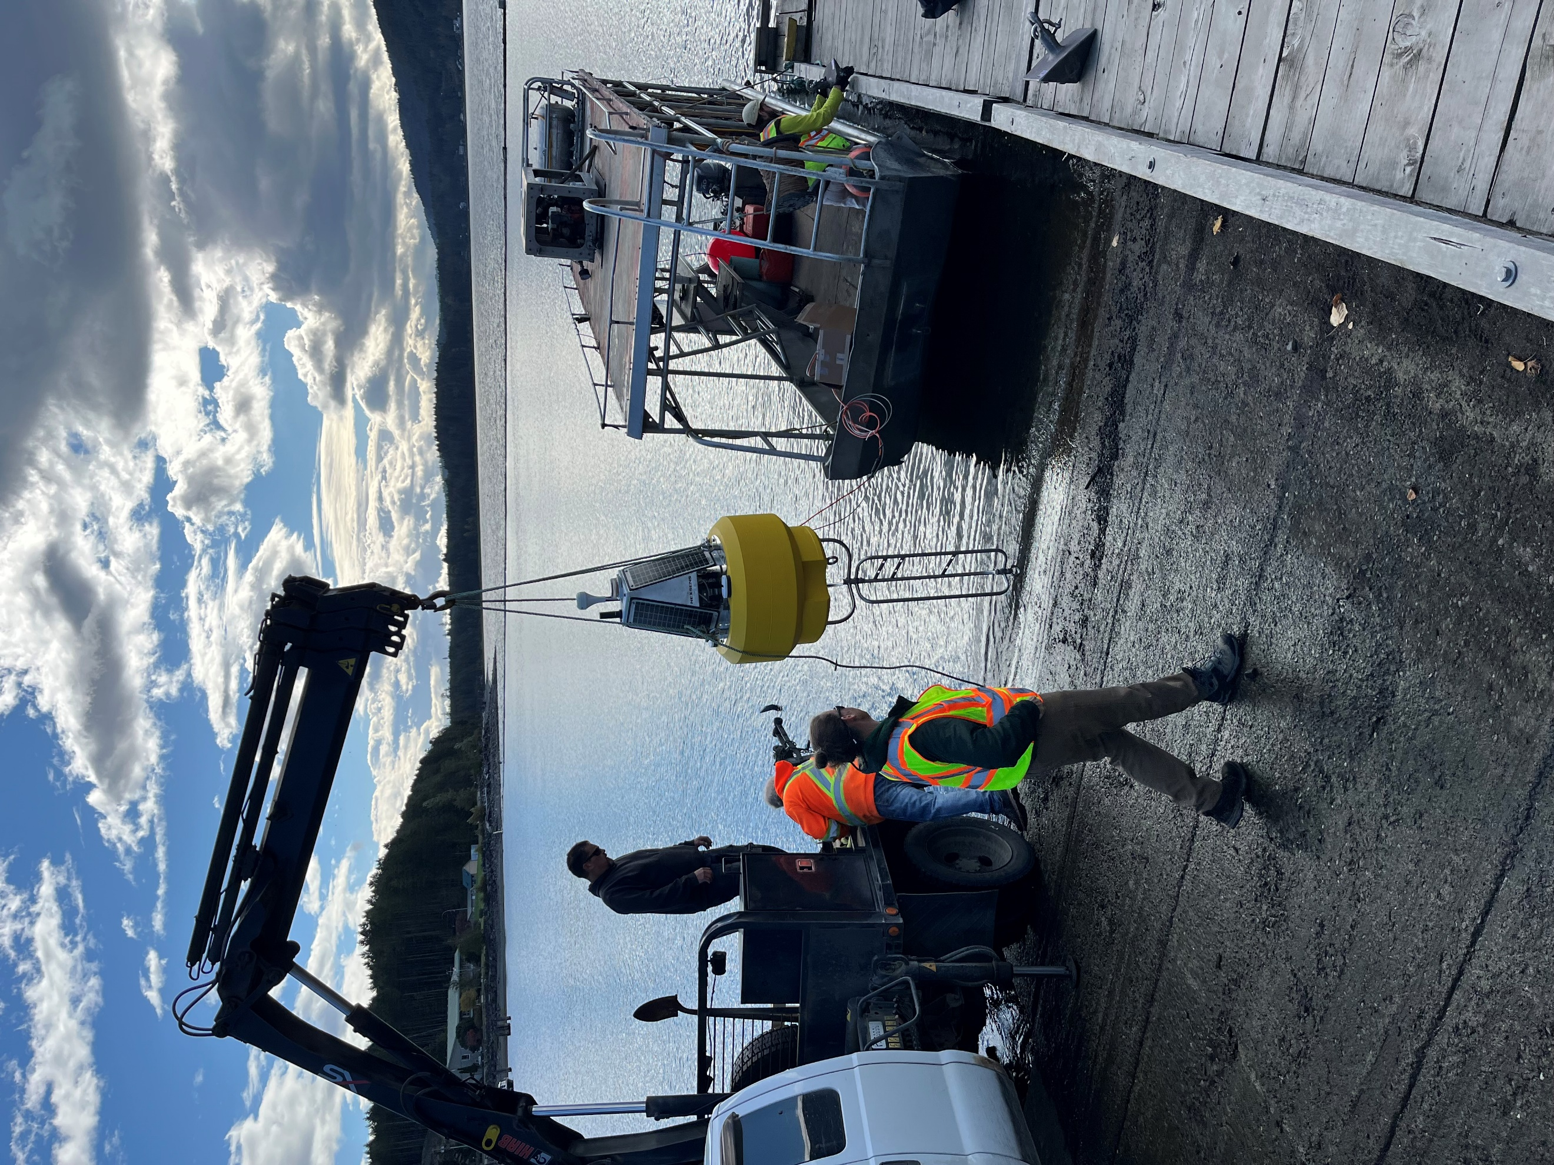
Gradual variations in source water temperature occur throughout the seasons, however, signifcant changes can upset various water treatment processess. The average source water temperature in 2024 was 12.2℃.
Thermistor buoy deployment on Comox Lake.

Source Water – pH
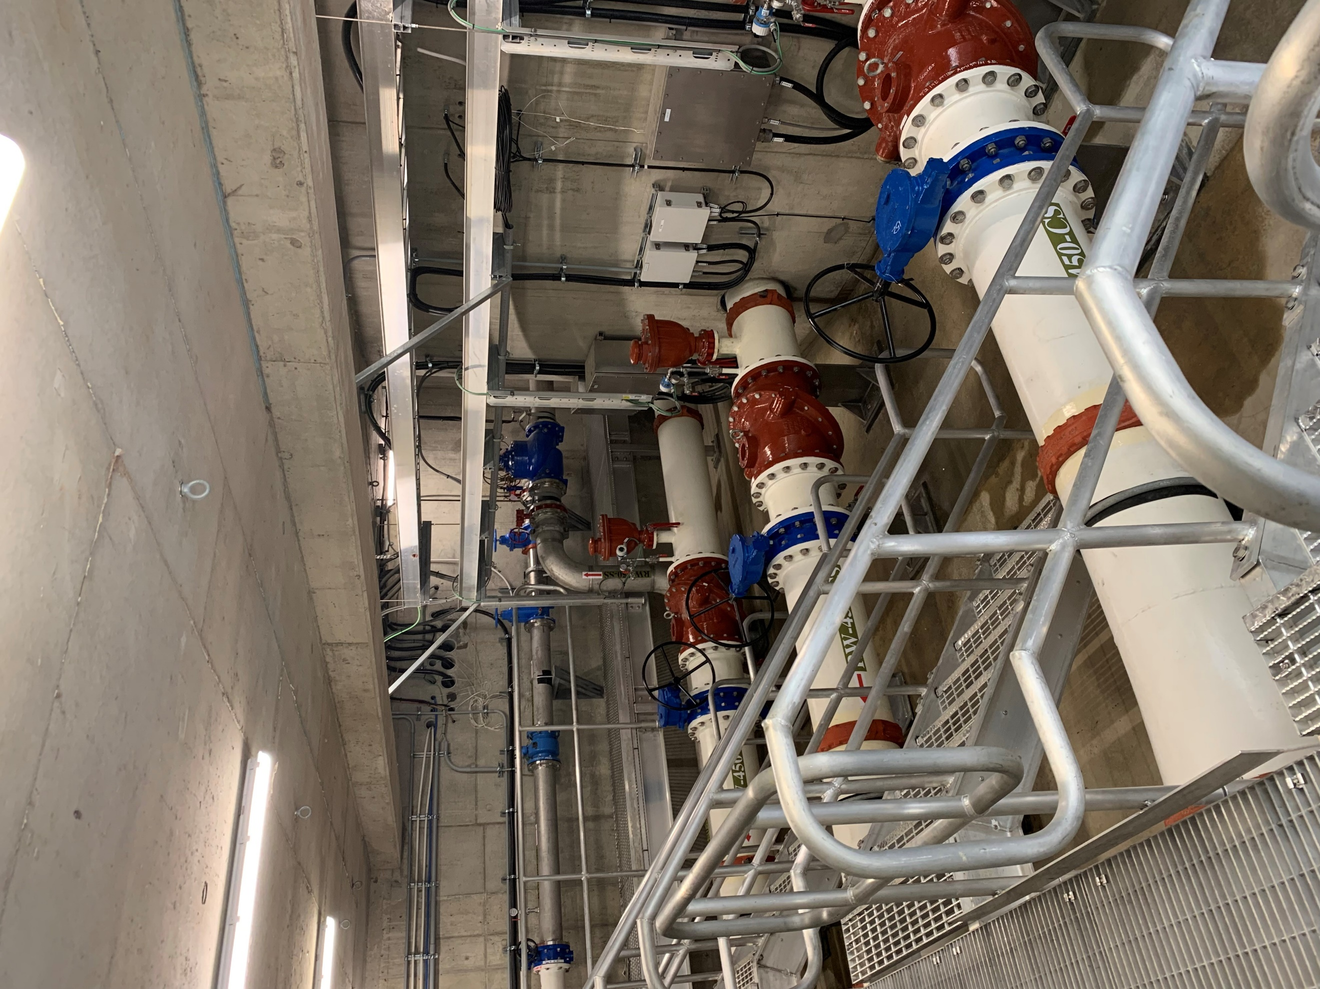
pH is a measure of the acidity or alkalinity of a substance. It is a logarithymic scale value that ranges from 0 to 14, with 7 being neutral - below 7 is acidic, above is alkaline. The pH of water affects its chemical and physical properties, thereby influencing the behavior of contaminants, and various treatment processes.
pH adjustment by chemical means is not needed for the source water from Comox Lake. The average pH in 2024 was 7.38.

Outlet piping at the raw water wet well.

Source Water – PFAs
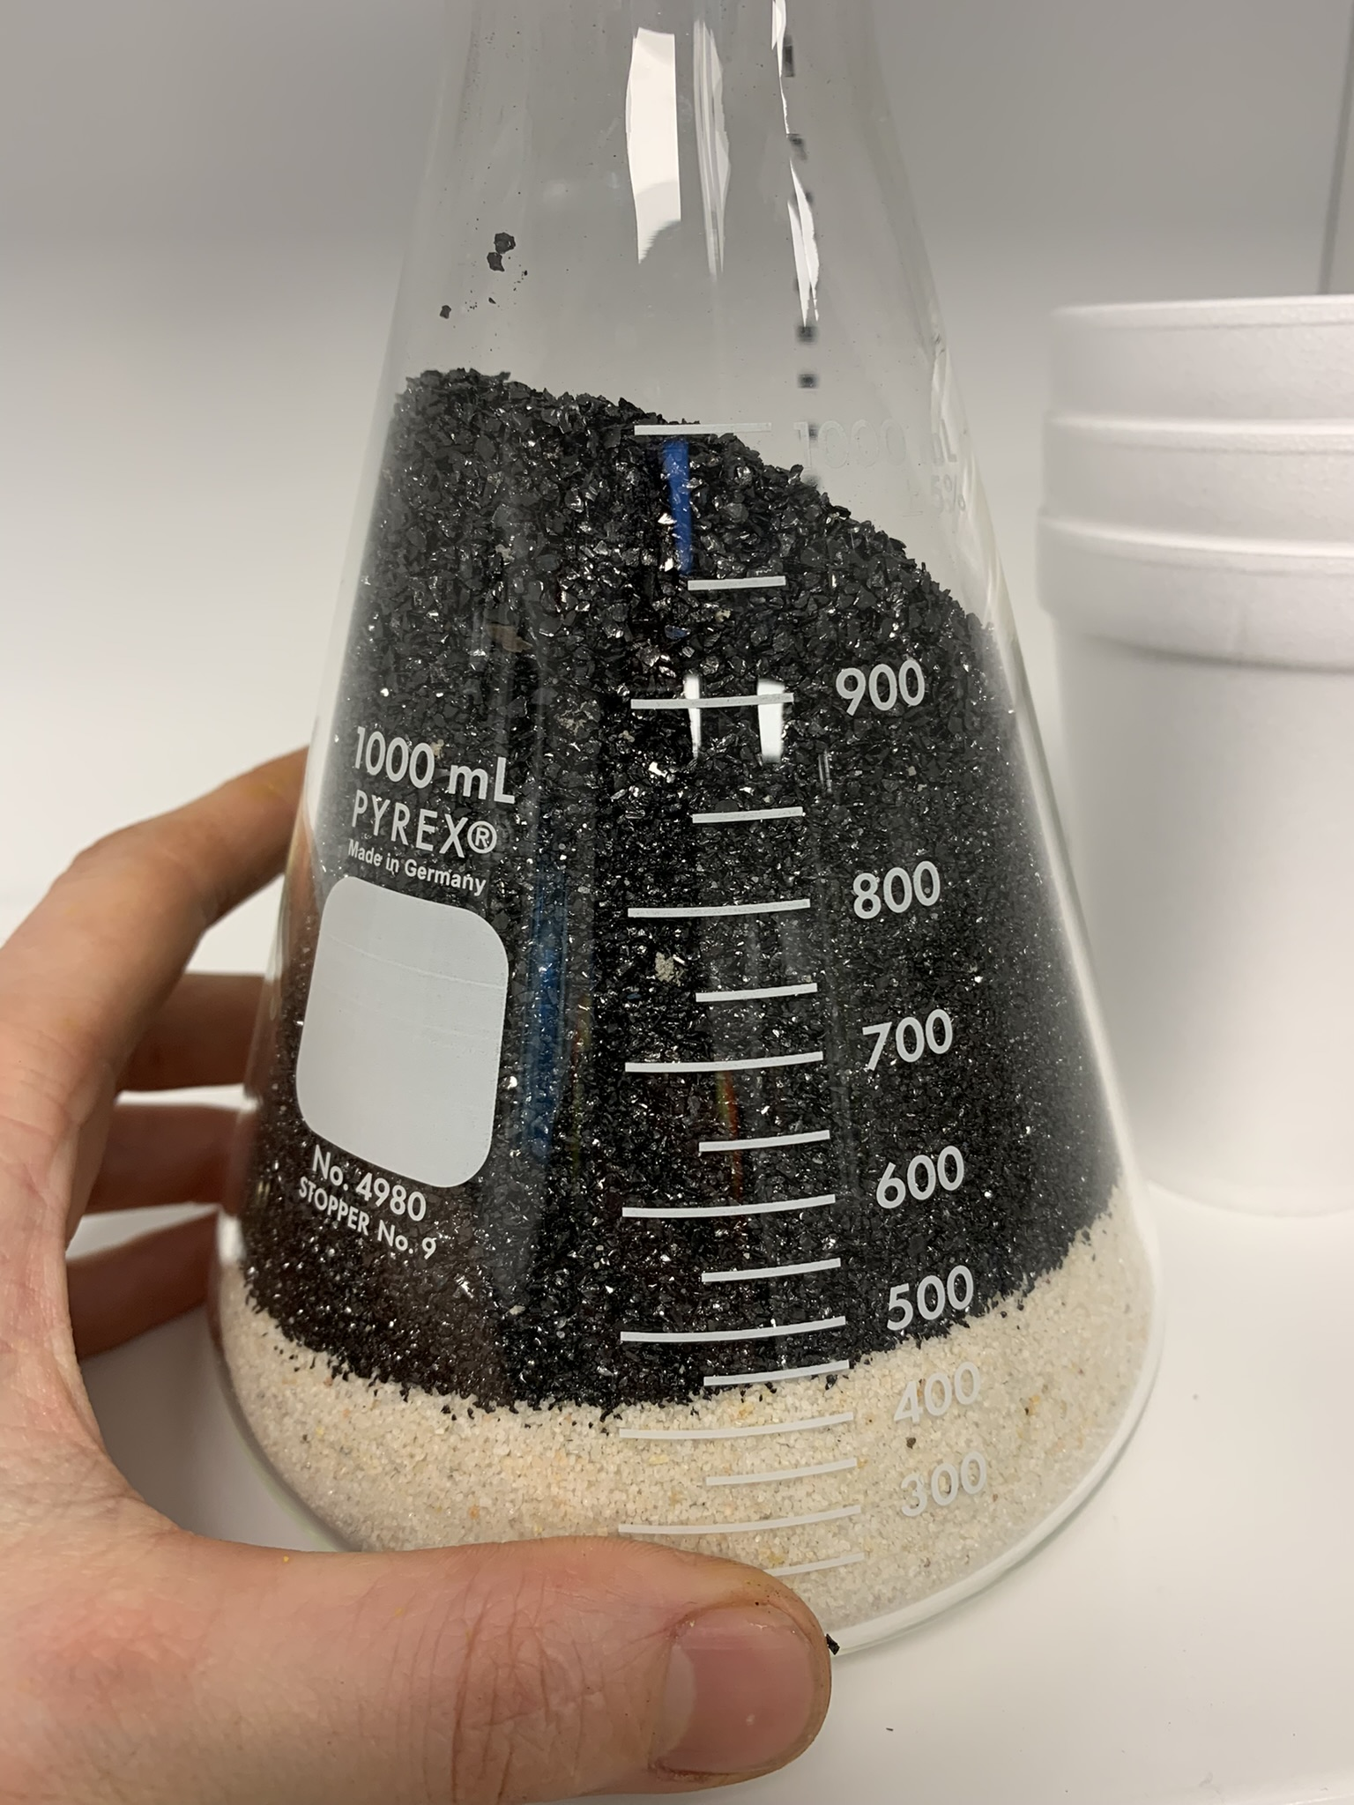
PFAs, or perfluoroalkyl and polyfluoroalkyl substances, are a large group of synthetic chemicals characterized by their water and oil repellent properties and high heat tolerance. They are typically used to make fabrics resistant to staining, to prevent food from adhering to cookware, in firefighting foam, in hygienic products, paints, medical devices, solvents, lubricants, manufacturing and metal processing.
A sample of filter media; anthracite and sand.
Testing for these chemicals is difficult due to their low detection levels, structural diversity, varying sizes and toxicities, and the vast number of potential compounds makes traditional separation methods inadequate. Fortunately, our water source is so close to its origin which means that PFAs compounds are unlikely to be found in Comox Lake.
Currently, there is no requirement for drinking water utilities to test for PFAs in Canada, but the CVRD Water Services division instituted a PFAs testing program in 2024. Raw water samples were collected from Comox Lake and all samples were below detectable limits of 0.02 micrograms per litre.

Distribution Water - Turbidity
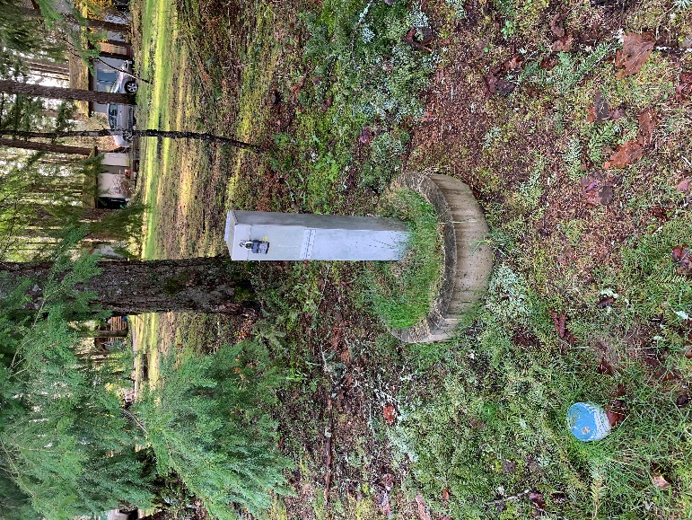
Samples are collected from various points in the distribution system on a weekly basis and field analysis of turbidity is carried out. The following chart displays a compiled average of those weekly samples.
Turbidity is a measure of the clarity of water. It is an optical characteristic and is measured by capturing the amount of light scattered by material in the water. The guideline for turbidity in the distribution system is <1.0 NTU.
In 2024, no sample exceeded 0.71 NTU and the average was 0.09 NTU.
A sample station in the distribution system.

Distribution Water - Temperature
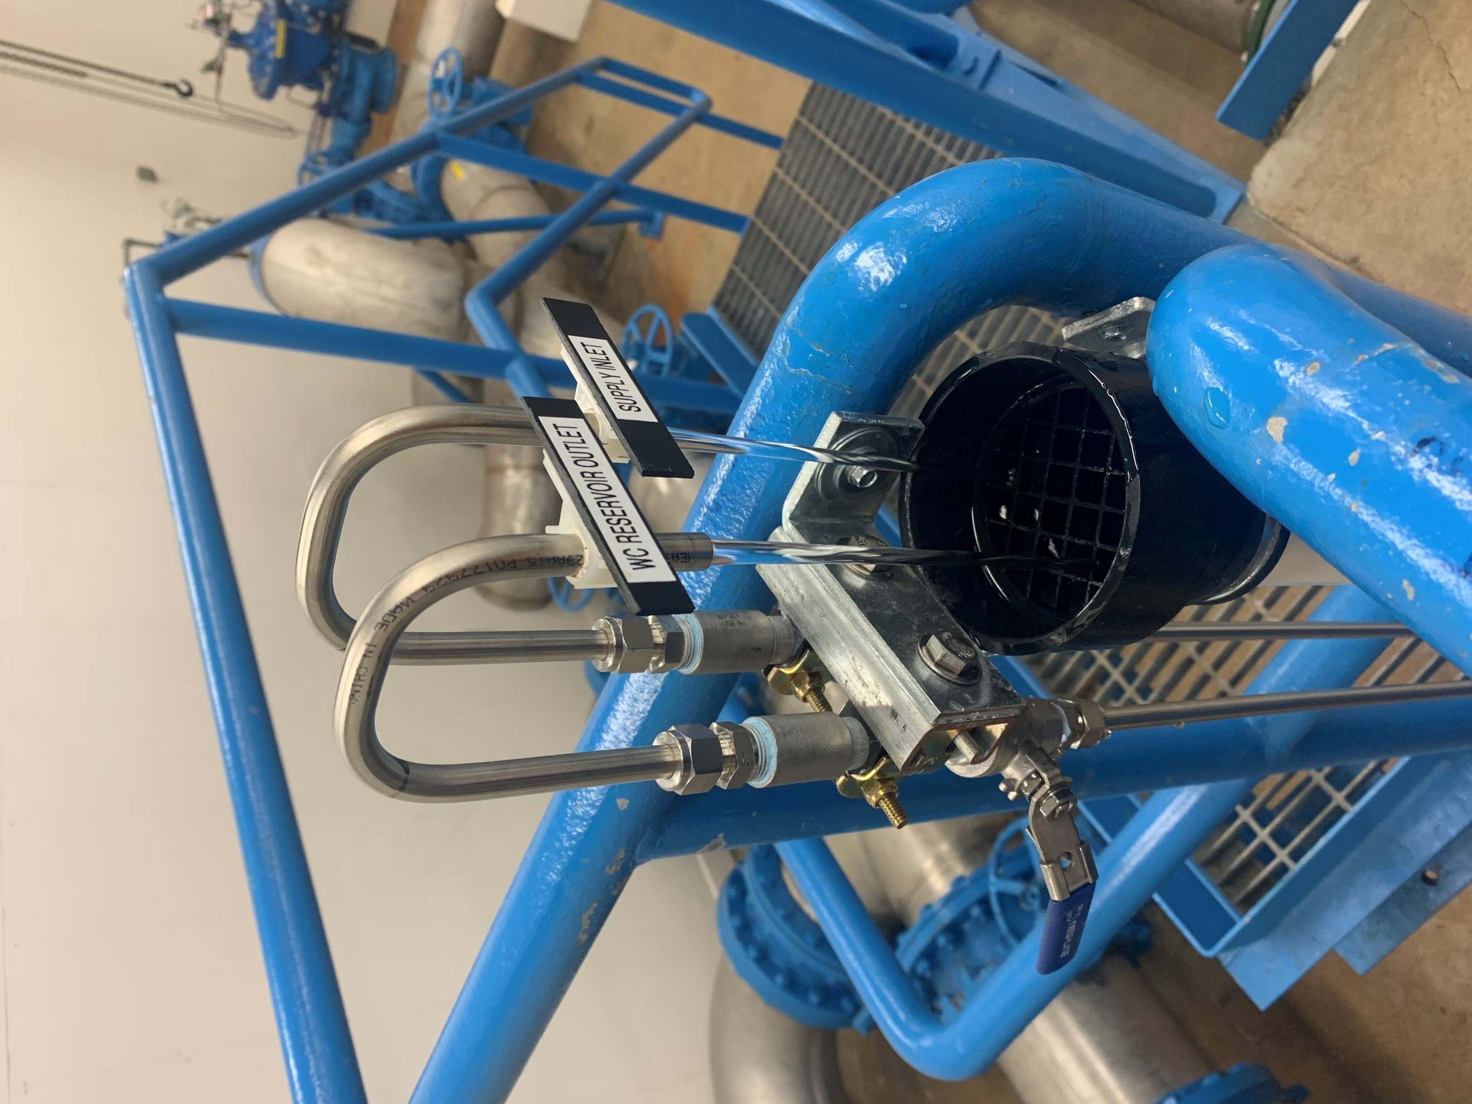
Samples are collected from various points in the distribution system on a weekly basis and field analysis of temperature is carried out - the operational goal is <15˚C. The following chart displays a compiled average of those weekly samples.
The average temperature across the distribution system in 2024 was 12.3˚C, with a lowest sample temperature of 5.9˚ on March 4th, and a highest sample temperature of 22.5˚C on August 6th.

Sample taps at West Courtenay Reservoir.

Distribution Water - pH
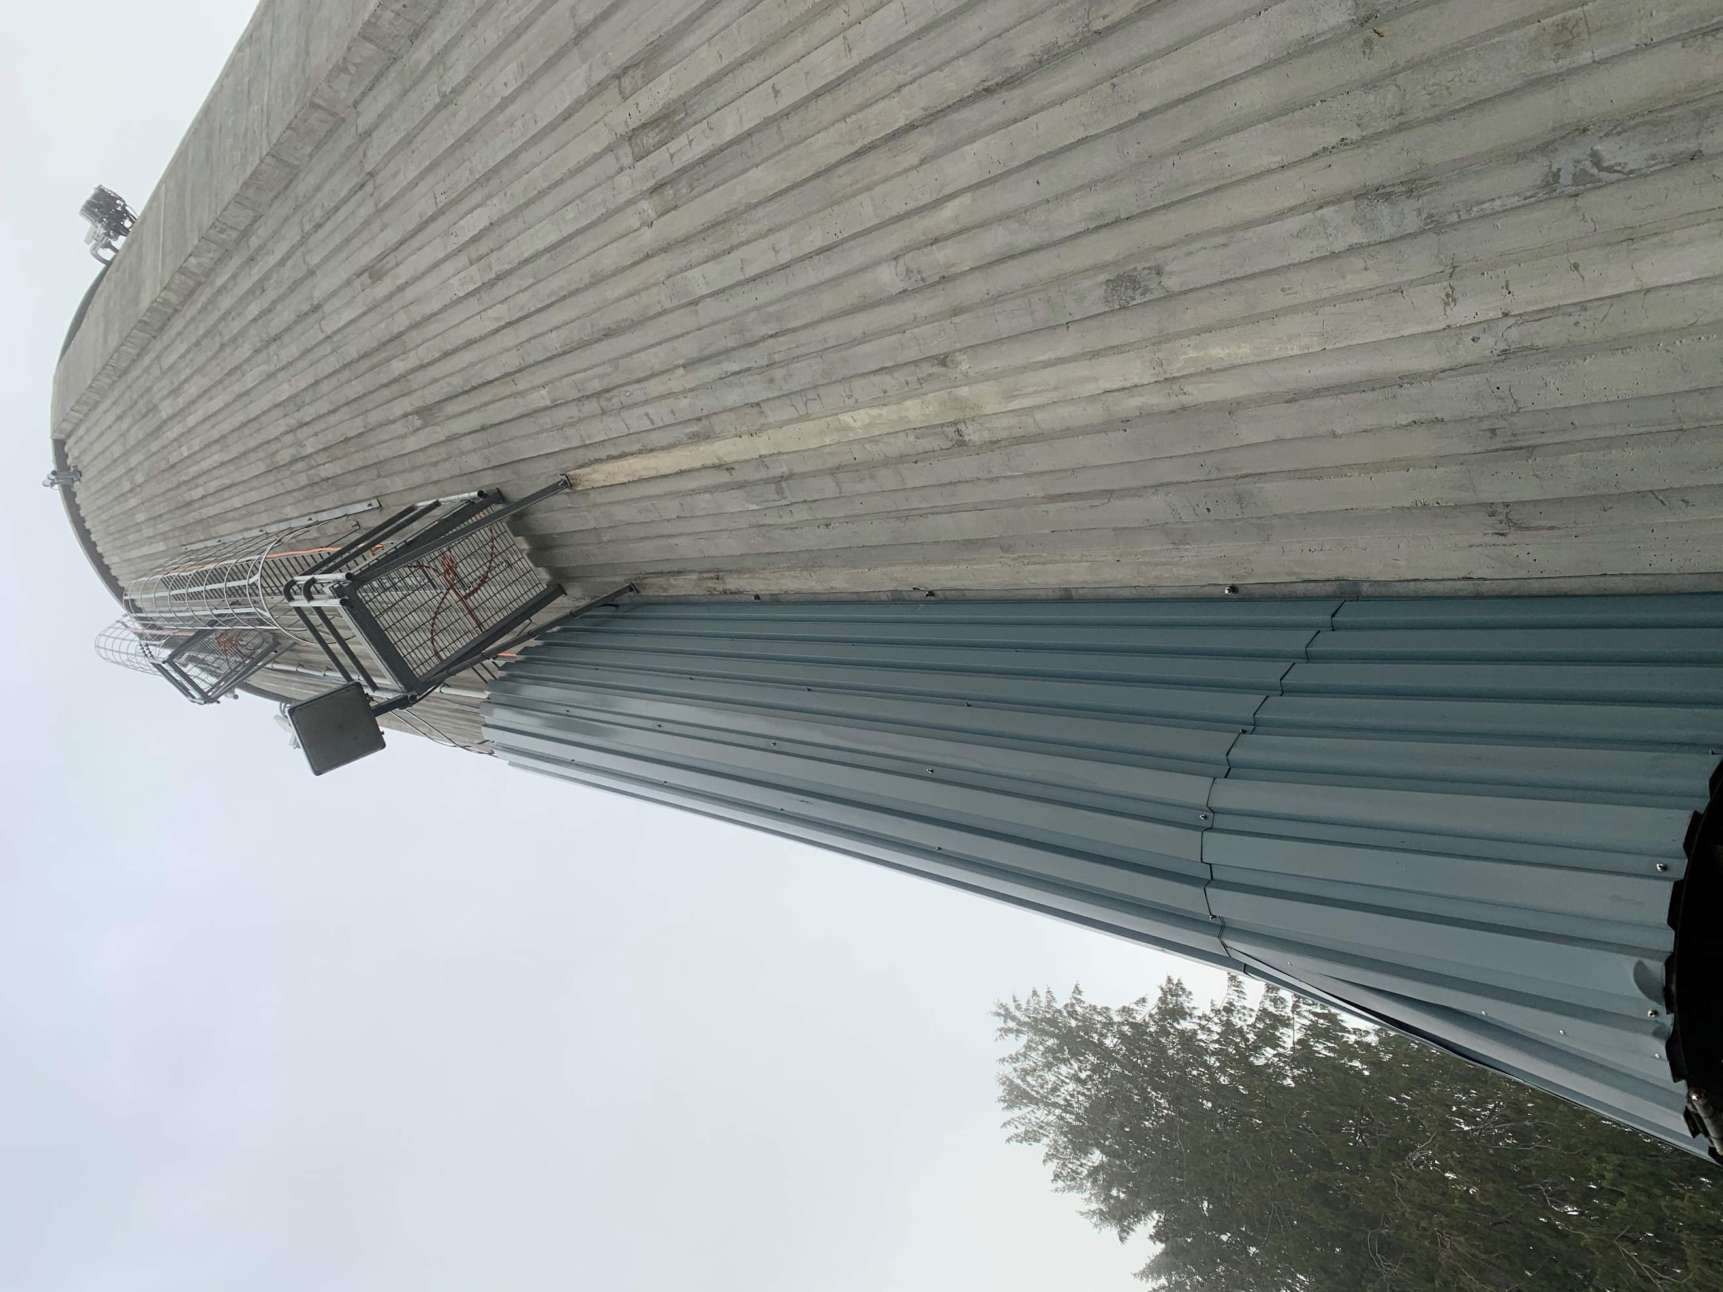
Samples are collected from various points in the distribution system on a weekly basis and field analysis of pH is carried out. The following chart displays a compiled average of those weekly samples.
The operational goal of pH in distribution systems is between 7-10.5.
The average pH across the distribution system in 2024 was 7.9, with the lowest pH value of 7 and the highest of 10.8.

Marsden Reservoir.

Distribution Water – Chlorine Residual
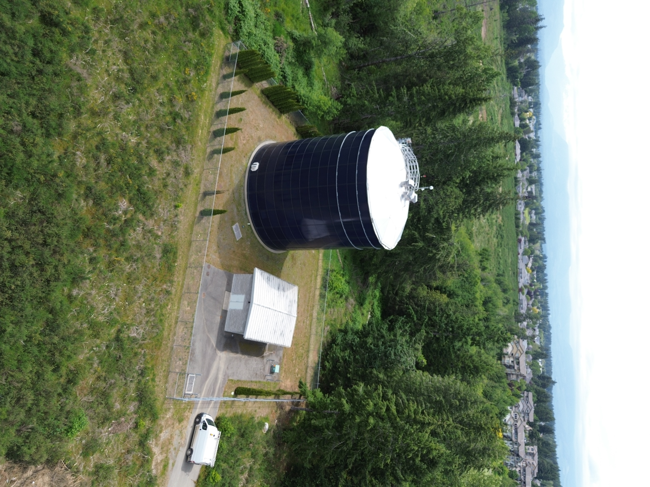
Samples are collected from various points in the distribution system on a weekly basis and field analysis of chlorine is carried out.
The operational goal of chlorine levels in distribution systems is between 0.04 – 2.0 mg/L.
The average chlorine level across the distribution system in 2024 was 0.75 mg/L, with no samples below 0.15 mg/L and none exceeding 1.2 mg/L.

Crown Isle Reservoir and valve house.

Distribution Water – Total Coliforms
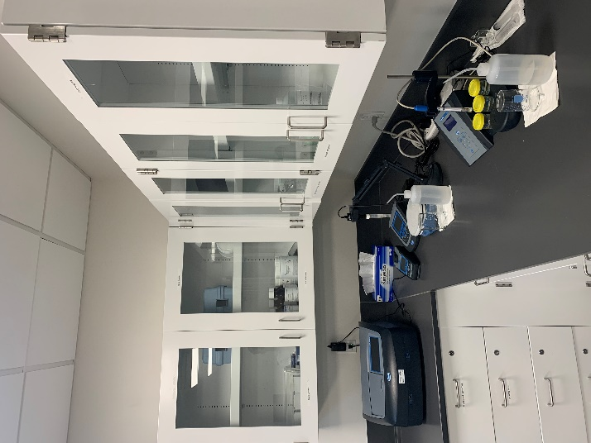
Samples are collected from the distribution system on a weekly basis and sent to a laboratory for total coliform testing. Total coliforms are naturally found in surface water, on plants, soils, and in the intestines of humans and warm-blooded animals. The presence of total coliforms in drinking water does not, on its own, indicate potential health effects from pathogenic microorganisms; testing for them helps determine how well the water treatment system is operating and to indicate water quality changes in the distribution system.
The standards that pertain to total coliform bacteria are written in two parts: at least 90% of all samples collected in a system must be free of total coliform bacteria, and if any samples have the bacteria present it must be in a concentration of less than 10 total coliform per 100mL.
Lab equipment at the water treatment plant.

2024
Analyte | Standard | Results from 637 Samples
Total Coliform Bacteria | At least 90% of samples must have no detectable total coliform bacteria per 100 mL | All samples had no detectable total coliform bacteria per 100mL
Total Coliform Bacteria | No sample has more than 10 total coliform bacteria per 100 mL | No sample exceeded 0 total coliform bacteria per 100mL

Distribution Water – E. Coli
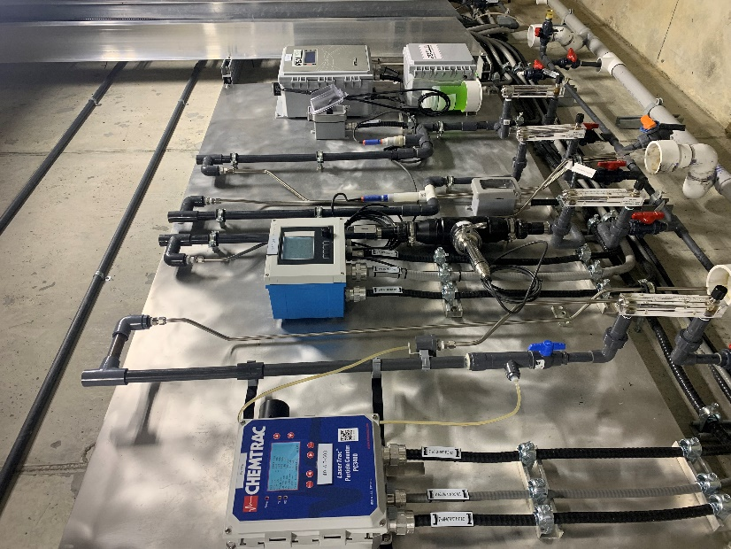
Samples are collected from the distribution system on a weekly basis and sent to a laboratory for E. Coli testing. The presence of E. Coli in drinking water indicates recent fecal contamination and possibly the presence of disease-causing pathogens, such as bacteria, viruses, and parasites.
The standard for E. Coli in drinking water is no detectable E. Coli per 100mL.

A wall of analyzers and sample points.

2024
Analyte | Standard | Results from 637 Samples
E. Coli | No detectable E. Coli per 100mL | No detectable E. Coli per 100mL

Distribution Water – Trihalomethanes
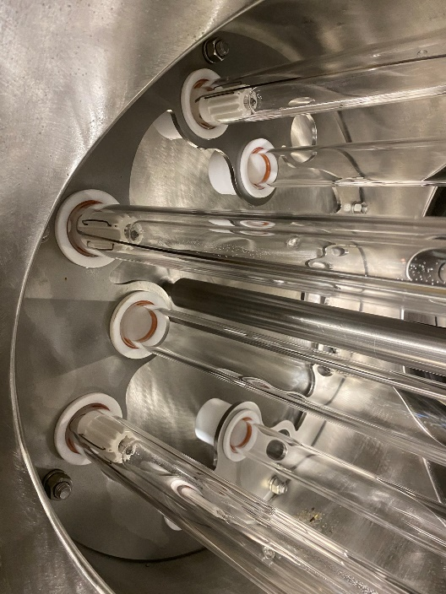
Samples are collected quarterly from Comox Reservoir and tested for disinfection by-products. Disinfection by-products are formed when chlorine interacts with natural organic materials in water – the most common type are called trihalomethanes. This term refers to the sum of bromodichloromethane, bromoform, chloroform, and dibromochloromethane. At elevated levels, they are associated with negative health effects such as cancer and adverse reproductive outcomes. The standard for total trihalomethanes is <0.1mg/L.
Ultraviolet bulbs inside a reactor.

2024 (mg/L)
Analyte | Maximum Acceptable Concentration | Crown Isle Reservoir Results
Analyte | Maximum Acceptable Concentration | Mar. 19 | June 11 | Sept. 4 | Dec. 10
Bromodichloromethane | N/A | <0.001 | <0.001 | <0.001 | <0.001
Bromoform | N/A | <0.001 | <0.001 | <0.001 | <0.001
Dibromochloromethane | N/A | <0.001 | <0.001 | <0.001 | <0.001
Chloroform | N/A | 0.0089 | 0.01 | 0.078 | 0.011
Total Trihalomethanes | 0.1 | 0.0089 | 0.01 | 0.078 | 0.011

Distribution Water – Data by Sample Site
 | 74 Salsbury Rd. |  |  | 2874 Arden Rd. |  |  | 1750 Astra Rd. |  |  | 2490 Waveland Rd. |  |  | 4871 Greaves Rd.
Date | Cl₂ | pH | NTU | Cl₂ | pH | NTU | Cl₂ | pH | NTU | Cl₂ | pH | NTU | Cl₂ | pH | NTU
01/02 | 0.83 | 8.3 | 0.15 | 0.77 | 7.6 | 0.13 | 0.67 | 8.0 | 0.12 | 0.66 | 8.6 | 0.11 | 0.80 | 7.2 | 0.23
01/08 | 0.72 | 7.9 | 0.11 | 0.73 | 7.8 | 0.10 | 0.64 | 8.2 | 0.08 | 0.40 | 8.9 | 0.07 | 0.77 | 7.4 | 0.06
01/15 | 0.65 | 8.2 | 0.07 | 0.71 | 8.0 | 0.06 | 0.64 | 8.0 | 0.08 | 0.61 | 8.8 | 0.06 | 0.65 | 7.8 | 0.06
01/22 | 0.65 | 7.9 | 0.09 | 0.61 | 7.8 | 0.05 | 0.70 | 8.0 | 0.08 | 0.64 | 8.7 | 0.46 | 0.63 | 7.5 | 0.06
01/29 | 0.70 | 8.3 | 0.17 | 0.78 | 8.2 | 0.21 | 0.70 | 7.5 | 0.17 | 0.64 | 7.9 | 0.19 | 0.82 | 7.9 | 0.10
02/05 | 0.77 | 7.5 | 0.11 | 0.77 | 7.4 | 0.14 | 0.74 | 7.9 | 0.14 | 0.71 | 8.5 | 0.11 | 0.84 | 7.4 | 0.12
02/12 | 0.78 | 7.9 | 0.13 | 0.84 | 7.5 | 0.07 | 0.56 | 7.8 | 0.08 | 0.64 | 8.2 | 0.10 | 0.95 | 7.4 | 0.08
02/21 | 0.66 | 7.8 | 0.10 | 0.75 | 7.5 | 0.11 | 0.72 | 8.0 | 0.22 | 0.72 | 8.5 | 0.16 | 0.80 | 7.6 | 0.11
02/26 | 0.74 | 7.9 | 0.57 | 0.85 | 7.4 | 0.71 | 0.64 | 7.9 | 0.06 | 0.43 | 7.9 | 0.09 | 0.80 | 7.4 | 0.07
03/04 | 0.63 | 7.9 | 0.07 | 0.65 | 7.6 | 0.05 | 0.61 | 7.3 | 0.43 | 0.59 | 7.9 | 0.18 | 0.73 | 7.2 | 0.14
03/11 | 0.59 | 7.6 | 0.13 | 0.67 | 7.4 | 0.10 | 0.69 | 7.9 | 0.11 | 0.74 | 8.5 | 0.09 | 0.83 | 7.6 | 0.09
03/18 | 0.69 | 8.0 | 0.08 | 0.78 | 7.7 | 0.08 | 0.69 | 8.2 | 0.10 | 0.69 | 8.7 | 0.11 | 0.80 | 7.9 | 0.14
03/25 | 0.75 | 8.3 | 0.14 | 0.78 | 8.1 | 0.13 | 0.69 | 7.6 | 0.14 | 0.71 | 8.2 | 0.10 | 0.85 | 7.4 | 0.08
04/02 | 0.76 | 7.4 | 0.10 | 0.72 | 7.4 | 0.10 | 0.67 | 8.0 | 0.21 | 0.71 | 8.6 | 0.19 | 0.83 | 7.6 | 0.14
04/08 | 0.76 | 8.0 | 0.27 | 0.83 | 7.7 | 0.11 | 0.60 | 8.3 | 0.10 | 0.63 | 8.7 | 0.07 | 0.80 | 8.0 | 0.10
04/16 | 0.74 | 8.4 | 0.16 | 0.79 | 8.2 | 0.08 | 0.74 | 7.8 | 0.12 | 0.78 | 8.4 | 0.09 | 0.78 | 7.5 | 0.19
04/22 | 0.63 | 7.8 | 0.13 | 0.74 | 7.5 | 0.09 | 0.67 | 7.8 | 0.32 | 0.73 | 8.1 | 0.14 | 0.74 | 7.6 | 0.17
04/29 | 0.74 | 7.8 | 0.12 | 0.76 | 8.1 | 0.07 | 0.77 | 7.7 | 0.06 | 0.75 | 8.3 | 0.08 | 0.81 | 7.9 | 0.07
05/06 | 0.79 | 8.2 | 0.08 | 0.77 | 8.2 | 0.06 | 0.69 | 8.2 | 0.14 | 0.73 | 8.6 | 0.12 | 0.75 | 8.0 | 0.08
05/14 | 0.71 | 8.3 | 0.13 | 0.82 | 7.9 | 0.09 | 0.78 | 8.0 | 0.11 | 0.80 | 8.1 | 0.13 | 0.87 | 7.9 | 0.10
05/21 | 0.72 | 8.2 | 0.09 | 0.78 | 7.9 | 0.08 | 0.77 | 8.0 | 0.08 | 0.78 | 8.3 | 0.11 | 0.84 | 7.9 | 0.08
05/27 | 0.79 | 8.0 | 0.07 | 0.80 | 7.9 | 0.08 | 0.72 | 8.0 | 0.10 | 0.28 | 8.3 | 0.06 | 0.84 | 7.9 | 0.07
06/03 | 0.79 | 8.2 | 0.09 | 0.79 | 7.9 | 0.08 | 0.77 | 8.1 | 0.09 | 0.75 | 8.1 | 0.07 | 0.81 | 7.8 | 0.09
06/10 | 0.78 | 8.1 | 0.08 | 0.83 | 7.8 | 0.11 | 0.68 | 7.7 | 0.12 | 0.83 | 8.1 | 0.11 | 0.88 | 7.7 | 0.08
06/17 | 0.78 | 7.8 | 0.10 | 0.81 | 7.9 | 0.07 | 0.73 | 8.1 | 0.07 | 0.87 | 8.4 | 0.08 | 0.91 | 7.9 | 0.07
06/24 | 0.77 | 8.1 | 0.13 | 0.74 | 7.9 | 0.09 | 0.66 | 8.1 | 0.11 | 0.72 | 8.3 | 0.08 | 0.78 | 8.0 | 0.08
07/02 | 0.73 | 8.1 | 0.09 | 0.73 | 8.4 | 0.08 | 0.75 | 8.6 | 0.16 | 0.80 | 8.8 | 0.11 | 0.80 | 7.6 | 0.07
07/08 | 0.73 | 8.7 | 0.08 | 0.79 | 7.7 | 0.07 | 0.73 | 7.8 | 0.07 | 0.80 | 7.9 | 0.07 | 0.84 | 7.7 | 0.06
07/15 | 0.73 | 7.9 | 0.08 | 0.79 | 7.9 | 0.08 | 0.73 | 8.0 | 0.10 | 0.80 | 7.9 | 0.08 | 0.82 | 7.7 | 0.08
07/22 | 0.77 | 7.9 | 0.08 | 0.79 | 8.0 | 0.07 | 0.71 | 8.0 | 0.11 | 0.75 | 8.2 | 0.08 | 0.86 | 8.0 | 0.07
07/29 | 0.76 | 8.0 | 0.08 | 0.80 | 8.1 | 0.07 | 0.67 | 8.2 | 0.08 | 0.72 | 8.5 | 0.09 | 0.80 | 8.0 | 0.07
08/06 | 0.76 | 8.3 | 0.07 | 0.78 | 7.7 | 0.10 | 0.76 | 7.7 | 0.12 | 0.85 | 7.9 | 0.16 | 0.89 | 7.3 | 0.14
08/12 | 0.80 | 7.8 | 0.10 | 0.84 | 7.7 | 0.06 | 0.78 | 7.8 | 0.07 | 0.84 | 8.1 | 0.07 | 0.89 | 7.6 | 0.07
08/19 | 0.74 | 7.9 | 0.09 | 0.76 | 7.8 | 0.07 | 0.75 | 7.9 | 0.15 | 0.82 | 8.1 | 0.14 | 0.86 | 7.8 | 0.07
08/26 | 0.58 | 8.1 | 0.11 | 0.62 | 7.7 | 0.09 | 0.54 | 7.8 | 0.09 | 0.59 | 8.0 | 0.12 | 0.66 | 7.7 | 0.11
09/03 | 0.68 | 8.1 | 0.09 | 0.83 | 8.0 | 0.09 | 0.66 | 7.7 | 0.13 | 0.75 | 7.9 | 0.24 | 0.85 | 7.6 | 0.10
09/09 | 0.74 | 8.1 | 0.07 | 0.78 | 7.7 | 0.07 | 0.67 | 7.8 | 0.07 | 0.25 | 8.1 | 0.09 | 0.82 | 7.4 | 0.08
09/16 | 0.73 | 8.1 | 0.07 | 0.82 | 7.7 | 0.10 | 0.64 | 7.9 | 0.07 | 0.63 | 8.7 | 0.08 | 0.83 | 7.6 | 0.08
09/23 | 0.71 | 8.3 | 0.08 | 0.77 | 7.8 | 0.09 | 0.69 | 7.9 | 0.09 | 0.71 | 8.5 | 0.08 | 0.83 | 7.5 | 0.13
10/01 | 0.74 | 7.9 | 0.46 | 0.82 | 7.8 | 0.07 | 0.68 | 7.8 | 0.14 | 0.66 | 8.4 | 0.15 | 0.80 | 7.5 | 0.10
10/07 | 0.71 | 8.5 | 0.10 | 0.79 | 7.8 | 0.10 | 0.68 | 8.0 | 0.08 | 0.64 | 9.0 | 0.08 | 0.79 | 7.9 | 0.06
10/15 | 0.76 | 8.6 | 0.09 | 0.78 | 8.1 | 0.07 | 0.54 | 8.4 | 0.08 | 0.49 | 9.1 | 0.06 | 0.77 | 7.5 | 0.09
10/21 | 0.72 | 8.4 | 0.07 | 0.80 | 7.6 | 0.10 | 0.65 | 8.2 | 0.07 | 0.61 | 9.0 | 0.07 | 0.73 | 7.5 | 0.08
10/28 | 0.69 | 8.5 | 0.10 | 0.77 | 7.7 | 0.10 | 0.68 | 8.2 | 0.08 | 0.60 | 8.0 | 0.09 | 0.78 | 7.4 | 0.06
11/04 | 0.71 | 7.6 | 0.07 | 0.77 | 7.6 | 0.06 | 0.65 | 8.1 | 0.10 | 0.62 | 9.0 | 0.07 | 0.83 | 7.6 | 0.09
11/12 | 0.61 | 8.2 | 0.11 | 0.82 | 7.6 | 0.08 | 0.58 | 8.1 | 0.10 | 0.61 | 8.8 | 0.11 | 0.75 | 7.4 | 0.10
11/18 | 0.70 | 8.2 | 0.09 | 0.77 | 7.6 | 0.10 | 0.65 | 8.0 | 0.08 | 0.61 | 8.9 | 0.09 | 0.72 | 7.2 | 0.06
11/25 | 0.68 | 8.0 | 0.10 | 0.77 | 7.4 | 0.06 | 0.64 | 7.9 | 0.06 | 0.57 | 8.8 | 0.06 | 0.68 | 7.3 | 0.06
12/02 | 0.65 | 8.0 | 0.07 | 0.69 | 7.5 | 0.08 | 0.55 | 7.9 | 0.09 | 0.53 | 8.6 | 0.09 | 0.85 | 7.4 | 0.06
12/09 | 0.75 | 7.9 | 0.06 | 0.83 | 7.5 | 0.07 | 0.71 | 7.8 | 0.05 | 0.71 | 8.5 | 0.06 | 0.78 | 7.2 | 0.12
12/16 | 0.80 | 7.5 | 0.08 | 0.90 | 7.4 | 0.08 | 0.62 | 7.8 | 0.11 | 0.61 | 8.3 | 0.06 | 0.79 | 7.4 | 0.10
12/23 | 0.75 | 8.1 | 0.08 | 0.80 | 7.7 | 0.13 | 0.74 | 7.8 | 0.13 | 0.74 | 8.5 | 0.18 | 1.02 | 7.7 | 0.08
12/30 | 0.95 | 7.6 | 0.10 | 0.84 | 7.5 | 0.08 | 0.76 | 7.8 | 0.06 | 0.74 | 8.4 | 0.08 | 0.91 | 7.5 | 0.08

 | 3441 Cumberland Rd. |  |  | Comox Reservoir |  |  | Crown Isle Reservoir |  |  | East Courtenay Res. |  |  | Marsden Reservoir
Date | Cl₂ | pH | NTU | Cl₂ | pH | NTU | Cl₂ | pH | NTU | Cl₂ | pH | NTU | Cl₂ | pH | NTU
01/02 | 0.74 | 7.5 | 0.09 | 0.74 | 7.6 | 0.06 | 0.76 | 7.4 | 0.06 | 0.75 | 7.7 | 0.08 | 0.76 | 7.5 | 0.10
01/08 | 0.65 | 7.8 | 0.06 | 0.83 | 7.7 | 0.08 | 0.68 | 8.1 | 0.09 | 0.76 | 7.9 | 0.08 | 0.72 | 7.8 | 0.06
01/15 | 0.55 | 7.8 | 0.06 | 0.77 | 7.4 | 0.09 | 0.67 | 7.8 | 0.09 | 0.73 | 7.7 | 0.05 | 0.70 | 7.6 | 0.09
01/22 | 0.72 | 7.9 | 0.17 | 0.73 | 7.9 | 0.06 | 0.76 | 7.8 | 0.07 | 0.82 | 7.9 | 0.07 | 0.79 | 8.6 | 0.11
01/29 | 0.76 | 7.2 | 0.18 | 0.81 | 7.8 | 0.08 | 0.78 | 7.3 | 0.10 | 0.74 | 7.3 | 0.18 | 0.82 | 7.7 | 0.15
02/05 | 0.82 | 7.6 | 0.06 | 0.77 | 7.3 | 0.12 | 0.78 | 7.5 | 0.14 | 0.84 | 7.6 | 0.07 | 0.95 | 7.6 | 0.12
02/12 | 0.75 | 7.5 | 0.18 | 0.85 | 7.5 | 0.09 | 0.79 | 7.3 | 0.11 | 0.71 | 7.6 | 0.08 | 0.72 | 7.5 | 0.10
02/21 | 0.62 | 7.6 | 0.06 | 0.75 | 7.5 | 0.10 | 0.74 | 7.6 | 0.10 | 0.73 | 7.4 | 0.14 | 0.81 | 7.5 | 0.08
02/26 | 0.64 | 7.3 | 0.35 | 0.69 | 7.5 | 0.06 | 0.78 | 7.6 | 0.07 | 0.76 | 7.5 | 0.06 | 0.68 | 7.5 | 0.07
03/04 | 0.75 | 7.6 | 0.10 | 0.72 | 7.5 | 0.08 | 0.66 | 7.3 | 0.06 | 0.73 | 7.6 | 0.11 | 0.70 | 7.4 | 0.10
03/11 | 0.77 | 8.2 | 0.14 | 0.75 | 7.3 | 0.17 | 0.77 | 7.3 | 0.11 | 0.75 | 7.7 | 0.09 | 0.74 | 7.9 | 0.10
03/18 | 0.76 | 7.7 | 0.18 | 0.73 | 7.6 | 0.08 | 0.73 | 8.1 | 0.06 | 0.74 | 7.9 | 0.08 | 0.78 | 8.4 | 0.10
03/25 | 0.72 | 7.6 | 0.13 | 0.22 | 8.0 | 0.08 | 0.76 | 7.6 | 0.09 | 0.78 | 7.4 | 0.19 | 0.76 | 7.8 | 0.13
04/02 | 0.73 | 8.0 | 0.08 | 0.80 | 7.4 | 0.11 | 0.69 | 7.8 | 0.11 | 0.68 | 7.7 | 0.09 | 0.89 | 7.6 | 0.07
04/08 | 0.73 | 7.5 | 0.10 | 0.75 | 7.7 | 0.18 | 0.74 | 7.9 | 0.08 | 0.76 | 7.8 | 0.10 | 0.77 | 8.3 | 0.11
04/16 | 0.72 | 7.5 | 0.09 | 0.84 | 7.8 | 0.11 | 0.73 | 7.7 | 0.09 | 0.79 | 7.5 | 0.07 | 0.80 | 7.5 | 0.15
04/22 | 0.75 | 8.0 | 0.07 | 0.81 | 7.5 | 0.10 | 0.72 | 7.7 | 0.10 | 0.79 | 7.5 | 0.08 | 0.74 | 7.6 | 0.07
04/29 | 0.63 | 8.0 | 0.08 | 0.74 | 7.6 | 0.06 | 0.85 | 7.4 | 0.06 | 0.79 | 8.0 | 0.06 | 0.78 | 8.1 | 0.05
05/06 | 0.80 | 7.9 | 0.07 | 0.82 | 7.9 | 0.05 | 0.75 | 8.1 | 0.12 | 0.81 | 8.0 | 0.07 | 0.73 | 8.2 | 0.08
05/14 | 0.73 | 7.9 | 0.08 | 0.82 | 7.7 | 0.09 | 0.80 | 7.9 | 0.09 | 0.86 | 7.9 | 0.10 | 0.83 | 7.9 | 0.09
05/21 | 0.81 | 7.9 | 0.09 | 0.85 | 7.9 | 0.09 | 0.80 | 8.0 | 0.07 | 0.83 | 7.9 | 0.08 | 0.81 | 7.9 | 0.07
05/27 | 0.77 | 7.7 | 0.09 | 0.84 | 7.9 | 0.08 | 0.80 | 7.9 | 0.07 | 0.85 | 7.9 | 0.07 | 0.84 | 7.9 | 0.08
06/03 | 0.73 | 7.9 | 0.08 | 0.86 | 7.9 | 0.09 | 0.80 | 7.9 | 0.07 | 0.82 | 7.9 | 0.07 | 0.82 | 7.9 | 0.07
06/10 | 0.74 | 8.0 | 0.10 | 0.82 | 7.9 | 0.09 | 0.82 | 7.8 | 0.11 | 0.86 | 7.6 | 0.10 | 0.83 | 7.7 | 0.11
06/17 | 0.74 | 8.3 | 0.11 | 0.87 | 7.6 | 0.12 | 0.80 | 8.0 | 0.10 | 0.87 | 7.9 | 0.09 | 0.84 | 7.9 | 0.09
06/24 | 0.77 | 7.6 | 0.10 | 0.87 | 7.9 | 0.06 | 0.76 | 8.0 | 0.10 | 0.79 | 7.9 | 0.08 | 0.75 | 8.0 | 0.02
07/02 | 0.74 | 7.7 | 0.09 | 0.79 | 7.9 | 0.09 | 0.74 | 8.3 | 0.08 | 0.78 | 8.2 | 0.08 | 0.77 | 8.3 | 0.06
07/08 | 0.75 | 8.0 | 0.10 | 0.87 | 8.2 | 0.08 | 0.77 | 7.7 | 0.08 | 0.84 | 7.7 | 0.08 | 0.79 | 7.7 | 0.11
07/15 | 0.75 | 8.0 | 0.02 | 0.77 | 7.8 | 0.07 | 0.68 | 7.4 | 0.07 | 0.84 | 7.8 | 0.09 | 0.74 | 8.0 | 0.06
07/22 | 0.83 | 7.4 | 0.10 | 0.81 | 8.0 | 0.07 | 0.88 | 7.5 | 0.02 | 0.73 | 8.0 | 0.09 | 0.79 | 7.9 | 0.08
07/29 | 0.79 | 7.5 | 0.06 | 0.83 | 8.0 | 0.08 | 0.75 | 8.2 | 0.07 | 0.83 | 7.9 | 0.08 | 0.80 | 8.0 | 0.02
08/06 | 0.81 | 7.7 | 0.08 | 0.83 | 7.4 | 0.14 | 0.81 | 7.7 | 0.14 | 0.87 | 7.5 | 0.10 | 0.83 | 7.3 | 0.12
08/12 | 0.57 | 7.5 | 0.13 | 0.88 | 7.5 | 0.10 | 0.83 | 7.7 | 0.05 | 0.92 | 7.6 | 0.07 | 0.84 | 7.7 | 0.05
08/19 | 0.73 | 7.7 | 0.09 | 0.87 | 7.7 | 0.09 | 0.76 | 7.8 | 0.09 | 0.89 | 7.8 | 0.08 | 0.80 | 7.7 | 0.07
08/26 | 0.75 | 7.6 | 0.06 | 0.56 | 7.6 | 0.07 | 0.68 | 7.7 | 0.10 | 0.69 | 7.8 | 0.10 | 0.71 | 7.8 | 0.08
09/03 | 0.67 | 7.7 | 0.07 | 0.76 | 7.9 | 0.17 | 0.61 | 7.8 | 0.08 | 0.77 | 7.7 | 0.17 | 0.78 | 8.3 | 0.07
09/09 | 0.74 | 7.6 | 0.07 | 0.81 | 7.6 | 0.08 | 0.76 | 7.7 | 0.09 | 0.81 | 7.4 | 0.08 | 0.80 | 7.3 | 0.07
09/16 | 0.75 | 7.6 | 0.11 | 0.81 | 7.7 | 0.06 | 0.84 | 7.5 | 0.05 | 0.84 | 7.6 | 0.09 | 0.78 | 7.8 | 0.11
09/23 | 0.73 | 7.6 | 0.08 | 0.82 | 7.6 | 0.08 | 0.75 | 7.7 | 0.08 | 0.81 | 7.7 | 0.08 | 0.76 | 7.7 | 0.08
10/01 | 0.75 | 8.1 | 0.06 | 0.81 | 7.6 | 0.08 | 0.73 | 7.7 | 0.14 | 0.84 | 7.7 | 0.15 | 0.79 | 7.8 | 0.07
10/07 | 0.72 | 7.7 | 0.09 | 0.82 | 7.7 | 0.14 | 0.72 | 7.8 | 0.07 | 0.79 | 7.6 | 0.08 | 0.80 | 7.8 | 0.09
10/15 | 0.73 | 7.6 | 0.09 | 0.78 | 8.0 | 0.06 | 0.67 | 8.2 | 0.06 | 0.79 | 7.9 | 0.08 | 0.73 | 7.9 | 0.05
10/21 | 0.72 | 7.4 | 0.09 | 0.78 | 7.7 | 0.07 | 0.81 | 7.9 | 0.07 | 0.78 | 7.7 | 0.08 | 0.81 | 7.8 | 0.09
10/28 | 0.92 | 7.7 | 0.10 | 0.76 | 7.7 | 0.08 | 0.73 | 7.8 | 0.08 | 0.74 | 7.6 | 0.07 | 0.67 | 7.6 | 0.07
11/04 | 0.70 | 7.5 | 0.10 | 0.80 | 7.6 | 0.08 | 0.72 | 7.8 | 0.07 | 0.78 | 7.6 | 0.08 | 0.82 | 7.5 | 0.10
11/12 | 0.70 | 7.2 | 0.08 | 0.80 | 7.7 | 0.08 | 0.71 | 7.8 | 0.11 | 0.82 | 7.7 | 0.07 | 0.70 | 7.6 | 0.12
11/18 | 0.62 | 7.3 | 0.08 | 0.76 | 7.6 | 0.08 | 0.72 | 7.7 | 0.07 | 0.76 | 7.6 | 0.11 | 0.78 | 7.8 | 0.13
11/25 | 0.78 | 7.4 | 0.07 | 0.76 | 7.5 | 0.11 | 0.65 | 7.6 | 0.06 | 0.75 | 7.4 | 0.07 | 0.70 | 7.5 | 0.11
12/02 | 0.75 | 7.4 | 0.30 | 0.72 | 7.5 | 0.09 | 0.64 | 7.6 | 0.09 | 0.68 | 7.4 | 0.12 | 0.72 | 7.5 | 0.06
12/09 | 0.79 | 7.5 | 0.08 | 0.83 | 7.4 | 0.05 | 0.78 | 7.6 | 0.05 | 0.79 | 7.4 | 0.08 | 0.85 | 7.4 | 0.07
12/16 | 0.87 | 7.5 | 0.14 | 0.75 | 7.3 | 0.05 | 0.69 | 7.6 | 0.06 | 0.73 |  | 0.06 | 0.83 | 7.5 | 0.06
12/23 | 0.66 | 7.7 | 0.08 | 0.87 | 7.5 | 0.12 | 0.80 | 7.6 | 0.15 | 0.78 | 7.5 | 0.06 | 0.83 | 7.5 | 0.08
12/30 | 0.80 | 7.9 | 0.13 | 0.85 | 7.5 | 0.05 | 0.88 | 7.6 | 0.05 | 0.87 | 7.4 | 0.06 | 0.91 | 7.7 | 0.07

 | West Courtenay Res. |  |  | 2390 Rennison Rd. |  |  | 2472 Gibson Rd. |  |  | 2701 Elmo Rd.
Date | Cl₂ | pH | NTU | Cl₂ | pH | NTU | Cl₂ | pH | NTU | Cl₂ | pH | NTU
01/02 | 0.81 | 7.5 | 0.12 | 0.61 | 8.9 | 0.08
01/08 | 0.79 | 7.9 | 0.06 |  |  |  | 0.61 | 9.0 | 0.06
01/15 | 0.79 | 7.6 | 0.08 | 0.63 | 8.9 | 0.09
01/22 | 0.83 | 8.8 | 0.57 |  |  |  |  |  |  | 0.51 | 9.9 | 0.11
01/29 | 0.86 | 7.7 | 0.27 |  |  |  | 0.77 | 8.0 | 0.13
02/05 | 0.97 | 7.6 | 0.19 | 0.72 | 8.4 | 0.11
02/12 | 0.84 | 7.5 | 0.09 |  |  |  | 0.72 | 8.5 | 0.09
02/21 | 0.78 | 7.6 | 0.14
02/26 | 0.73 | 7.6 | 0.06 |  |  |  | 0.64 | 8.3 | 0.05 | 0.72 | 9.0 | 0.08
03/04 | 0.78 | 7.4 | 0.10
03/11 | 0.90 | 7.9 | 0.09 |  |  |  | 0.84 | 8.2 | 0.10
03/18 | 0.86 | 8.8 | 0.11 | 0.74 | 8.3 | 0.13
03/25 | 0.79 | 7.9 | 0.09 |  |  |  |  |  |  | 0.66 | 9.4 | 0.22
04/02 | 0.84 | 7.6 | 0.13 | 0.15 | 9.0 | 0.15
04/08 | 0.88 | 8.7 | 0.08 |  |  |  | 0.81 | 8.7 | 0.10
04/16 | 0.90 | 7.5 | 0.10 | 0.57 | 9.0 | 0.14
04/22 | 0.83 | 7.6 | 0.07
04/29 | 0.84 | 8.1 | 0.05 |  |  |  | 0.78 | 8.3 | 0.09 | 0.68 | 9.2 | 0.11
05/06 | 0.90 | 8.2 | 0.08 | 0.59 | 8.9 | 0.14
05/14 | 0.86 | 7.9 | 0.09 |  |  |  | 0.82 | 8.5 | 0.08
05/21 | 0.84 | 7.9 | 0.18 | 0.54 | 9.2 | 0.11
05/27 | 0.89 | 7.9 | 0.11 |  |  |  |  |  |  | 0.67 | 8.6 | 0.18
06/03 | 0.79 | 7.9 | 0.09 | 0.71 | 8.4 | 0.09
06/10 | 0.86 | 7.7 | 0.10 |  |  |  | 0.81 | 8.6 | 0.12
06/17 | 0.86 | 7.9 | 0.11 | 0.69 | 8.2 | 0.07
06/24 | 0.78 | 7.9 | 0.09 |  |  |  |  |  |  | 0.72 | 9.2 | 0.09
07/02 | 0.82 | 8.1 | 0.10 | 0.50 | 9.1 | 0.12
07/08 | 0.81 | 7.8 | 0.10 |  |  |  | 0.84 | 8.0 | 0.11
07/15 | 0.83 | 8.0 | 0.08 | 0.69 | 7.7 | 0.07
07/22 | 0.82 | 7.9 | 0.07
07/29 | 0.81 | 8.0 | 0.02 |  |  |  |  |  |  | 0.69 | 9.1 | 0.07
08/06 | 0.88 | 7.4 | 0.10 | 0.60 | 8.0 | 0.07
08/12 | 0.90 | 7.5 | 0.06 |  |  |  | 0.89 | 8.3 | 0.05
08/19 | 0.84 | 7.9 | 0.08 | 0.79 | 7.0 | 0.12
08/26 | 0.92 | 7.8 | 0.07 |  |  |  |  |  |  | 0.59 | 8.5 | 0.16
09/03 | 0.81 | 8.5 | 0.11 | 0.71 | 8.6 | 0.11
09/09 | 0.82 | 8.1 | 0.09 |  |  |  | 0.74 | 8.5 | 0.09
09/16 | 0.77 | 7.7 | 0.13 | 0.67 | 8.4 | 0.23
09/23 | 0.83 | 7.7 | 0.09
10/01 | 0.78 | 7.8 | 0.16 |  |  |  | 0.76 | 8.4 | 0.10 | 0.71 | 9.0 | 0.09
10/07 | 0.79 | 7.9 | 0.08 | 0.59 | 9.1 | 0.09
10/15 | 0.82 | 8.1 | 0.09 |  |  |  | 0.66 | 9.1 | 0.12
10/21 | 0.83 | 7.8 | 0.09 | 0.66 | 9.0 | 0.09
10/28 | 0.77 | 7.7 | 0.07 |  |  |  |  |  |  | 0.54 | 9.6 | 0.14
11/04 | 0.86 | 7.5 | 0.07 | 0.61 | 9.2 | 0.11
11/12 | 0.73 | 7.6 | 0.11 |  |  |  | 0.75 | 9.0 | 0.09
11/18 | 0.77 | 7.9 | 0.09 | 0.60 | 9.2 | 0.09
11/25 | 0.75 | 7.7 | 0.14 |  |  |  |  |  |  | 0.45 | 10.8 | 0.11
12/02 | 0.74 | 7.6 | 0.06 | 0.62 | 9.0 | 0.11
12/09 | 0.87 | 7.5 | 0.07 |  |  |  | 0.79 | 8.8 | 0.05
12/16 | 0.88 | 7.5 | 0.10 | 0.50 | 8.9 | 0.15
12/23 | 0.85 | 7.6 | 0.07 |  |  |  |  |  |  | 0.47 | 10.5 | 0.08
12/30 | 0.95 | 7.8 | 0.06 |  |  |  | 0.84 | 8.7 | 0.07

Distribution Water – Other Analytes
Parameter | Units | Matrix | Q1 | Q2 | Q3 | Q4
Nitrite (N) | mg/L | Result | <0.0050 | <0.0050 | <0.0050 | <0.0050
Nitrite (N) | mg/L | DL | 0.005 | 0.005 | 0.005 | 0.005
Nitrate (N) | mg/L | Result | 0.035 | <0.020 | <0.020 | 0.026
Nitrate (N) | mg/L | DL | 0.02 | 0.02 | 0.02 | 0.02
Conductivity | uS/cm | Result | 45 | 45 | 46 | 47
Conductivity | uS/cm | DL | 2 | 2 | 2 | 2
pH | pH | Result | 6.88 | 6.64 | 6.69 | 6.59
pH | pH | DL | N/A | N/A | N/A | N/A
Alkalinity (PP as CaCO3) | mg/L | Result | <1.0 | <1.0 | <1.0 | <1.0
Alkalinity (PP as CaCO3) | mg/L | DL | 1 | 1 | 1 | 1
Alkalinity (CaCO3) | mg/L | Result | 16 | 16 | 21 | 23
Alkalinity (CaCO3) | mg/L | DL | 1 | 1 | 1 | 1
Bicarbonate (HCO3) | mg/L | Result | 19 | 20 | 25 | 28
Bicarbonate (HCO3) | mg/L | DL | 1 | 1 | 1 | 1
Carbonate (CO3) | mg/L | Result | <1.0 | <1.0 | <1.0 | <1.0
Carbonate (CO3) | mg/L | DL | 1 | 1 | 1 | 1
Hydroxide (OH) | mg/L | Result | <1.0 | <1.0 | <1.0 | <1.0
Hydroxide (OH) | mg/L | DL | 1 | 1 | 1 | 1
Chloride (Cl) | mg/L | Result | 1.4 | 1.1 | 1.1 | 1.5
Chloride (Cl) | mg/L | DL | 1 | 1 | 1 | 1
Sulphate (SO4) | mg/L | Result | 1 | 1.2 | <1.0 | <1.0
Sulphate (SO4) | mg/L | DL | 1 | 1 | 1 | 1
True Colour | Col. Unit | Result | <2.0 | <2.0 | <2.0 | <2.0
True Colour | Col. Unit | DL | 2 | 2 | 2 | 2
Orthophosphate (P) | mg/L | Result | 0.019 | 0.0039 | <0.0030 | 0.005
Orthophosphate (P) | mg/L | DL | 0.003 | 0.003 | 0.003 | 0.003
Nitrate plus Nitrite (N) | mg/L | Result | 0.035 | <0.020 | <0.020 | 0.026
Nitrate plus Nitrite (N) | mg/L | DL | 0.02 | 0.02 | 0.02 | 0.02
Dissolved Fluoride (F) | mg/L | Result | <0.050 | <0.050 | <0.050 | <0.050
Dissolved Fluoride (F) | mg/L | DL | 0.05 | 0.05 | 0.05 | 0.05
Total Dissolved Solids | mg/L | Result | 36 | 26 | 28 | 24
Total Dissolved Solids | mg/L | DL | 10 | 10 | 10 | 10
Turbidity | NTU | Result | <0.10 | <0.10 | 0.11 | 0.11
Turbidity | NTU | DL | 0.1 | 0.1 | 0.1 | 0.1
Bromide (Br) | mg/L | Result | 0.077 | 0.064 | 0.038 | 0.027
Bromide (Br) | mg/L | DL | 0.01 | 0.01 | 0.01 | 0.01
Total Hardness (CaCO3) | mg/L | Result | 17.9 | 17.7 | 18.2 | 18.2
Total Hardness (CaCO3) | mg/L | DL | 0.5 | 0.5 | 0.5 | 0.5
Total Aluminum (Al) | ug/L | Result | 5.2 | 9.8 | 11.6 | 4.9
Total Aluminum (Al) | ug/L | DL | 3 | 3 | 3 | 3
Total Antimony (Sb) | ug/L | Result | <0.50 | <0.50 | <0.50 | <0.50
Total Antimony (Sb) | ug/L | DL | 0.5 | 0.5 | 0.5 | 0.5
Total Arsenic (As) | ug/L | Result | <0.10 | <0.10 | <0.10 | <0.10
Total Arsenic (As) | ug/L | DL | 0.1 | 0.1 | 0.1 | 0.1
Total Barium (Ba) | ug/L | Result | <1.0 | <1.0 | <1.0 | <1.0
Total Barium (Ba) | ug/L | DL | 1 | 1 | 1 | 1
Total Beryllium (Be) | ug/L | Result | <0.10 | <0.10 | <0.10 | <0.10
Total Beryllium (Be) | ug/L | DL | 0.1 | 0.1 | 0.1 | 0.1
Total Bismuth (Bi) | ug/L | Result | <1.0 | <1.0 | <1.0 | <1.0
Total Bismuth (Bi) | ug/L | DL | 1 | 1 | 1 | 1
Total Boron (B) | ug/L | Result | <50 | <50 | <50 | <50
Total Boron (B) | ug/L | DL | 50 | 50 | 50 | 50
Total Cadmium (Cd) | ug/L | Result | <0.010 | <0.010 | <0.010 | <0.010
Total Cadmium (Cd) | ug/L | DL | 0.01 | 0.01 | 0.01 | 0.01
Total Chromium (Cr) | ug/L | Result | <1.0 | <1.0 | <1.0 | <1.0
Total Chromium (Cr) | ug/L | DL | 1 | 1 | 1 | 1
Total Cobalt (Co) | ug/L | Result | <0.20 | <0.20 | <0.20 | <0.20
Total Cobalt (Co) | ug/L | DL | 0.2 | 0.2 | 0.2 | 0.2
Total Copper (Cu) | ug/L | Result | 0.89 | 0.78 | 0.98 | 1.58
Total Copper (Cu) | ug/L | DL | 0.2 | 0.2 | 0.2 | 0.2
Total Iron (Fe) | ug/L | Result | <5.0 | <5.0 | <5.0 | <5.0
Total Iron (Fe) | ug/L | DL | 5 | 5 | 5 | 5
Total Lead (Pb) | ug/L | Result | <0.20 | <0.20 | <0.20 | <0.20
Total Lead (Pb) | ug/L | DL | 0.2 | 0.2 | 0.2 | 0.2
Total Manganese (Mn) | ug/L | Result | <1.0 | <1.0 | <1.0 | <1.0
Total Manganese (Mn) | ug/L | DL | 1 | 1 | 1 | 1
Total Molybdenum (Mo) | ug/L | Result | <1.0 | <1.0 | <1.0 | <1.0
Total Molybdenum (Mo) | ug/L | DL | 1 | 1 | 1 | 1
Total Nickel (Ni) | ug/L | Result | <1.0 | <1.0 | <1.0 | <1.0
Total Nickel (Ni) | ug/L | DL | 1 | 1 | 1 | 1
Total Selenium (Se) | ug/L | Result | <0.10 | <0.10 | <0.10 | <0.10
Total Selenium (Se) | ug/L | DL | 0.1 | 0.1 | 0.1 | 0.1
Total Silicon (Si) | ug/L | Result | 2150 | 2130 | 1930 | 2230
Total Silicon (Si) | ug/L | DL | 100 | 100 | 100 | 100
Total Silver (Ag) | ug/L | Result | <0.020 | <0.020 | <0.020 | <0.020
Total Silver (Ag) | ug/L | DL | 0.02 | 0.02 | 0.02 | 0.02
Total Strontium (Sr) | ug/L | Result | 7.9 | 8.4 | 8 | 8.7
Total Strontium (Sr) | ug/L | DL | 1 | 1 | 1 | 1
Total Thallium (Tl) | ug/L | Result | <0.010 | <0.010 | <0.010 | <0.010
Total Thallium (Tl) | ug/L | DL | 0.01 | 0.01 | 0.01 | 0.01
Total Tin (Sn) | ug/L | Result | <5.0 | <5.0 | <5.0 | <5.0
Total Tin (Sn) | ug/L | DL | 5 | 5 | 5 | 5
Total Titanium (Ti) | ug/L | Result | <5.0 | <5.0 | <5.0 | <5.0
Total Titanium (Ti) | ug/L | DL | 5 | 5 | 5 | 5
Total Uranium (U) | ug/L | Result | <0.10 | <0.10 | <0.10 | <0.10
Total Uranium (U) | ug/L | DL | 0.1 | 0.1 | 0.1 | 0.1
Total Vanadium (V) | ug/L | Result | <5.0 | <5.0 | <5.0 | <5.0
Total Vanadium (V) | ug/L | DL | 5 | 5 | 5 | 5
Total Zinc (Zn) | ug/L | Result | <5.0 | <5.0 | <5.0 | <5.0
Total Zinc (Zn) | ug/L | DL | 5 | 5 | 5 | 5
Total Zirconium (Zr) | ug/L | Result | <0.10 | <0.10 | <0.10 | <0.10
Total Zirconium (Zr) | ug/L | DL | 0.1 | 0.1 | 0.1 | 0.1
Total Calcium (Ca) | mg/L | Result | 5.89 | 5.73 | 5.87 | 5.91
Total Calcium (Ca) | mg/L | DL | 0.05 | 0.05 | 0.05 | 0.05
Total Magnesium (Mg) | mg/L | Result | 0.781 | 0.818 | 0.848 | 0.825
Total Magnesium (Mg) | mg/L | DL | 0.05 | 0.05 | 0.05 | 0.05
Total Potassium (K) | mg/L | Result | <0.050 | 0.053 | <0.050 | <0.050
Total Potassium (K) | mg/L | DL | 0.05 | 0.05 | 0.05 | 0.05
Total Sodium (Na) | mg/L | Result | 1.54 | 1.61 | 1.72 | 1.68
Total Sodium (Na) | mg/L | DL | 0.05 | 0.05 | 0.05 | 0.05
Total Sulphur (S) | mg/L | Result | <3.0 | <3.0 | <3.0 | <3.0
Total Sulphur (S) | mg/L | DL | 3 | 3 | 3 | 3
Total Mercury (Hg) | ug/L | Result | 0.0184 | <0.0019 | <0.0019 | <0.0019
Total Mercury (Hg) | ug/L | DL | 0.0019 | 0.0019 | 0.0019 | 0.0019
Total Trihalomethanes | ug/L | Result | 8.9 | 10 | 7.8 | 11
Total Trihalomethanes | ug/L | DL | 1 | 1 | 1 | 1
Bromodichloromethane | ug/L | Result | <1.0 | <1.0 | <1.0 | <1.0
Bromodichloromethane | ug/L | DL | 1 | 1 | 1 | 1
Bromoform | ug/L | Result | <1.0 | <1.0 | <1.0 | <1.0
Bromoform | ug/L | DL | 1 | 1 | 1 | 1
Dibromochloromethane | ug/L | Result | <1.0 | <1.0 | <1.0 | <1.0
Dibromochloromethane | ug/L | DL | 1 | 1 | 1 | 1
Chloroform | ug/L | Result | 8.9 | 10 | 7.8 | 11
Chloroform | ug/L | DL | 1 | 1 | 1 | 1

Watershed Protection Plan
Providing high-quality drinking water requires preservation of water at its source. The Watershed Protection Plan includes collaboration with stakeholders, hydrodynamic modelling, and water quality monitoring within the watershed. Water quality parameters are observed at all major tributaries to the Comox Lake and the data is recorded in a watershed database.
The CVRD has partnered with the Town of Comox, City of Courtenay, Village of Cumberland and K’ómoks First Nation on a multi-year initiative with the Municipal Natural Asset Initiative. The goal of the project is to value natural assets in the watershed to better understand, measure and manage the drinking water services that are provided.
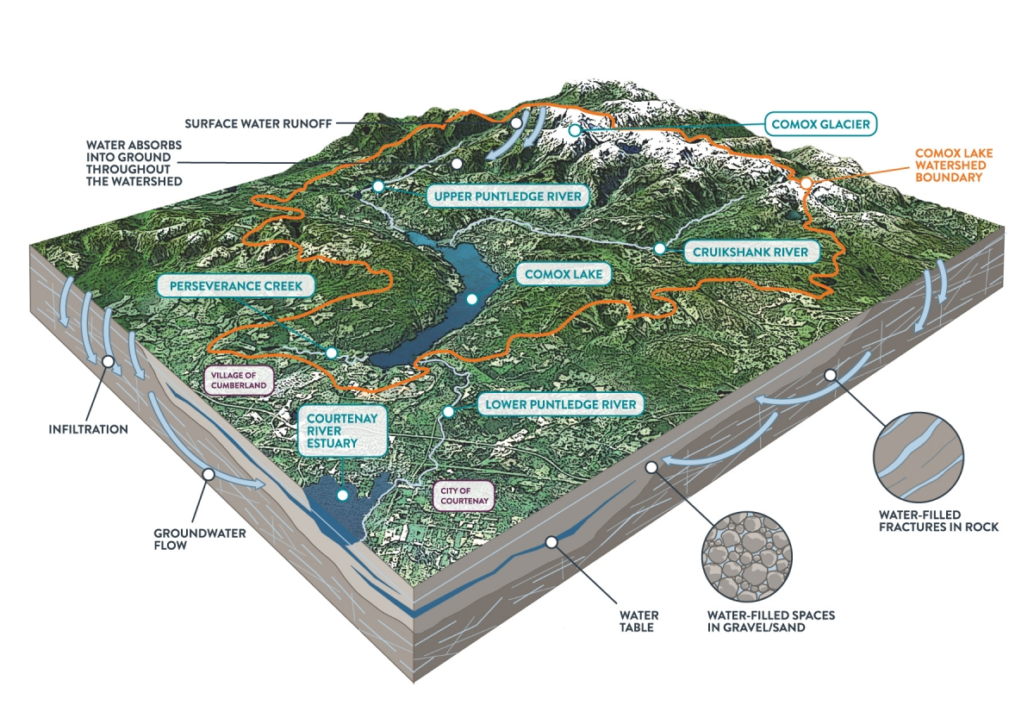
Comox Lake watershed.

Consumption Metrics and Water Rates
The average daily water production in 2024 was 26.7 million litres per day, or approximately 485L per person, compared to the Canadian average of 329 litres per person per day. Demand is highest during the summer months - almost twice as much as during the winter. In 2024, system demand reached its highest point on July 18th with 51.9 million liters of water being produced.
In response to the COVID-19 pandemic, water rates for 2021 and 2022 were decreased to $0.80/m³. Rates increased in 2023 to $0.96/m³, and $1.00/m³ in 2024.
To help reduce consumption the CVRD has rebate programs in place to encourage Comox Valley residents to be water efficient. In 2024, this included rebates for smart irrigation controllers, and soil amendments.

Conservation
Water conservation is an increasingly important initiative and while it seems as if there is an abundance of water available, our supply is truly a limited resource - particularly during the summer months.
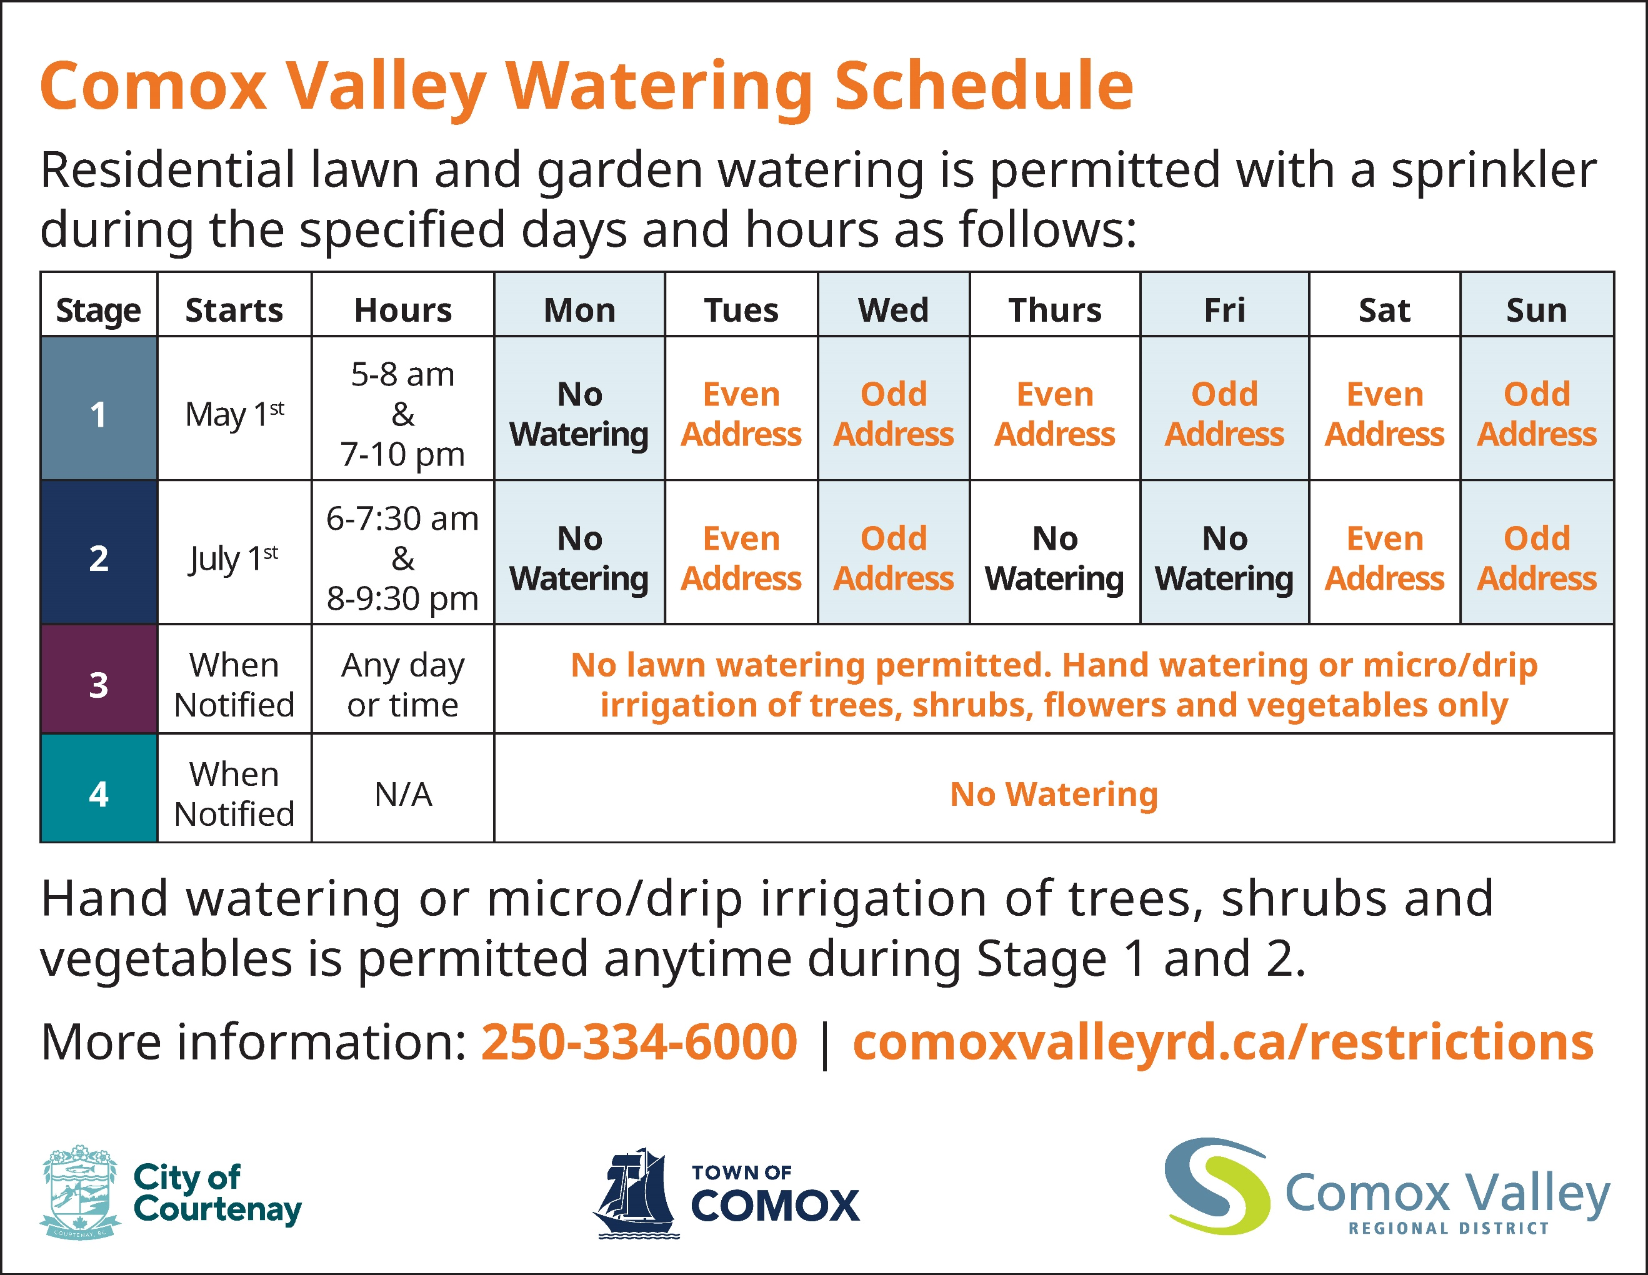
The CVRD has a four-stage system in place for managing water consumption. Stage one is the least restrictive and comes into effect annually on May 1 unless otherwise noted. Stages two and three are more restrictive and are implemented as per the water-use agreement with BC Hydro which is primarily based on the environmental flow needs of the Puntledge River. Stage four can be implemented in circumstances where it is essential to bring water consumption down as low as possible to maintain critical flows to accommodate major repairs or extremely low river flows.

Operations
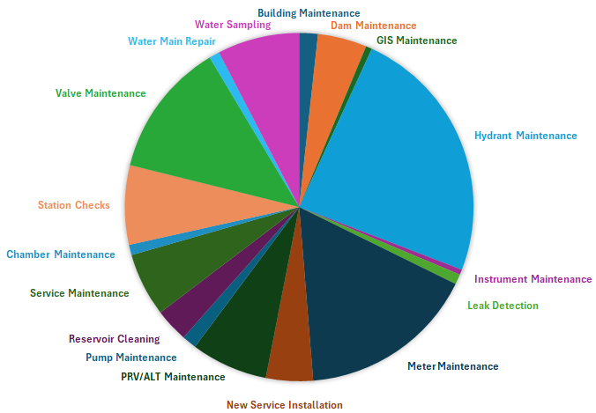
Water treatment facilities and distribution systems are operated by 15 qualified operators. In 2024, several ongoing and annual maintenance activities were carried out, as well as improvements to work order tracking, data collection, and map improvements.
Additionally, many non-annual projects were completed such as reservoir cleaning, and hydrant painting.

2024 Achievements
- Installed seismic sensors at West Courtenay Reservoir
- Disassembled and removed obsolete chlorine scrubber
- Implemented a sampling program to test for PFAs
- Designed a new Traffic Control (TC) Plan and designed and constructed an operational TC trailer.
- Installed hardware at various sites to improve remote communications
- Continued planning and design of the South Water Extension Project

2025 Objectives
- Paint East Courtenay Reservoir
- Upgrade control and instrumentation at East Courtenay Reservoir site
- Decommission Sandwick Reservoir
- Replace 3 bulk water meters
- Acquire multi-assessment permit from the BC Archaeology Branch
- Complete Greaves Crescent tie-in
- Complete the fibre optic connectivity of major regional sites

