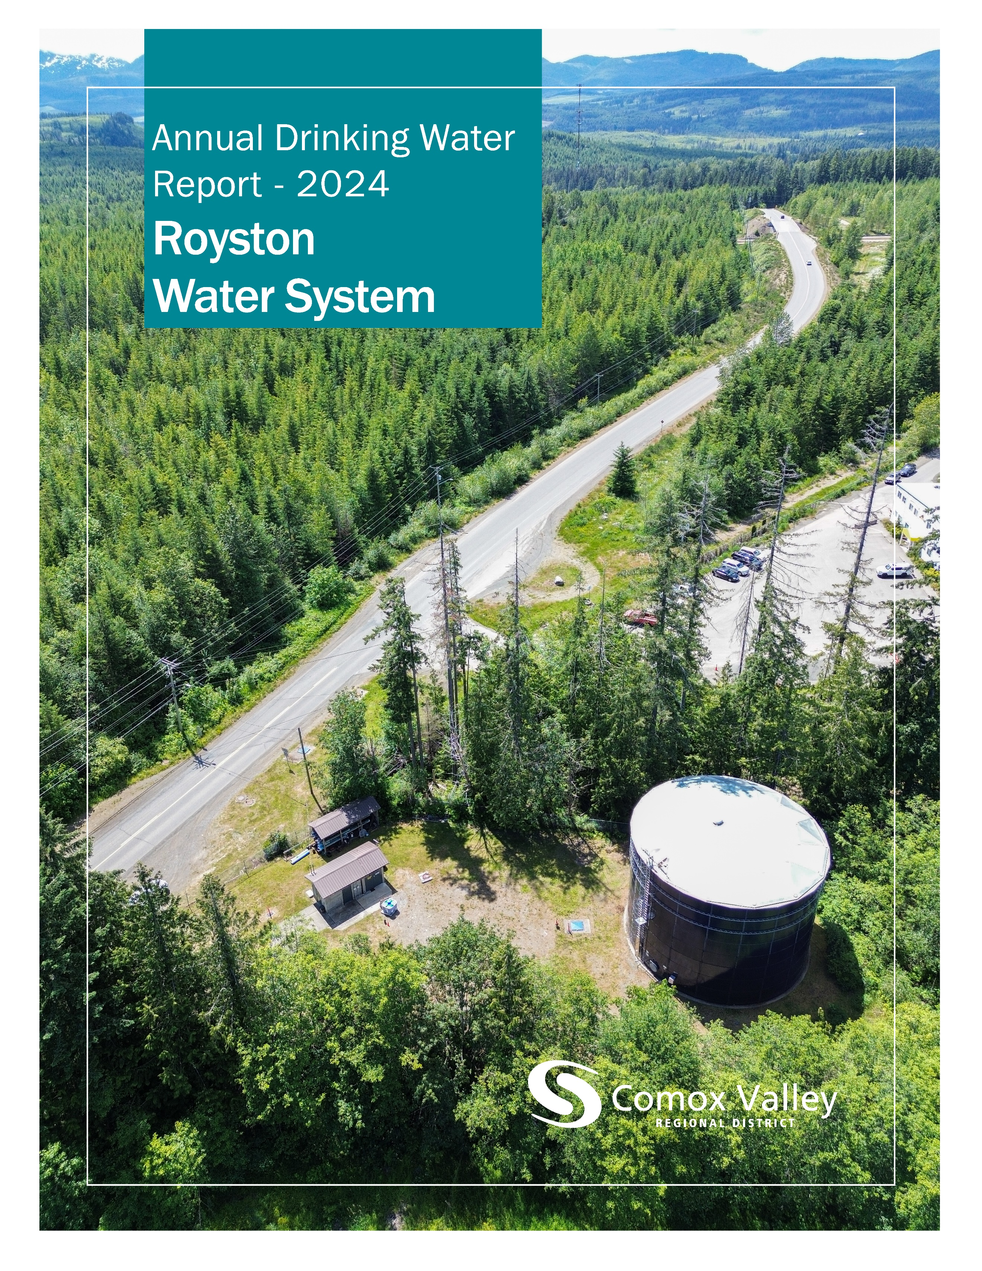

Table of Contents
Introduction 2
Source Water 2
Water Treatment 3
Water Distribution 4
Water Quality 4
Water Quality Summary 5
Distribution Water – Data by Sample Site 6
Distribution Water – Other Analytes 7
Consumption Metrics and Water Rates 9
Conservation 10
Operations 11
2024 Achievements 11
2025 Objectives 11

The Comox Valley Regional District respectfully acknowledges that the land on which it operates is the unceded territory of the K’ómoks First Nation, the traditional keepers of this land.

Introduction
The Comox Valley Regional District strives to provide high-quality drinking water through responsible operation and management of the water system. The CVRD is regulated by Island Health for its activities as a potable water supplier and is required under the Drinking Water Protection Act to report annually on the Royston Water System. This report includes information on water quality, consumption, maintenance, and capital projects.
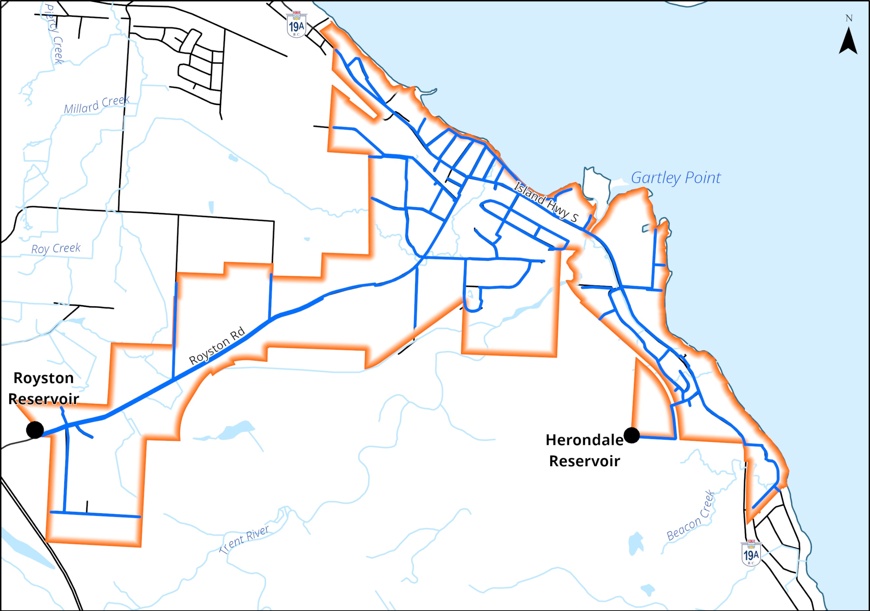
The CVRD provides water to roughly 2800 residents in the Royston Service Area.

Source Water
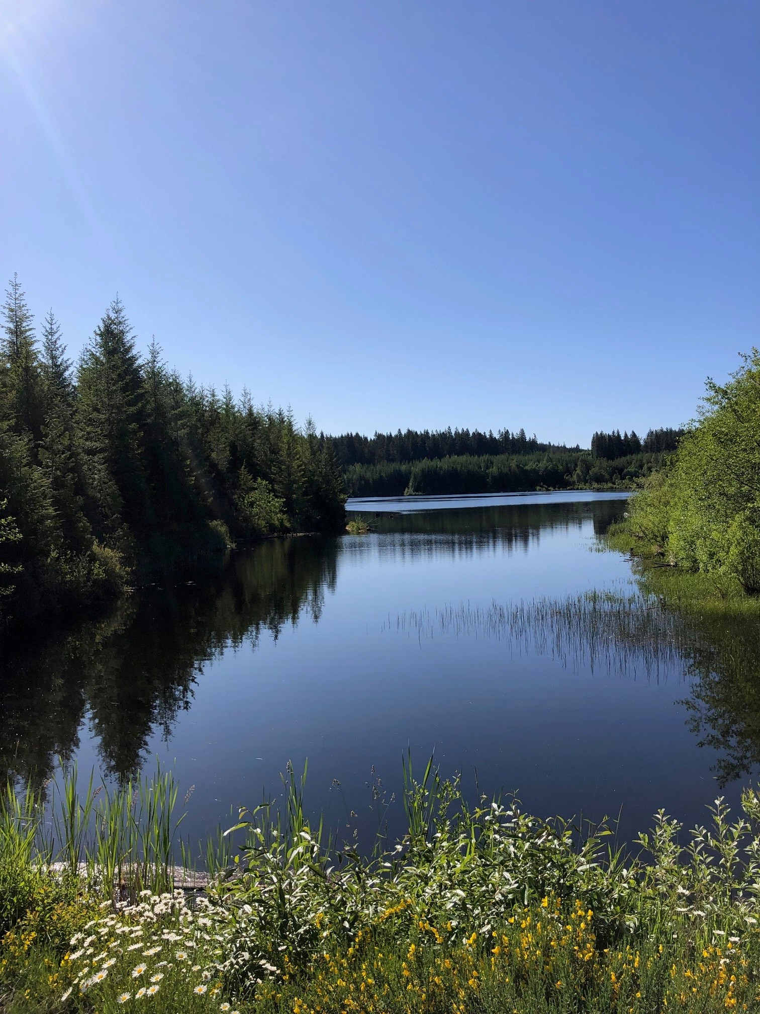
Water for the Royston Service Area is purchased from the Village of Cumberland, where it is sourced from a series of lakes including Allen Lake and a well at Coal Creek Historic Park.

Allen Lake.

Water Treatment
All water supply systems using surface water are governed by Island Health and are required to adhere to provincial “4-3-2-1-0” treatment objectives to ensure effective elimination of disease-causing viruses, bacteria, and parasites.
The “4-3-2-1-0” objectives are as follows:
- 4-log (99.99 per cent) removal/inactivation of viruses
- 3-log (99.9 per cent) removal/inactivation of Giardia and Cryptosporidium
- 2 types of treatment processes
- 1 maximum Nephelometric Turbidity Units in treated water
- 0 detectable E. Coli, fecal coliforms and total coliforms in treated water
Water entering the Royston Service Area is treated and provided by the Village of Cumberland and is compliant with provincial regulations. The water is re-chlorinated at the Royston Reservoir site for both the water that flows into the Royston Reservoir and water directed to the Kentwood pressure zone.

Water Distribution
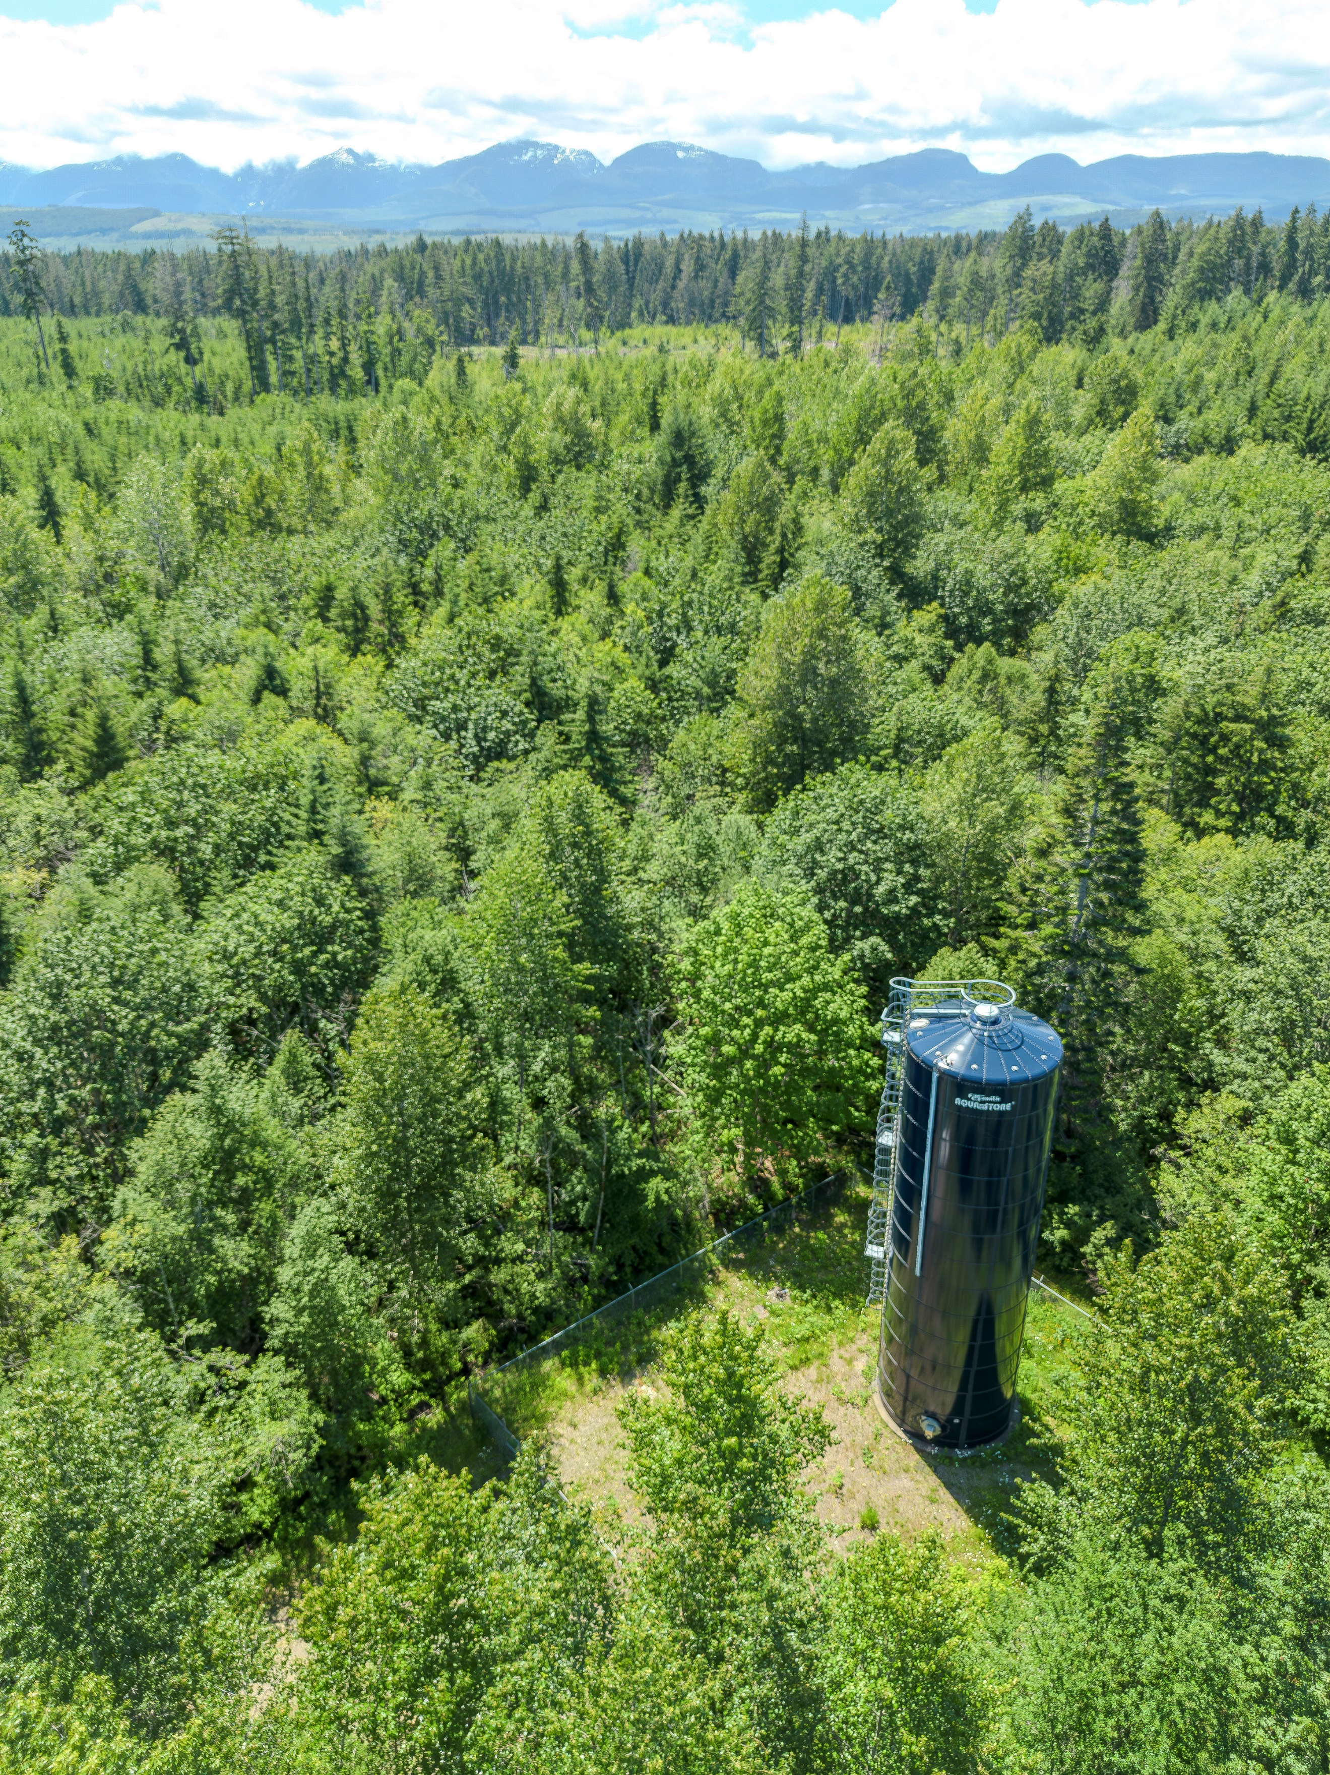
Water leaves the Royston Reservoir and travels downhill towards the community of Royston. As pressure builds, it passes through pressure reducing valves to bring it back down into a manageable range. By the time it reaches Marine Drive, it has built back up to approximately 90psi.
The system extends from beyond Thomson Road in the north, to Kilmarnock Drive in the south at the boundary with Union Bay. There is a second reservoir on Herondale Road that provides supply for fire protection for southern Royston.
There are 102 fire hydrants and 931 service connections in the distribution system.
Herondale Reservoir.

Water Quality
The Ministry of Health, through its regional body Island Health, regulates municipal drinking water quality through the Drinking Water Protection Act and the Drinking Water Protection Regulation. Both documents set out certain requirements for drinking water purveyors to ensure the provision of safe drinking water to their customers.
The Guidelines for Canadian Drinking Water Quality are developed by the Federal-Provincial-Territorial Committee on Drinking Water, and they provide a limit on microbial, chemical, physical, radiological substances called a “maximum acceptable concentration”. The guidelines also assign aesthetic objectives to substances that do not cause risk to human health, but influence consumer acceptance of the water based on factors such as taste, odour and colour.
The CVRD collects and analyzes weekly water quality samples at the water treatment facility, source water, Macaulay, and Kelland Reservoirs, and from various other strategic points within the distribution system to ensure that water is meeting regulatory objectives. Additionally, beyond the scope of this document, water from select locations is tested periodically throughout the year for over 200 different analytes to confirm the effectiveness of treatment processes, the quality of our source water, and the integrity of the distribution system.

Water Quality Summary
Distribution Water | 2023 | 2024 | Target
Turbidity (Average, NTU) | 0.42 | 0.31 | <1
Temperature (Average, ℃) | 11.9 | 11.8 | <15
pH (Average) | 7.4 | 7.5 | 7-10.5
Chlorine Residual (Average, mg/L) | 0.61 | 0.81 | 0.4≥≤2.0
Total Coliforms (Positive Samples) | 0 | 1 | 0
E. Coli (Positive Samples) | 0 | 0 | 0
Trihalomethanes (Average, mg/L) | 0.072 | 0.078* | <0.1
*No trihalomethanes sample result was higher than 0.096.

Distribution Water – Data by Sample Site
 | 262 Spindrift |  | 3200 Royston |  | 3269 Kentwood |  | 3771 Haas |  | 4090 Gartley Pt. |  | Herondale Res.
Date | Cl² | NTU | Cl² | NTU | Cl² | NTU | Cl² | NTU | Cl² | NTU | Cl² | NTU
02-Jan |  |  |  |  |  |  | 0.44 | 0.4
08-Jan |  |  | 0.82 | 0.42 | 0.66 | 0.96
15-Jan | 0.2 | 0.36
22-Jan |  |  |  |  |  |  |  |  | 0.85 | 0.53
05-Feb |  |  |  |  |  |  | 0.65 | 0.51
12-Feb |  |  | 1.04 | 0.16 | 0.76 | 0.28
21-Feb | 0.36 | 0.42
26-Feb |  |  |  |  |  |  |  |  | 0.94 | 0.2
04-Mar |  |  |  |  |  |  | 0.85 | 0.2
11-Mar |  |  | 1.07 | 0.24 | 0.67 | 0.18
18-Mar | 0.47 | 0.29
25-Mar |  |  |  |  |  |  |  |  | 0.82 | 0.54
02-Apr |  |  |  |  |  |  | 0.89 | 0.21
08-Apr |  |  | 1.13 | 0.3 | 0.64 | 0.29
15-Apr | 0.42 | 0.36
22-Apr |  |  |  |  |  |  |  |  | 7.8 | 0.35
06-May |  |  |  |  |  |  | 0.87 | 0.36
13-May |  |  | 0.95 | 0.38 | 0.66 | 0.32
21-May | 0.53 | 0.35
27-May |  |  |  |  |  |  |  |  | 0.9 | 0.33
06-Jun
10-Jun |  |  | 1.1 | 0.49 | 0.65 | 0.38 |  |  |  |  | 0.7 | 0.42
17-Jun | 0.31 | 0.44
24-Jun |  |  |  |  |  |  | 0.86 | 0.4
02-Jul |  |  |  |  |  |  | 0.9 | 0.68
08-Jul |  |  | 1.08 | 0.65 | 0.78 | 0.46
15-Jul | 0.53 | 0.47
22-Jul |  |  |  |  |  |  |  |  | 0.91 | 0.49
29-Jul |  |  |  |  |  |  |  |  | 0.67 | 0.36
06-Aug |  |  |  |  |  |  | 0.51 | 0.46
12-Aug |  |  | 1.08 | 0.66 | 0.7 | 0.6
19-Aug | 0.27 | 0.3
26-Aug |  |  |  |  |  |  |  |  | 0.63 | 0.35
03-Sep |  |  |  |  |  |  | 0.79 | 0.58 |  |  | 0.57 | 0.63
09-Sep |  |  | 1.05 | 0.38 | 0.73 | 0.38
16-Sep | 0.35 | 0.36
23-Sep |  |  |  |  |  |  |  |  | 0.93 | 0.34
03-Oct |  |  |  |  |  |  |  |  | 0.59 | 0.29
07-Oct |  |  |  |  |  |  | 0.72 | 0.4
15-Oct |  |  | 0.93 | 0.33 | 0.59 | 0.25
21-Oct | 0.2 | 0.39
28-Oct |  |  |  |  |  |  |  |  |  | 0.37
04-Nov |  |  |  |  |  |  |  | 0.51
12-Nov |  |  | 0.91 | 0.52 | 0.52 | 0.37
18-Nov |  | 0.42
25-Nov |  |  |  |  |  |  |  |  | 0.56 | 0.48
02-Dec |  |  |  |  |  |  | 0.53 | 0.51
09-Dec |  |  | 1.07 | 0.48 | 0.54 | 0.67 |  |  |  |  | 0.76 | 0.5
16-Dec | 0.09 | 0.39
23-Dec |  |  |  |  |  |  |  |  | 0.53 | 0.55

Distribution Water – Other Analytes
Parameter | Units | Matrix | Q1 | Q2 | Q3 | Q4
Nitrite (N) | mg/L | Result | <0.0050 | <0.0050 | <0.0050 | <0.0050
Nitrite (N) | mg/L | DL | 0.005 | 0.005 | 0.005 | 0.005
Nitrate (N) | mg/L | Result | <0.020 | <0.020 | 0.036 | <0.020
Nitrate (N) | mg/L | DL | 0.02 | 0.02 | 0.02 | 0.02
Conductivity | uS/cm | Result | 77 | 66 | 67 | 69
Conductivity | uS/cm | DL | 2 | 2 | 2 | 2
pH | pH | Result | 6.88 | 6.78 | 6.59 | 6.85
pH | pH | DL | N/A | N/A | N/A | N/A
Alkalinity (PP as CaCO3) | mg/L | Result | <1.0 | <1.0 | <1.0 | <1.0
Alkalinity (PP as CaCO3) | mg/L | DL | 1 | 1 | 1 | 1
Alkalinity (CaCO3) | mg/L | Result | 22 | 17 | 22 | 16
Alkalinity (CaCO3) | mg/L | DL | 1 | 1 | 1 | 1
Bicarbonate (HCO3) | mg/L | Result | 27 | 21 | 27 | 19
Bicarbonate (HCO3) | mg/L | DL | 1 | 1 | 1 | 1
Carbonate (CO3) | mg/L | Result | <1.0 | <1.0 | <1.0 | <1.0
Carbonate (CO3) | mg/L | DL | 1 | 1 | 1 | 1
Hydroxide (OH) | mg/L | Result | <1.0 | <1.0 | <1.0 | <1.0
Hydroxide (OH) | mg/L | DL | 1 | 1 | 1 | 1
Chloride (Cl) | mg/L | Result | 7.2 | 6.7 | 6.6 | 11
Chloride (Cl) | mg/L | DL | 1 | 1 | 1 | 1
Sulphate (SO4) | mg/L | Result | 1.7 | 1.4 | 1.1 | <1.0
Sulphate (SO4) | mg/L | DL | 1 | 1 | 1 | 1
True Colour | Col. Unit | Result | 2.1 | <2.0 | <2.0 | 2.7
True Colour | Col. Unit | DL | 2 | 2 | 2 | 2
Orthophosphate (P) | mg/L | Result | <0.0030 | 0.0039 | <0.0030 | 0.0078
Orthophosphate (P) | mg/L | DL | 0.003 | 0.003 | 0.003 | 0.003
Nitrate plus Nitrite (N) | mg/L | Result | <0.020 | <0.020 | 0.036 | <0.020
Nitrate plus Nitrite (N) | mg/L | DL | 0.02 | 0.02 | 0.02 | 0.02
Dissolved Fluoride (F) | mg/L | Result | <0.050 | <0.050 | <0.050 | <0.050
Dissolved Fluoride (F) | mg/L | DL | 0.05 | 0.05 | 0.05 | 0.05
Total Dissolved Solids | mg/L | Result | 54 | 54 | 40 | 42
Total Dissolved Solids | mg/L | DL | 10 | 10 | 10 | 10
Turbidity | NTU | Result | 0.24 | 0.43 | 2.4 | 0.53
Turbidity | NTU | DL | 0.1 | 0.1 | 0.1 | 0.1
Bromide (Br) | mg/L | Result | 0.055 | 0.034 | 0.048 | 0.022
Bromide (Br) | mg/L | DL | 0.01 | 0.01 | 0.01 | 0.01
Total Hardness (CaCO3) | mg/L | Result | 21.6 | 14.8 | 17.6 | 15.6
Total Hardness (CaCO3) | mg/L | DL | 0.5 | 0.5 | 0.5 | 0.5
Total Aluminum (Al) | ug/L | Result | 22.9 | 14.8 | 6.7 | 24.8
Total Aluminum (Al) | ug/L | DL | 3 | 3 | 3 | 3
Total Antimony (Sb) | ug/L | Result | <0.50 | <0.50 | <0.50 | <0.50
Total Antimony (Sb) | ug/L | DL | 0.5 | 0.5 | 0.5 | 0.5
Total Arsenic (As) | ug/L | Result | <0.10 | <0.10 | <0.10 | <0.10
Total Arsenic (As) | ug/L | DL | 0.1 | 0.1 | 0.1 | 0.1
Total Barium (Ba) | ug/L | Result | <1.0 | <1.0 | 1.2 | 1.1
Total Barium (Ba) | ug/L | DL | 1 | 1 | 1 | 1
Total Beryllium (Be) | ug/L | Result | <0.10 | <0.10 | <0.10 | <0.10
Total Beryllium (Be) | ug/L | DL | 0.1 | 0.1 | 0.1 | 0.1
Total Bismuth (Bi) | ug/L | Result | <1.0 | <1.0 | <1.0 | <1.0
Total Bismuth (Bi) | ug/L | DL | 1 | 1 | 1 | 1
Total Boron (B) | ug/L | Result | <50 | <50 | <50 | <50
Total Boron (B) | ug/L | DL | 50 | 50 | 50 | 50
Total Cadmium (Cd) | ug/L | Result | <0.010 | <0.010 | <0.010 | <0.010
Total Cadmium (Cd) | ug/L | DL | 0.01 | 0.01 | 0.01 | 0.01
Total Chromium (Cr) | ug/L | Result | <1.0 | <1.0 | <1.0 | <1.0
Total Chromium (Cr) | ug/L | DL | 1 | 1 | 1 | 1
Total Cobalt (Co) | ug/L | Result | <0.20 | <0.20 | <0.20 | <0.20
Total Cobalt (Co) | ug/L | DL | 0.2 | 0.2 | 0.2 | 0.2
Total Copper (Cu) | ug/L | Result | 1.38 | 3.97 | 1.93 | 1.56
Total Copper (Cu) | ug/L | DL | 0.2 | 0.2 | 0.2 | 0.2
Total Iron (Fe) | ug/L | Result | 97.4 | 90 | 264 | 107
Total Iron (Fe) | ug/L | DL | 5 | 5 | 5 | 5
Total Lead (Pb) | ug/L | Result | 0.2 | <0.20 | 0.92 | <0.20
Total Lead (Pb) | ug/L | DL | 0.2 | 0.2 | 0.2 | 0.2
Total Manganese (Mn) | ug/L | Result | 3.4 | 11.3 | 13 | 9.7
Total Manganese (Mn) | ug/L | DL | 1 | 1 | 1 | 1
Total Molybdenum (Mo) | ug/L | Result | <1.0 | <1.0 | <1.0 | <1.0
Total Molybdenum (Mo) | ug/L | DL | 1 | 1 | 1 | 1
Total Nickel (Ni) | ug/L | Result | <1.0 | <1.0 | <1.0 | <1.0
Total Nickel (Ni) | ug/L | DL | 1 | 1 | 1 | 1
Total Selenium (Se) | ug/L | Result | <0.10 | <0.10 | <0.10 | <0.10
Total Selenium (Se) | ug/L | DL | 0.1 | 0.1 | 0.1 | 0.1
Total Silicon (Si) | ug/L | Result | 3210 | 2770 | 2690 | 3140
Total Silicon (Si) | ug/L | DL | 100 | 100 | 100 | 100
Total Silver (Ag) | ug/L | Result | <0.020 | <0.020 | <0.020 | <0.020
Total Silver (Ag) | ug/L | DL | 0.02 | 0.02 | 0.02 | 0.02
Total Strontium (Sr) | ug/L | Result | 13.4 | 10.1 | 12.1 | 11.1
Total Strontium (Sr) | ug/L | DL | 1 | 1 | 1 | 1
Total Thallium (Tl) | ug/L | Result | <0.010 | <0.010 | <0.010 | <0.010
Total Thallium (Tl) | ug/L | DL | 0.01 | 0.01 | 0.01 | 0.01
Total Tin (Sn) | ug/L | Result | <5.0 | <5.0 | <5.0 | <5.0
Total Tin (Sn) | ug/L | DL | 5 | 5 | 5 | 5
Total Titanium (Ti) | ug/L | Result | <5.0 | <5.0 | <5.0 | <5.0
Total Titanium (Ti) | ug/L | DL | 5 | 5 | 5 | 5
Total Uranium (U) | ug/L | Result | <0.10 | <0.10 | <0.10 | <0.10
Total Uranium (U) | ug/L | DL | 0.1 | 0.1 | 0.1 | 0.1
Total Vanadium (V) | ug/L | Result | <5.0 | <5.0 | <5.0 | <5.0
Total Vanadium (V) | ug/L | DL | 5 | 5 | 5 | 5
Total Zinc (Zn) | ug/L | Result | <5.0 | <5.0 | <5.0 | <5.0
Total Zinc (Zn) | ug/L | DL | 5 | 5 | 5 | 5
Total Zirconium (Zr) | ug/L | Result | <0.10 | <0.10 | <0.10 | <0.10
Total Zirconium (Zr) | ug/L | DL | 0.1 | 0.1 | 0.1 | 0.1
Total Calcium (Ca) | mg/L | Result | 8.19 | 4.4 | 5.25 | 4.65
Total Calcium (Ca) | mg/L | DL | 0.05 | 0.05 | 0.05 | 0.05
Total Magnesium (Mg) | mg/L | Result | 0.274 | 0.92 | 1.1 | 0.956
Total Magnesium (Mg) | mg/L | DL | 0.05 | 0.05 | 0.05 | 0.05
Total Potassium (K) | mg/L | Result | 0.105 | 0.093 | 0.101 | 0.087
Total Potassium (K) | mg/L | DL | 0.05 | 0.05 | 0.05 | 0.05
Total Sodium (Na) | mg/L | Result | 5.95 | 5.77 | 5.91 | 7.45
Total Sodium (Na) | mg/L | DL | 0.05 | 0.05 | 0.05 | 0.05
Total Sulphur (S) | mg/L | Result | <3.0 | <3.0 | <3.0 | <3.0
Total Sulphur (S) | mg/L | DL | 3 | 3 | 3 | 3
Total Mercury (Hg) | ug/L | Result | 0.0207 | <0.0019 | <0.0019 | 0.002
Total Mercury (Hg) | ug/L | DL | 0.0019 | 0.0019 | 0.0019 | 0.0019
Total Trihalomethanes | ug/L | Result | 70 | 77 | 70 | 96
Total Trihalomethanes | ug/L | DL | 1 | 1 | 1 | 1
Bromodichloromethane | ug/L | Result | 2.2 | 2.3 | 3.3 | <1.0
Bromodichloromethane | ug/L | DL | 1 | 1 | 1 | 1
Bromoform | ug/L | Result | <1.0 | <1.0 | <1.0 | <1.0
Bromoform | ug/L | DL | 1 | 1 | 1 | 1
Dibromochloromethane | ug/L | Result | <1.0 | <1.0 | <1.0 | <1.0
Dibromochloromethane | ug/L | DL | 1 | 1 | 1 | 1
Chloroform | ug/L | Result | 68 | 74 | 66 | 96

Consumption Metrics and Water Rates
The average daily water production in 2024 was 872m³ per day. Demand is highest during the summer months - approximately twice as much as during the winter. In 2024, system demand reached its highest point on May 14th with 1938m³ of water being used.

 |  | 2024 | 2025
Residential & Commercial | Minimum Charge | $31.23 | $33.42
Residential & Commercial | 0m³ to 25m³ | $1.06/m³ | $1.13/m³
Residential & Commercial | 25m³ to 50m³ | $1.32/m³ | $1.41/m³
Residential & Commercial | Over 50m³ | $1.59/m³ | $1.71/m³

Conservation
Water conservation is an increasingly important initiative and while it seems as if there is an abundance of water available, our supply is truly a limited resource, particularly during the summer months.
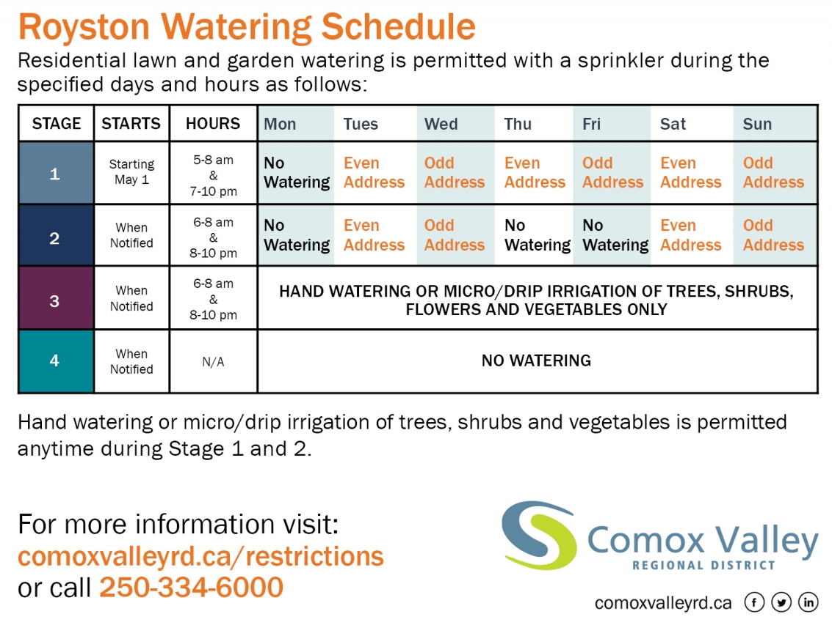
The CVRD has a four-stage system in place for managing water consumption. Stage one is the least restrictive and comes into effect annually on May 1st unless otherwise noted. Stage two, three, and four are more restrictive and are implemented as needed, depending on operational requirements or forecasts of water inflow provided by the Village of Cumberland.

Operations
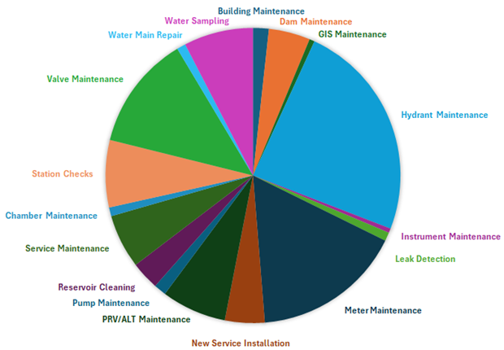
The water treatment facility and distribution system are operated by 15 qualified operators. In 2024, several ongoing and annual maintenance activities were carried out, as well as improvements to work order tracking, data collection, and map improvements.
Additionally, many non-annual projects were completed such as reservoir cleaning, and hydrant painting.

2024 Achievements
- Achieved 77% completion of the meter exchange project
- Continued progress on the Water South Extension Project design and details
- Carried out cleaning and maintenance on Herondale Reservoir
- Acquired design plans for a new water main on Mounce Road
- Completed upgrades of Trent PRV

2025 Objectives
- Replace Mounce Road water main
- Replace Livingstone pressure reducing valve
- Continue meter exchange program
- Acquire multi-assessment permit from the BC Archaeology Branch
- Continue planning and design of the South Water Extension Project
- Install new watering restriction sign

