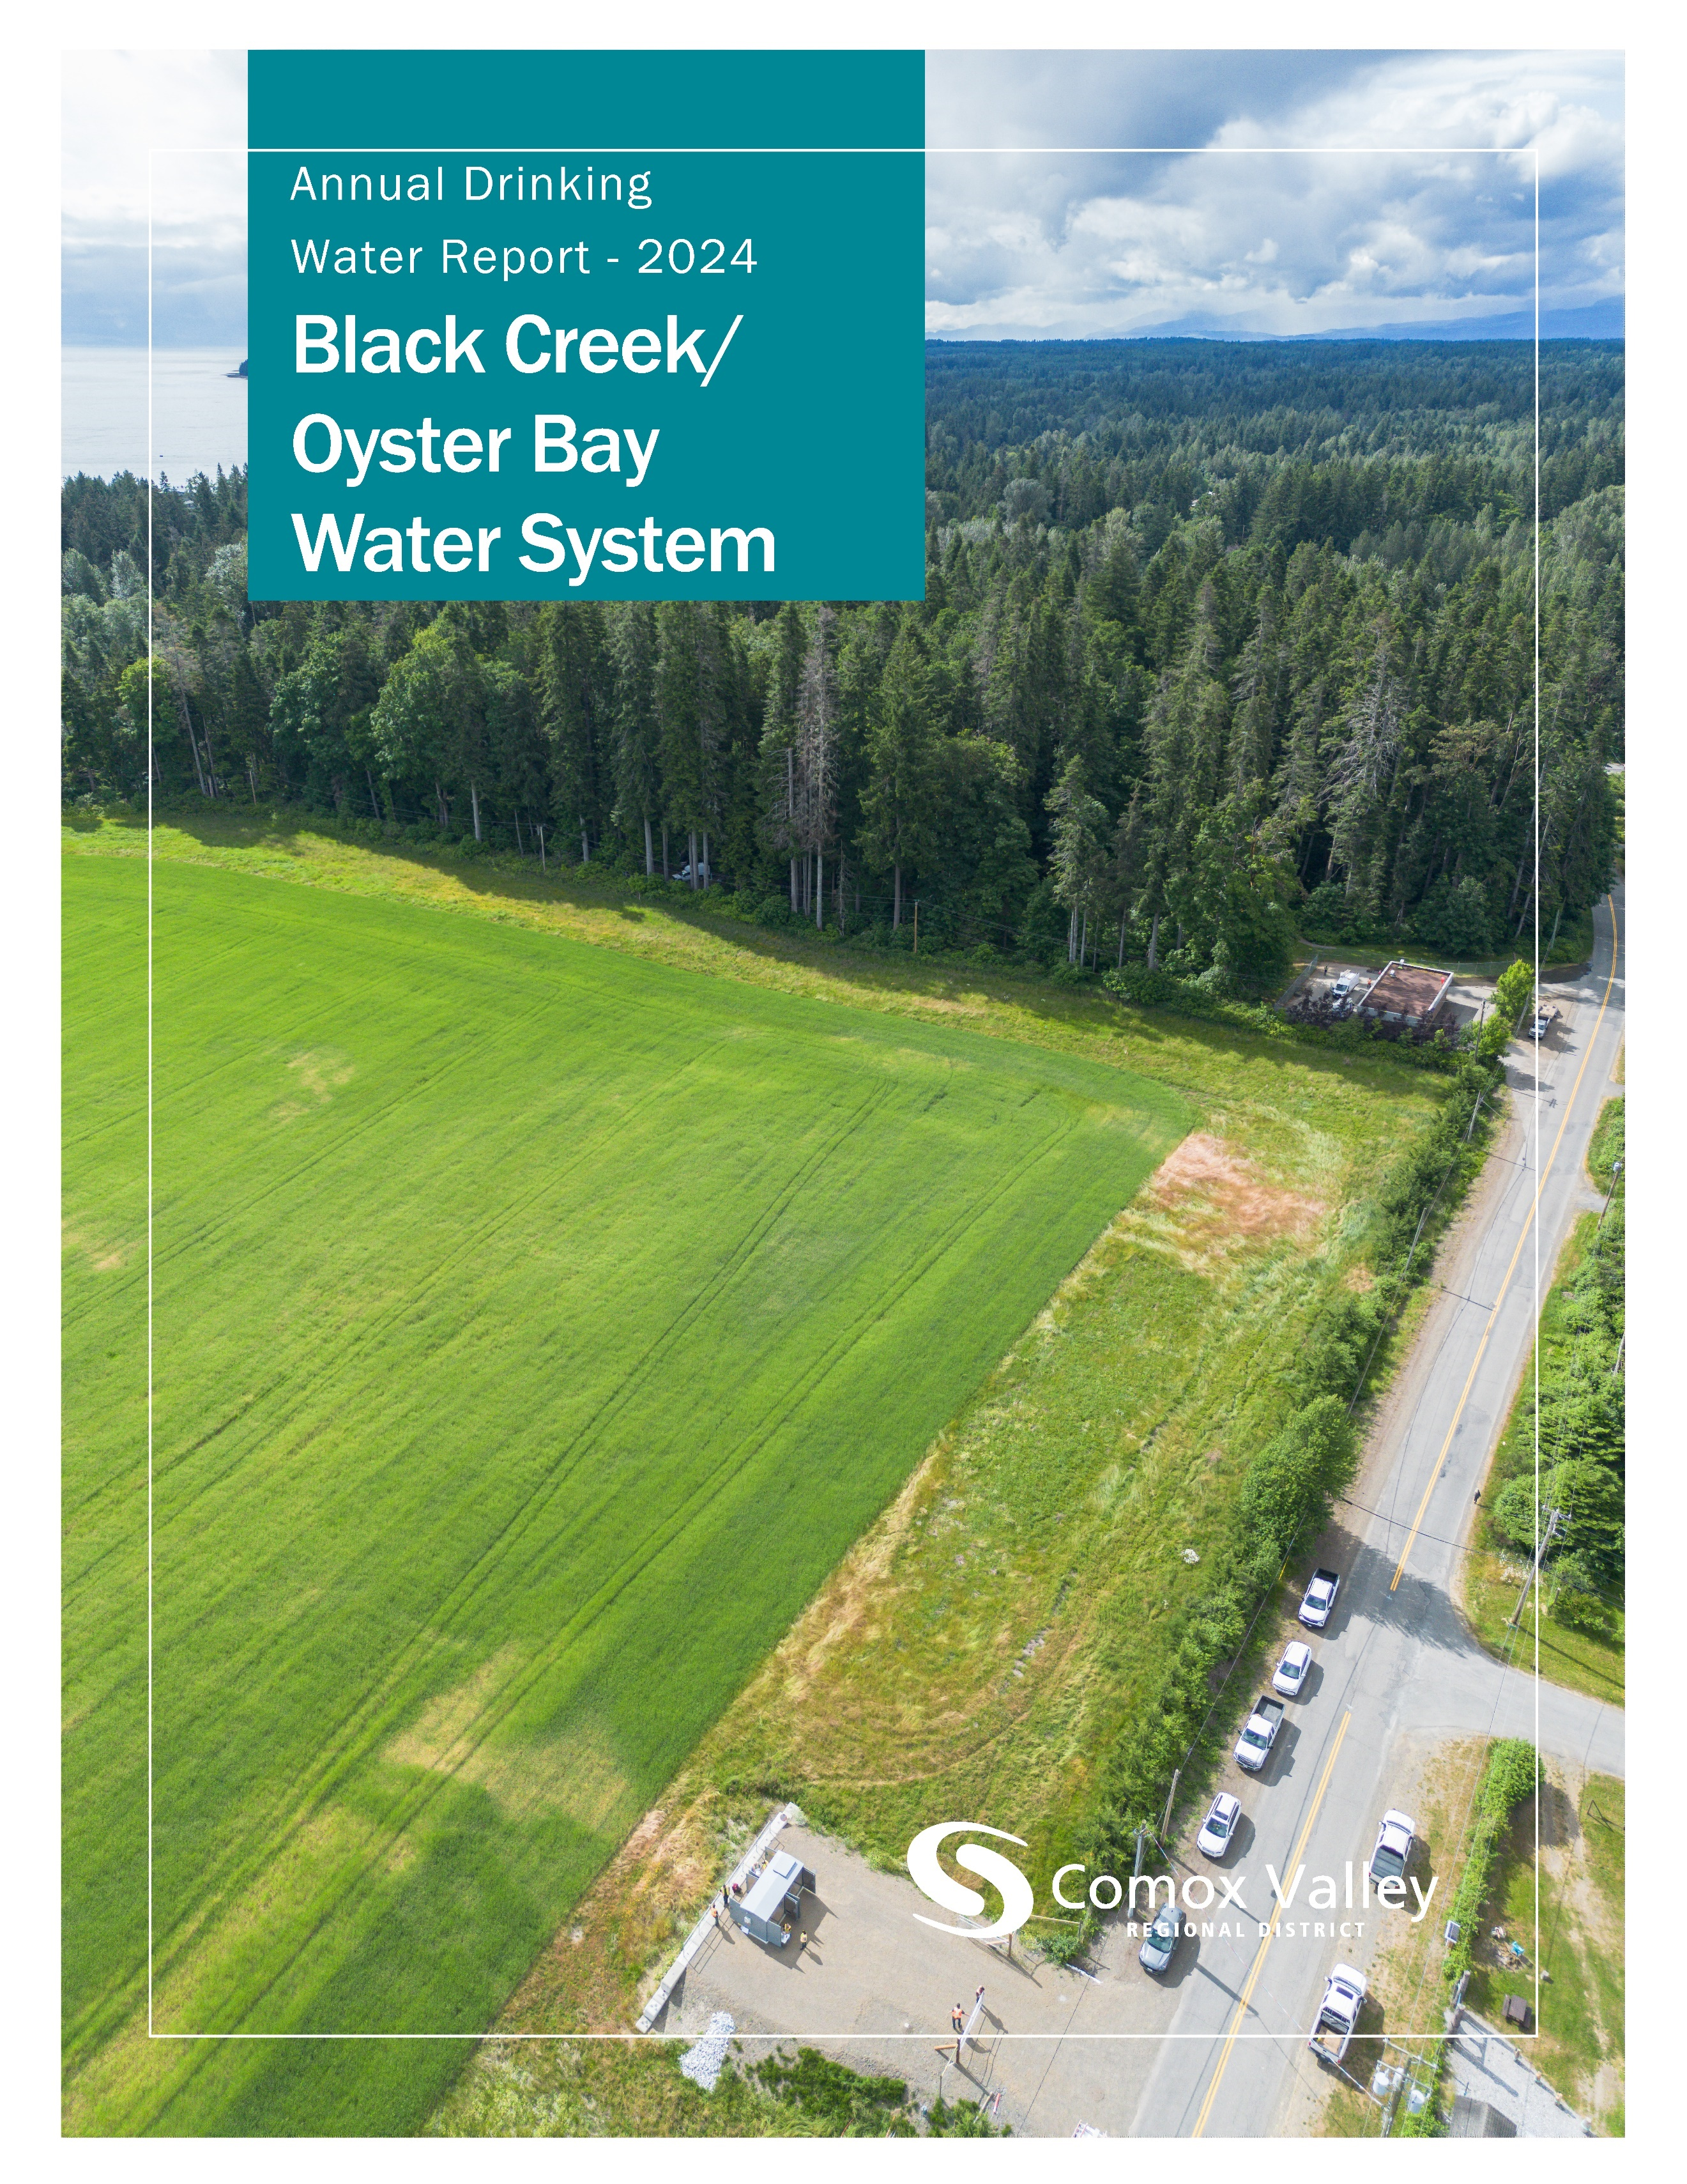

Table of Contents
Introduction 2
Source Water 2
Water Treatment 3
Water Distribution 4
Water Quality 4
Water Quality Summary 5
Distribution Water – Data by Sample Site 6
Distribution Water – Other Analytes 7
Consumption Metrics and Water Rates 9
Conservation 10
Operations 11
2024 Achievements 11
2025 Objectives 11

The CVRD respectfully acknowledges the Black Creek-Oyster Bay Water System operates on the unceded traditional territory of the K’ómoks First Nation and the Ligʷiłdaxʷ Peoples.

Introduction
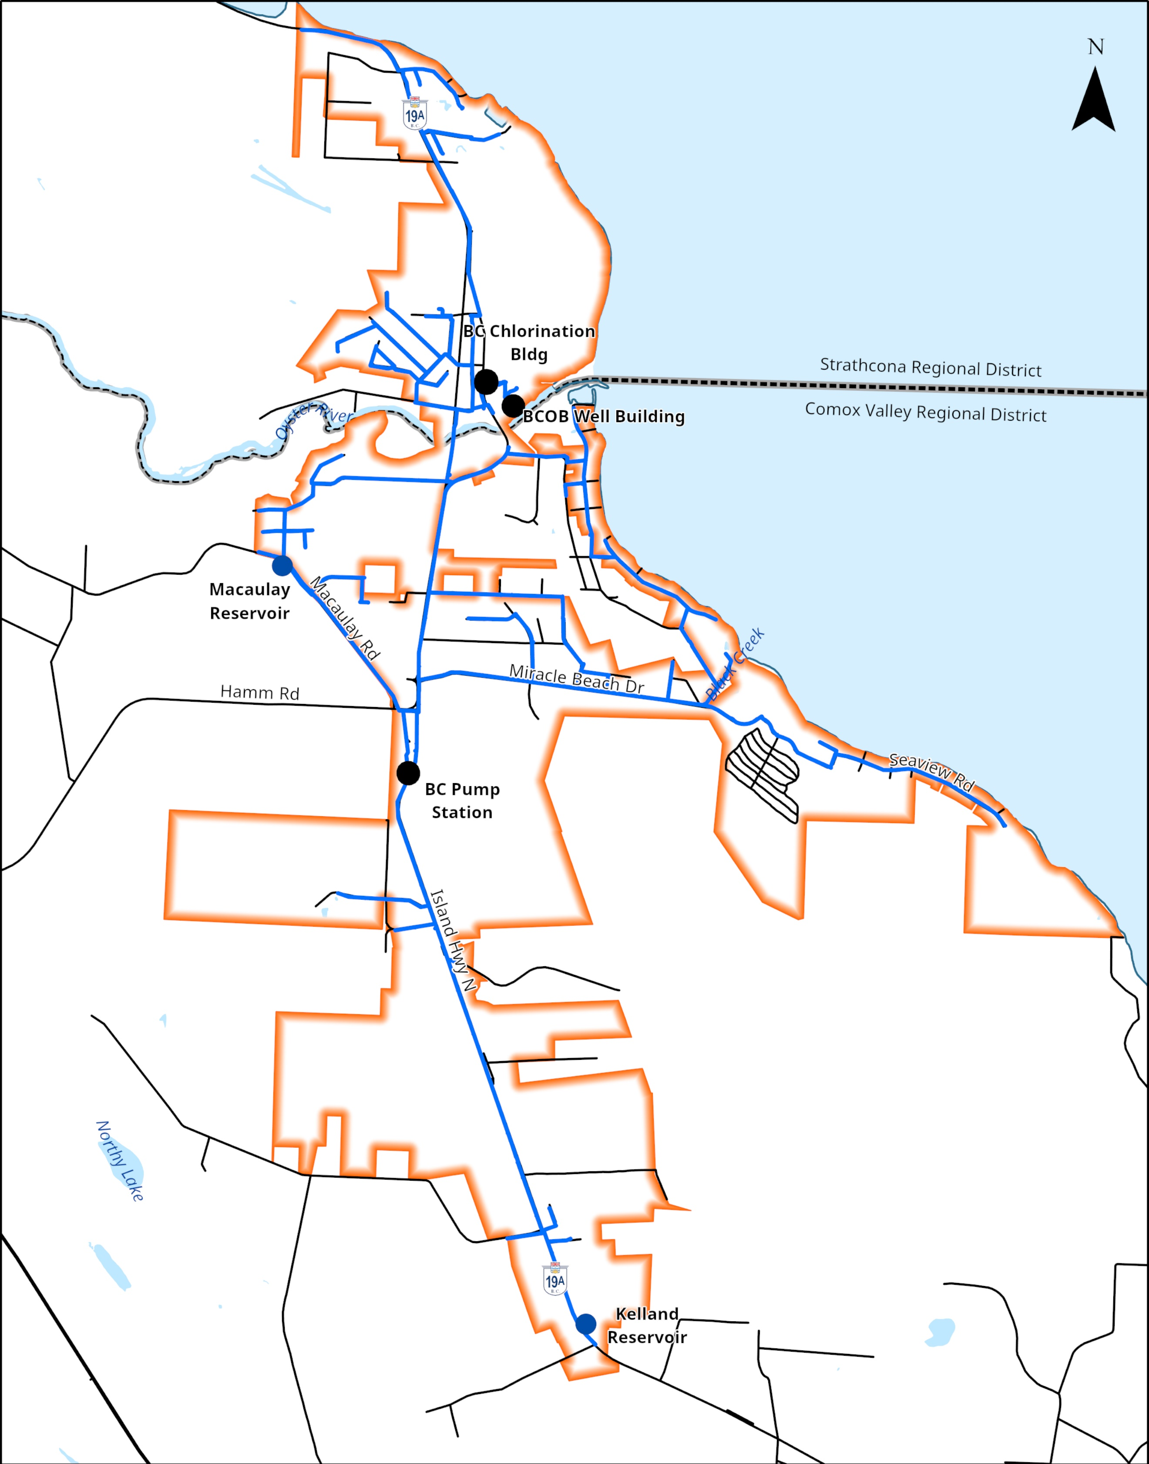
The Comox Valley Regional District strives to provide high-quality drinking water through responsible operation and management of the water system. The CVRD is regulated by Island Health for its activities as a potable water supplier and is required under the Drinking Water Protection Act to report annually on the Black Creek/Oyster Bay Water System. This report includes information on water quality, consumption, maintenance, and capital projects.
The CVRD provides water to roughly 2600 residents and 30 local businesses in the Black Creek/Oyster Bay Water System.

Source Water
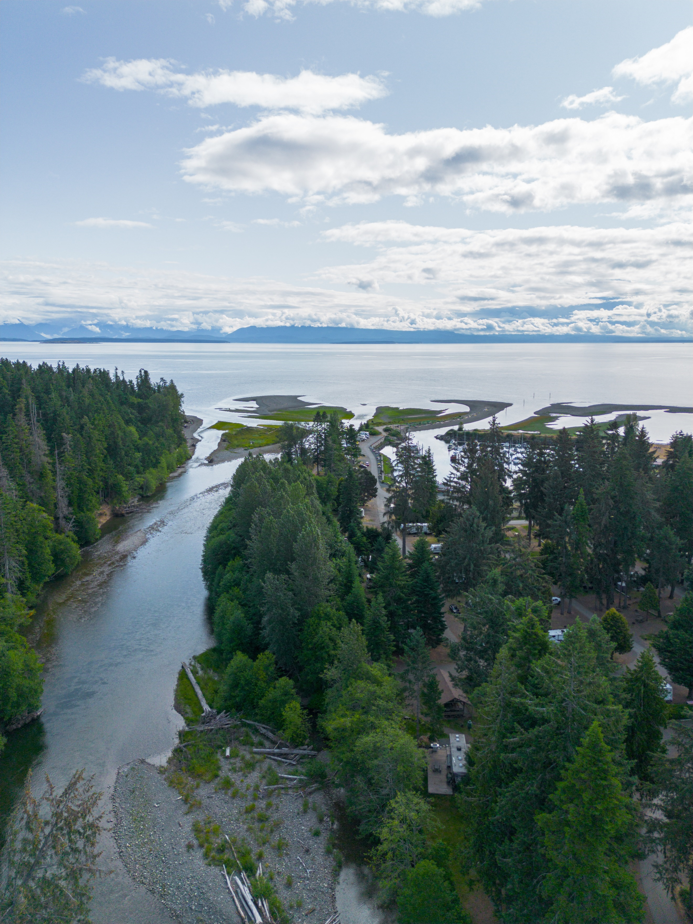
Water for the Black Creek/Oyster Bay Service Area is sourced from four wells and an infiltration gallery in the Oyster River Nature Park.
The Oyster River watershed is 376km² and originates in the mountains of Forbidden Plateau before travelling northeast to the Strait of Georgia. Its main tributaries are Little Oyster River, Woodhus Creek, Piggott Creek, and Adrian Creek.

The Oyster River near the infiltration gallery.

Water Treatment
All water supply systems using surface water are governed by Island Health and are required to adhere to provincial “4-3-2-1-0” treatment objectives to ensure effective elimination of disease-causing viruses, bacteria, and parasites.
The “4-3-2-1-0” objectives are as follows:
- 4-log (99.99 per cent) removal/inactivation of viruses
- 3-log (99.9 per cent) removal/inactivation of Giardia and Cryptosporidium
- 2 types of treatment processes
- 1 maximum Nephelometric Turbidity Units in treated water
- 0 detectable E. Coli, fecal coliforms and total coliforms in treated water
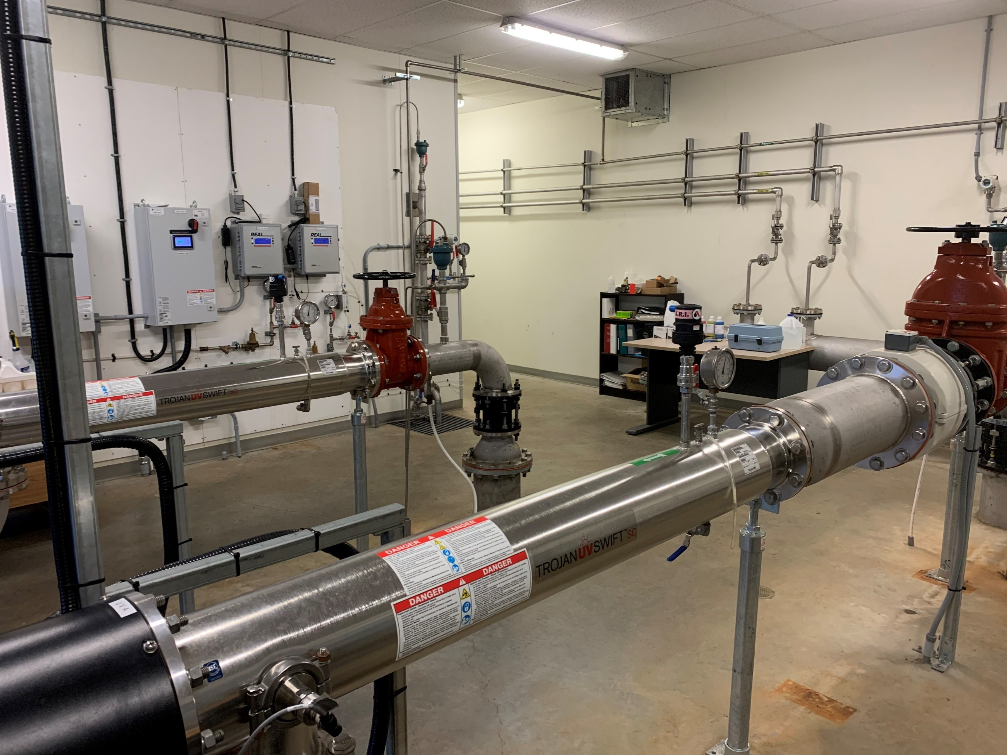
The journey from source to tap begins at one of the wells 20’ below the Oyster River Nature Park, or in the infiltration gallery near the river. Water is pumped to the treatment facility on Regent Road where it passes through Ultra-Violet (UV) reactors before being injected with sodium hypochlorite for disinfecting and caustic soda for pH adjustment. Water sourced from underground wells is typically very clear, has no microbiological growth, but has a low pH and is corrosive. If left unadjusted - in addition to impacting treatment processes - this can cause leaching of metal ions from fittings in the distribution system. Caustic soda is added to address this issue and raise the pH to 7-8.
Ultraviolet reactors.
The water then enters a large contact main which provides contact time for the sodium hypochlorite to disinfect any remaining bacteria.

Water Distribution
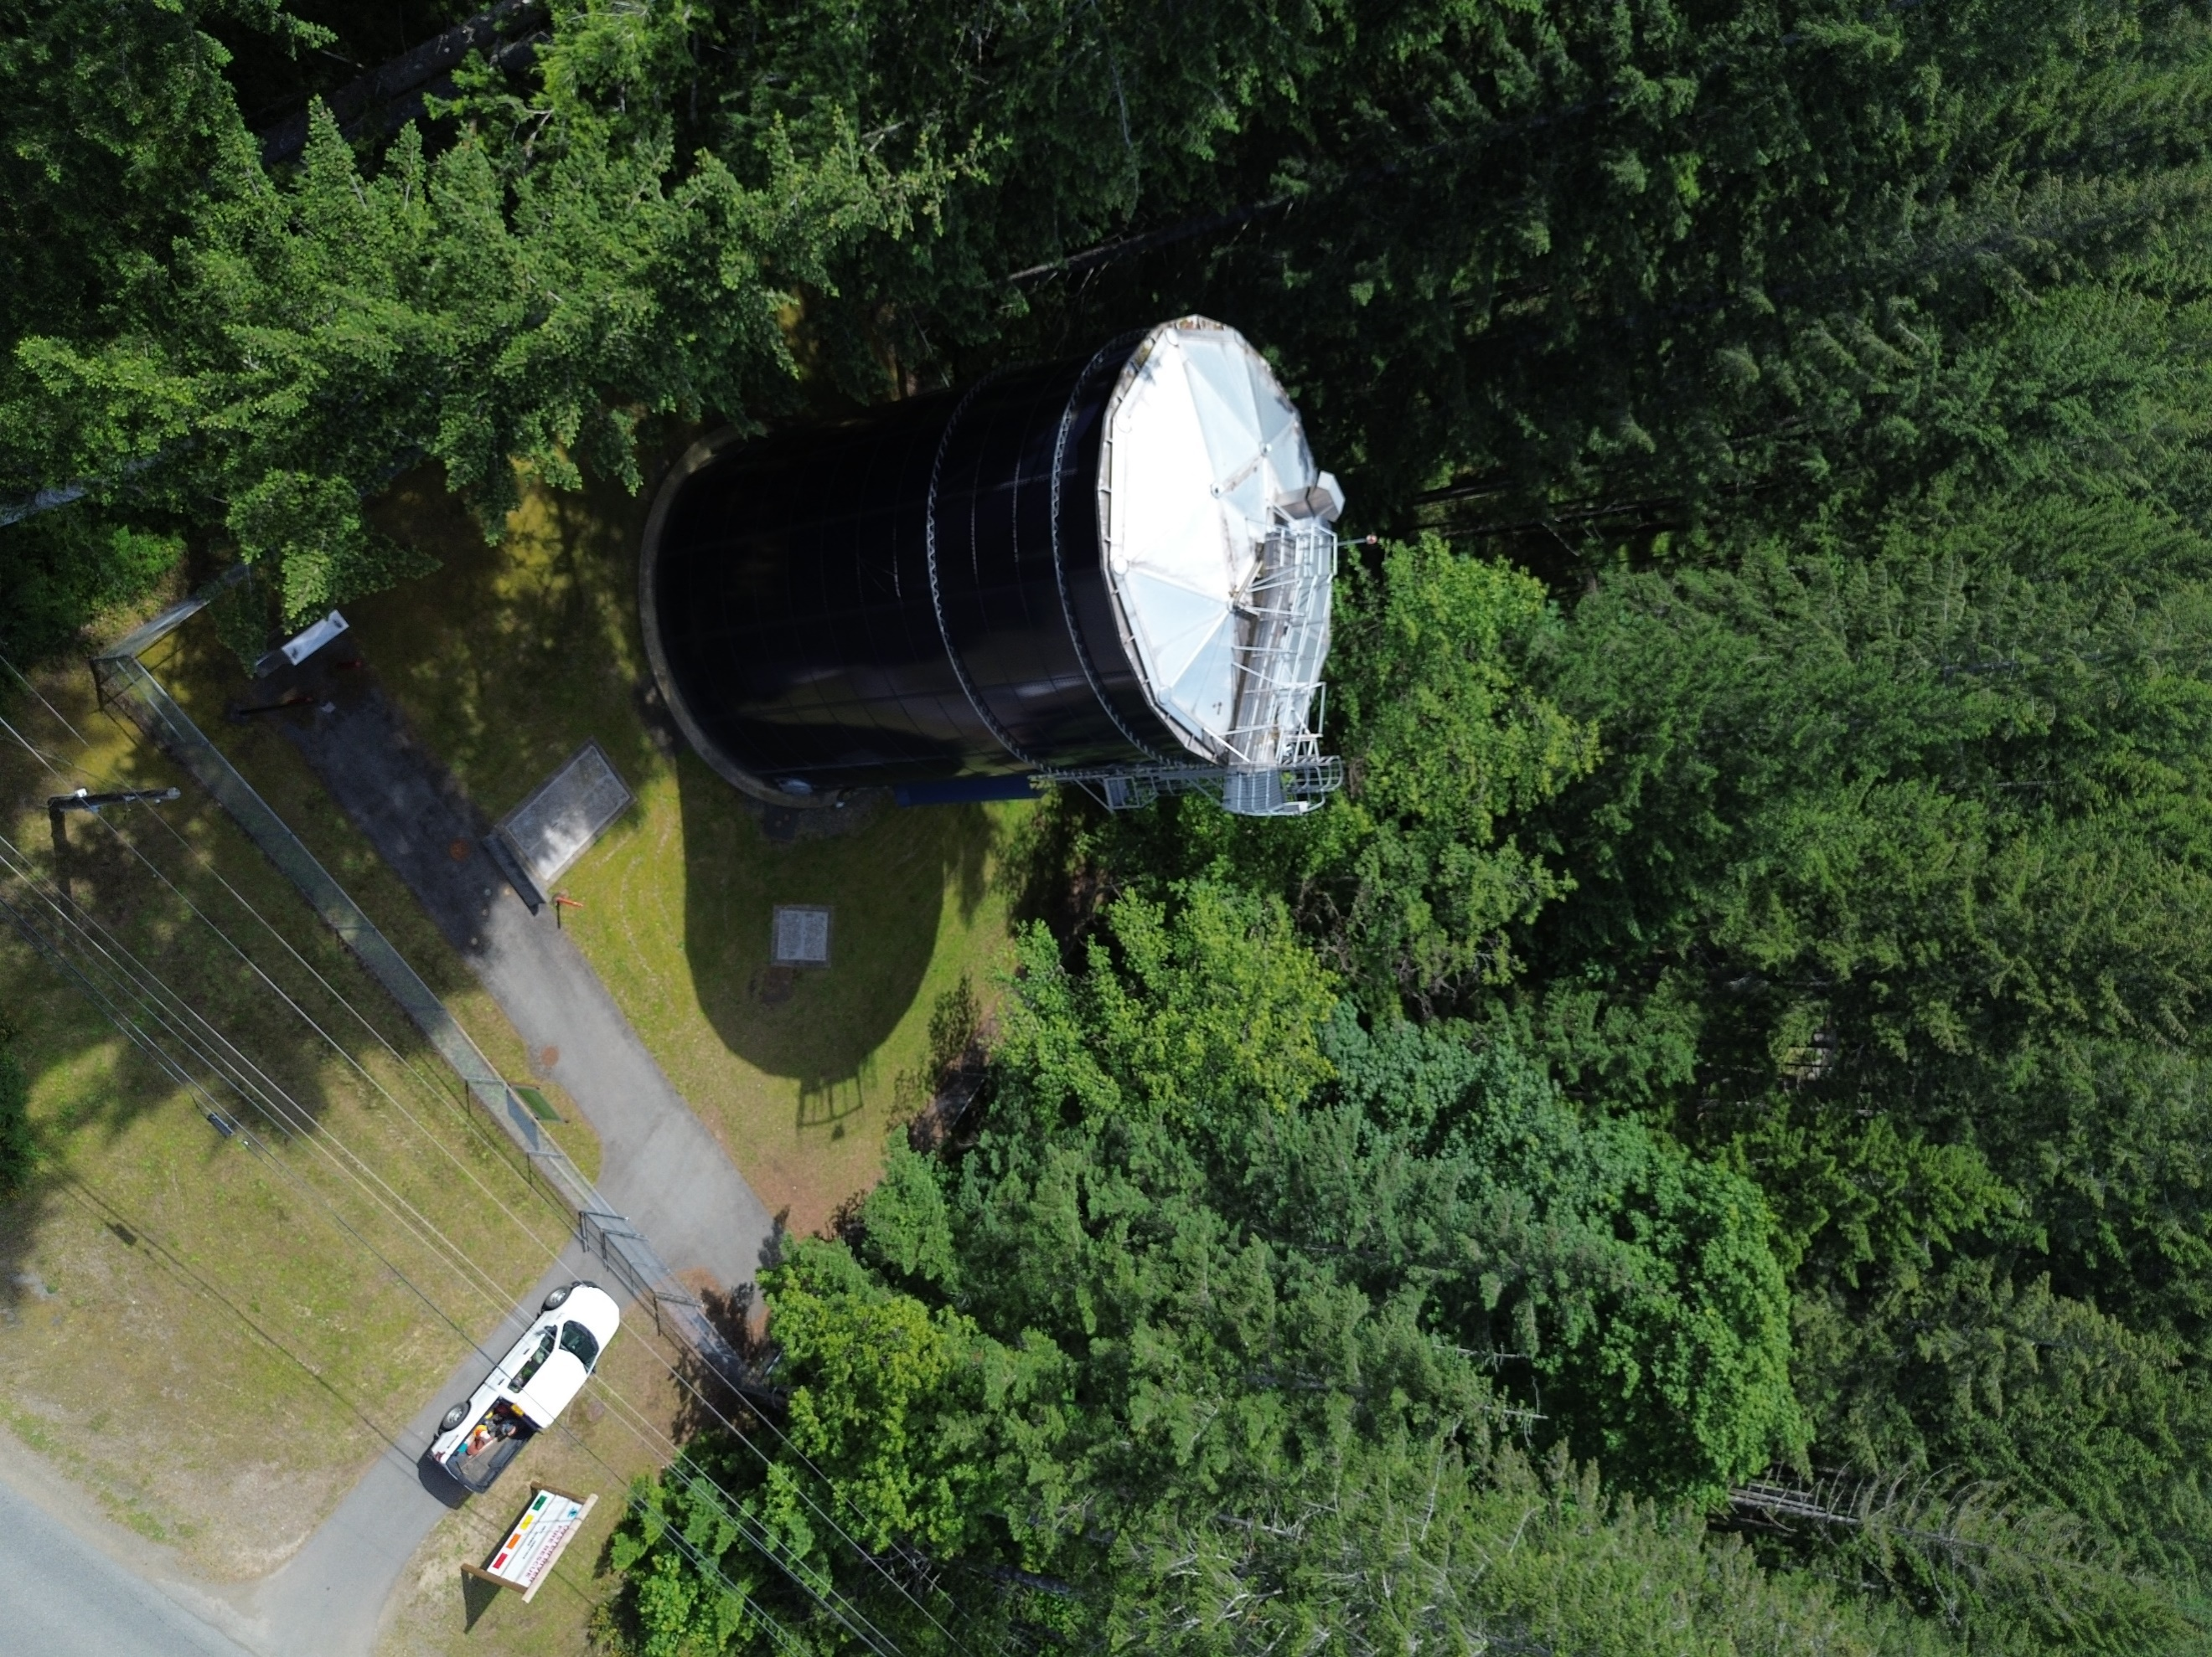
After these processes, the water travels to either Macaulay Reservoir, or is pumped through the Black Creek Booster Station towards Kelland Reservoir.
Water flows in and out of these reservoirs to provide water to residents from the Oyster Bay Shoreline Park in the north, to Kelland Road in the south.
There are 130 fire hydrants and 1072 service connections in the distribution system.

Water Quality
The Ministry of Health, through its regional body Island Health, regulates municipal drinking water quality through the Drinking Water Protection Act and the Drinking Water Protection Regulation. Both documents set out certain requirements for drinking water purveyors to ensure the provision of safe drinking water to their customers.
Macaulay Reservoir.
The Guidelines for Canadian Drinking Water Quality are developed by the Federal-Provincial-Territorial Committee on Drinking Water, and they provide a limit on microbial, chemical, physical, radiological substances called a “maximum acceptable concentration”. The guidelines also assign aesthetic objectives to substances that do not cause risk to human health, but influence consumer acceptance of the water based on factors such as taste, odour and colour.
The CVRD collects and analyzes weekly water quality samples at the water treatment facility, source water, Macaulay, and Kelland Reservoirs, and from various other strategic points within the distribution system to ensure that water is meeting regulatory objectives. Additionally, water from select locations is tested periodically throughout the year for over 200 different analytes to confirm the effectiveness of treatment processes, the quality of our source water, and the integrity of the distribution system.

Water Quality Summary
Source Water | 2023 | 2024
Turbidity (Average, NTU) | 0.03 | 0.03
Temperature (Average, ℃) | 11.5 | 14.2
pH (Average) | 5.3 | 6.6
Distribution Water | 2023 | 2024 | Target
Turbidity (Average, NTU) | 0.18 | 0.12 | <1
Temperature (Average, ℃) | 13.5 | 12.3 | <15
pH (Average) | 7.0 | 7.4 | 7-10.5
Chlorine Residual (Average, mg/L) | 0.88 | 0.95 | 0.4≥≤2.0
Total Coliforms (Positive Samples) | 0 | 0 | 0
E. Coli (Positive Samples) | 0 | 0 | 0
Trihalomethanes (Average, mg/L) | 0.001* | 0.001* | <0.1
*No trihalomethanes sample result was higher than 0.001.

Distribution Water – Data by Sample Site
 | 2220 Salmon Point Road |  | 1536 Seaview Road |  | 8527 Island Highway |  | 2315 King Road |  | Kelland Reservoir |  | Macaulay Reservoir
Date | Cl² | NTU | Cl² | NTU | Cl² | NTU | Cl² | NTU | Cl² | NTU | Cl² | NTU
02-Jan | 1 | 0.14 | 0.87 | 0.14
08-Jan |  |  |  |  | 0.85 | 0.09 | 0.87 | 0.09
15-Jan | 1.03 | 0.14 | 0.97 | 0.15 |  |  |  |  | 0.74 | 0.13
22-Jan |  |  |  |  | 0.99 | 0.11 | 1.01 | 0.14
05-Feb | 0.99 | 0.09 | 0.94 | 0.11
12-Feb |  |  |  |  | 0.96 | 0.18 | 1.09 | 0.14
21-Feb | 0.97 | 0.08 | 0.79 | 0.08 |  |  |  |  | 0.64 | 0.08
26-Feb |  |  |  |  | 0.87 | 0.07 | 1.07 | 0.06
04-Mar | 0.94 | 0.09 | 0.99 | 0.12
11-Mar |  |  |  |  | 1 | 0.07 | 1.06 | 0.05
18-Mar | 0.86 | 0.09 | 0.88 | 0.07 |  |  |  |  | 0.74 | 0.12 | 0.91 | 0.12
25-Mar |  |  |  |  | 0.89 | 0.2 | 1.16 | 0.07
02-Apr | 0.99 | 0.06 | 0.93 | 0.08
08-Apr |  |  |  |  | 0.92 | 0.22 | 1.06 | 0.18 | 0.73 | 0.07
15-Apr | 1.05 | 0.06 | 0.97 | 0.06
22-Apr |  |  |  |  | 0.96 | 0.06 | 1.06 | 0.06
06-May | 1.1 | 0.15 | 0.94 | 0.13
13-May |  |  |  |  | 1.04 | 0.15 | 1.02 | 0.1
21-May | 1.06 | 0.09 | 1.03 | 0.08 |  |  |  |  | 0.68 | 0.13
27-May |  |  |  |  | 1.1 | 0.08 | 0.92 | 0.04
03-Jun | 1.08 | 0.06 | 0.94 | 0.05
10-Jun |  |  |  |  | 0.95 | 0.2 | 1.16 | 0.17 |  |  | 0.95 | 0.07
17-Jun | 1 | 0.17 | 1.13 | 0.15 |  |  |  |  | 0.75 | 0.18
24-Jun |  |  |  |  | 1.04 | 0.15 | 1.04 | 0.08
02-Jul | 0.86 | 0.07 | 1.13 | 0.07
08-Jul |  |  |  |  | 0.98 | 0.6 | 1.05 | 0.13
15-Jul | 0.84 | 0.1 | 0.77 | 0.08 | 0.69 | 0.09
22-Jul |  |  |  |  | 0.79 | 0.22 | 0.77 | 0.24
29-Jul |  |  |  |  | 0.91 | 0.08 | 0.94 | 0.09
06-Aug | 0.66 | 0.16 | 0.73 | 0.13
12-Aug |  |  |  |  | 0.87 | 0.22 | 1.03 | 0.13
19-Aug | 1.05 | 0.07 | 0.91 | 0.14 | 0.4 | 0.13
26-Aug |  |  |  |  | 1 | 0.11 | 0.96 | 0.07
03-Sep | 0.9 | 0.07 | 0.74 | 0.06 |  |  |  |  |  |  | 1.07 | 1.07
09-Sep |  |  |  |  | 0.93 | 0.22 | 1.05 | 0.12
16-Sep | 1.29 | 0.09 | 1.13 | 0.13 | 1.01 | 0.17
23-Sep |  |  |  |  | 0.94 | 0.28 | 0.95 | 0.14
07-Oct | 1.08 | 0.09 | 0.92 | 0.11
16-Oct |  |  |  |  | 1.03 | 0.11 | 1.08 | 0.11
21-Oct | 1.09 | 0.07 | 0.9 | 0.07 | 1.01 | 0.1
28-Oct |  |  |  |  | 1.11 | 0.05 | 1.09 | 0.04
04-Nov | 1.04 | 0.38 | 0.92 | 0.2
12-Nov |  |  |  |  |  | 0.16 |  | 0.2
18-Nov | 1.1 | 0.06 | 0.97 | 0.08 | 0.99 | 0.06
25-Nov |  |  |  |  |  |  | 1.11 | 0.08
02-Dec | 1.02 | 0.1 | 0.89 | 0.08
09-Dec |  |  |  |  | 1.05 | 0.08 | 1.03 | 0.09 |  |  | 1.02 | 0.12
16-Dec | 0.94 | 0.08 | 0.95 | 0.08 | 0.72 | 0.7
23-Dec |  |  |  |  | 1.06 | 0.08 | 1.09 | 0.08

Distribution Water – Other Analytes
Parameter | Units | Matrix | Q1 | Q2 | Q3 | Q4
Nitrite (N) | mg/L | Result | <0.0050 | <0.0050 | <0.0050 | <0.0050
Nitrite (N) | mg/L | DL | 0.005 | 0.005 | 0.005 | 0.005
Nitrate (N) | mg/L | Result | 2.55 | 1.72 | 0.149 | 1.77
Nitrate (N) | mg/L | DL | 0.02 | 0.02 | 0.02 | 0.02
Conductivity | uS/cm | Result | 250 | 230 | 64 | 220
Conductivity | uS/cm | DL | 2 | 2 | 2 | 2
pH | pH | Result | 7.84 | 7.84 | 7.01 | 7.81
pH | pH | DL | N/A | N/A | N/A | N/A
Alkalinity (PP as CaCO3) | mg/L | Result | <1.0 | <1.0 | <1.0 | <1.0
Alkalinity (PP as CaCO3) | mg/L | DL | 1 | 1 | 1 | 1
Alkalinity (CaCO3) | mg/L | Result | 95 | 91 | 28 | 86
Alkalinity (CaCO3) | mg/L | DL | 1 | 1 | 1 | 1
Bicarbonate (HCO3) | mg/L | Result | 120 | 110 | 34 | 100
Bicarbonate (HCO3) | mg/L | DL | 1 | 1 | 1 | 1
Carbonate (CO3) | mg/L | Result | <1.0 | <1.0 | <1.0 | <1.0
Carbonate (CO3) | mg/L | DL | 1 | 1 | 1 | 1
Hydroxide (OH) | mg/L | Result | <1.0 | <1.0 | <1.0 | <1.0
Hydroxide (OH) | mg/L | DL | 1 | 1 | 1 | 1
Chloride (Cl) | mg/L | Result | 10 | 7.1 | 1.4 | 6.6
Chloride (Cl) | mg/L | DL | 1 | 1 | 1 | 1
Sulphate (SO4) | mg/L | Result | 3.2 | 3.5 | 1.5 | 3.1
Sulphate (SO4) | mg/L | DL | 1 | 1 | 1 | 1
True Colour | Col. Unit | Result | <2.0 | <2.0 | <2.0 | <2.0
True Colour | Col. Unit | DL | 2 | 2 | 2 | 2
Orthophosphate (P) | mg/L | Result | <0.0030 | 0.0087 | <0.0030 | 0.014
Orthophosphate (P) | mg/L | DL | 0.003 | 0.003 | 0.003 | 0.003
Nitrate plus Nitrite (N) | mg/L | Result | 2.55 | 1.72 | 0.149 | 1.77
Nitrate plus Nitrite (N) | mg/L | DL | 0.02 | 0.02 | 0.02 | 0.02
Dissolved Fluoride (F) | mg/L | Result | <0.050 | <0.050 | <0.050 | <0.050
Dissolved Fluoride (F) | mg/L | DL | 0.05 | 0.05 | 0.05 | 0.05
Total Dissolved Solids | mg/L | Result | 160 | 130 | 36 | 100
Total Dissolved Solids | mg/L | DL | 10 | 10 | 10 | 10
Turbidity | NTU | Result | 0.22 | <0.10 | <0.10 | 0.12
Turbidity | NTU | DL | 0.1 | 0.1 | 0.1 | 0.1
Bromide (Br) | mg/L | Result | 0.113 | 0.1 | 0.101 | 0.043
Bromide (Br) | mg/L | DL | 0.01 | 0.01 | 0.01 | 0.01
Total Hardness (CaCO3) | mg/L | Result | 46.3 | 43 | 20.2 | 44.4
Total Hardness (CaCO3) | mg/L | DL | 0.5 | 0.5 | 0.5 | 0.5
Total Aluminum (Al) | ug/L | Result | <3.0 | 24 | 4.6 | 10
Total Aluminum (Al) | ug/L | DL | 3 | 3 | 3 | 3
Total Antimony (Sb) | ug/L | Result | <0.50 | <0.50 | <0.50 | <0.50
Total Antimony (Sb) | ug/L | DL | 0.5 | 0.5 | 0.5 | 0.5
Total Arsenic (As) | ug/L | Result | <0.10 | <0.10 | 0.13 | <0.10
Total Arsenic (As) | ug/L | DL | 0.1 | 0.1 | 0.1 | 0.1
Total Barium (Ba) | ug/L | Result | 1.2 | 1 | <1.0 | 1.2
Total Barium (Ba) | ug/L | DL | 1 | 1 | 1 | 1
Total Beryllium (Be) | ug/L | Result | <0.10 | <0.10 | <0.10 | <0.10
Total Beryllium (Be) | ug/L | DL | 0.1 | 0.1 | 0.1 | 0.1
Total Bismuth (Bi) | ug/L | Result | <1.0 | <1.0 | <1.0 | <1.0
Total Bismuth (Bi) | ug/L | DL | 1 | 1 | 1 | 1
Total Boron (B) | ug/L | Result | <50 | <50 | <50 | <50
Total Boron (B) | ug/L | DL | 50 | 50 | 50 | 50
Total Cadmium (Cd) | ug/L | Result | <0.010 | <0.010 | <0.010 | <0.010
Total Cadmium (Cd) | ug/L | DL | 0.01 | 0.01 | 0.01 | 0.01
Total Chromium (Cr) | ug/L | Result | <1.0 | <1.0 | <1.0 | <1.0
Total Chromium (Cr) | ug/L | DL | 1 | 1 | 1 | 1
Total Cobalt (Co) | ug/L | Result | <0.20 | <0.20 | <0.20 | <0.20
Total Cobalt (Co) | ug/L | DL | 0.2 | 0.2 | 0.2 | 0.2
Total Copper (Cu) | ug/L | Result | 0.72 | 1.98 | 1.12 | 1.66
Total Copper (Cu) | ug/L | DL | 0.2 | 0.2 | 0.2 | 0.2
Total Iron (Fe) | ug/L | Result | 8.8 | <5.0 | <5.0 | <5.0
Total Iron (Fe) | ug/L | DL | 5 | 5 | 5 | 5
Total Lead (Pb) | ug/L | Result | <0.20 | <0.20 | <0.20 | <0.20
Total Lead (Pb) | ug/L | DL | 0.2 | 0.2 | 0.2 | 0.2
Total Manganese (Mn) | ug/L | Result | <1.0 | <1.0 | <1.0 | <1.0
Total Manganese (Mn) | ug/L | DL | 1 | 1 | 1 | 1
Total Molybdenum (Mo) | ug/L | Result | <1.0 | <1.0 | <1.0 | <1.0
Total Molybdenum (Mo) | ug/L | DL | 1 | 1 | 1 | 1
Total Nickel (Ni) | ug/L | Result | <1.0 | <1.0 | <1.0 | <1.0
Total Nickel (Ni) | ug/L | DL | 1 | 1 | 1 | 1
Total Selenium (Se) | ug/L | Result | 0.11 | <0.10 | <0.10 | 0.1
Total Selenium (Se) | ug/L | DL | 0.1 | 0.1 | 0.1 | 0.1
Total Silicon (Si) | ug/L | Result | 7450 | 7360 | 2260 | 8040
Total Silicon (Si) | ug/L | DL | 100 | 100 | 100 | 100
Total Silver (Ag) | ug/L | Result | <0.020 | <0.020 | <0.020 | <0.020
Total Silver (Ag) | ug/L | DL | 0.02 | 0.02 | 0.02 | 0.02
Total Strontium (Sr) | ug/L | Result | 35.5 | 31.6 | 14.5 | 33.2
Total Strontium (Sr) | ug/L | DL | 1 | 1 | 1 | 1
Total Thallium (Tl) | ug/L | Result | <0.010 | <0.010 | <0.010 | <0.010
Total Thallium (Tl) | ug/L | DL | 0.01 | 0.01 | 0.01 | 0.01
Total Tin (Sn) | ug/L | Result | <5.0 | <5.0 | <5.0 | <5.0
Total Tin (Sn) | ug/L | DL | 5 | 5 | 5 | 5
Total Titanium (Ti) | ug/L | Result | <5.0 | <5.0 | <5.0 | <5.0
Total Titanium (Ti) | ug/L | DL | 5 | 5 | 5 | 5
Total Uranium (U) | ug/L | Result | <0.10 | <0.10 | <0.10 | <0.10
Total Uranium (U) | ug/L | DL | 0.1 | 0.1 | 0.1 | 0.1
Total Vanadium (V) | ug/L | Result | <5.0 | <5.0 | <5.0 | <5.0
Total Vanadium (V) | ug/L | DL | 5 | 5 | 5 | 5
Total Zinc (Zn) | ug/L | Result | <5.0 | <5.0 | <5.0 | <5.0
Total Zinc (Zn) | ug/L | DL | 5 | 5 | 5 | 5
Total Zirconium (Zr) | ug/L | Result | <0.10 | <0.10 | <0.10 | <0.10
Total Zirconium (Zr) | ug/L | DL | 0.1 | 0.1 | 0.1 | 0.1
Total Calcium (Ca) | mg/L | Result | 13.2 | 12.1 | 6.09 | 12.5
Total Calcium (Ca) | mg/L | DL | 0.05 | 0.05 | 0.05 | 0.05
Total Magnesium (Mg) | mg/L | Result | 3.24 | 3.12 | 1.22 | 3.19
Total Magnesium (Mg) | mg/L | DL | 0.05 | 0.05 | 0.05 | 0.05
Total Potassium (K) | mg/L | Result | 0.239 | 0.231 | 0.12 | 0.226
Total Potassium (K) | mg/L | DL | 0.05 | 0.05 | 0.05 | 0.05
Total Sodium (Na) | mg/L | Result | 34.9 | 31.1 | 5.05 | 28
Total Sodium (Na) | mg/L | DL | 0.05 | 0.05 | 0.05 | 0.05
Total Sulphur (S) | mg/L | Result | <3.0 | <3.0 | <3.0 | <3.0
Total Sulphur (S) | mg/L | DL | 3 | 3 | 3 | 3
Total Mercury (Hg) | ug/L | Result | 0.0194 | <0.0019 | <0.0019 | <0.0019
Total Mercury (Hg) | ug/L | DL | 0.0019 | 0.0019 | 0.0019 | 0.0019
Total Trihalomethanes | ug/L | Result | 8.2 | 6.1 | 11 | 6.9
Total Trihalomethanes | ug/L | DL | 1 | 1 | 1 | 1
Bromodichloromethane | ug/L | Result | 2.4 | 1.9 | <1.0 | 2.5
Bromodichloromethane | ug/L | DL | 1 | 1 | 1 | 1
Bromoform | ug/L | Result | <1.0 | <1.0 | <1.0 | <1.0
Bromoform | ug/L | DL | 1 | 1 | 1 | 1
Dibromochloromethane | ug/L | Result | 2.3 | 1.6 | <1.0 | 1.7
Dibromochloromethane | ug/L | DL | 1 | 1 | 1 | 1
Chloroform | ug/L | Result | 3.5 | 2.6 | 11 | 2.8
Chloroform | ug/L | DL | 1 | 1 | 1 | 1

Consumption Metrics and Water Rates
The average daily water production in 2024 was 1206m³ per day. Demand is highest during the summer months - approximately twice as much as during the winter. In 2024, system demand reached its highest point on July 9th with 2570m³ of water being produced.

 |  | 2024 | 2025
Residential | Minimum charge up to 15m³ | $27.08 | $27.76
Residential | 15m³ to 45m³ | $1.62/m³ | $1.66/m³
Residential | 25m³ to 37.5m³ | $2.35/m³ | $2.41/m³
Residential | Over 45m³ | $2.44/m³ | $2.50/m³
Commercial | Minimum charge up to 15m³ | $42.19 | $43.24
Commercial | Over 15m³ | $2.11/m³ | $2.16/m³

Conservation
Water conservation is an increasingly important initiative and while it seems as if there is an abundance of water available, our supply is truly a limited resource, particularly during the summer months.
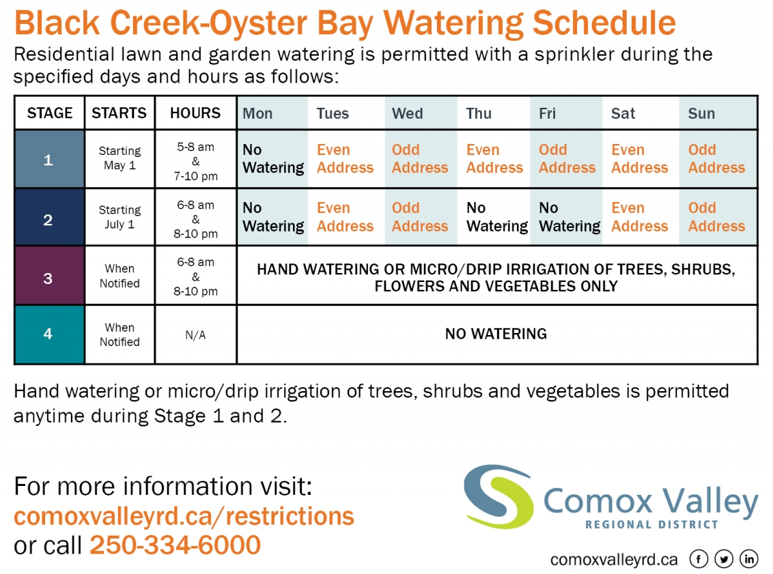
The CVRD has a four-stage system in place for managing water consumption. Stage one is the least restrictive and comes into effect annually on May 1st until September 30th unless otherwise noted. Stage two is implemented on July 1st. Stages three and four are the most restrictive and are typically reserved for emergencies.

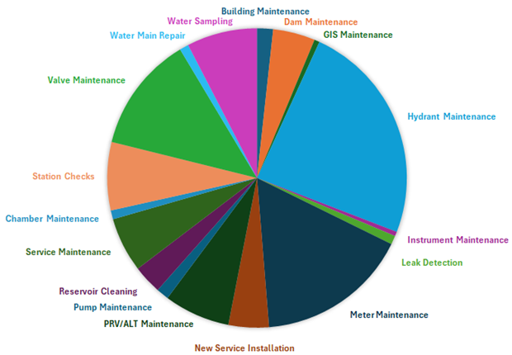
Operations
Water treatment facilities and distribution systems are operated by 15 qualified operators. In 2024, several ongoing and annual maintenance activities were carried out, as well as improvements to work order tracking, data collection, and map improvements.
Additionally, many non-annual projects were completed such as reservoir cleaning, and hydrant painting.

2024 Achievements
- Achieved 64% completion of the meter exchange program
- Full replacement of caustic system pumps and piping
- Installed new sodium hypochlorite spill containment system
- Installed electric valve actuators for UV reactors
- Acquire water license for Well #6
- Renewed old piping infrastructure near wells #1 and #4
- Sandblasted and painted all BCOB fire hydrants

2025 Objectives
- Commission Well #6 and begin use
- Abandon old asbestos concrete transmission main
- Continue residential meter exchange program
- Acquire multi-assessment permit from the BC Archaeology Branch
- Pipe cleanup and abandoned chamber removal at Catherwood and Highway intersection

