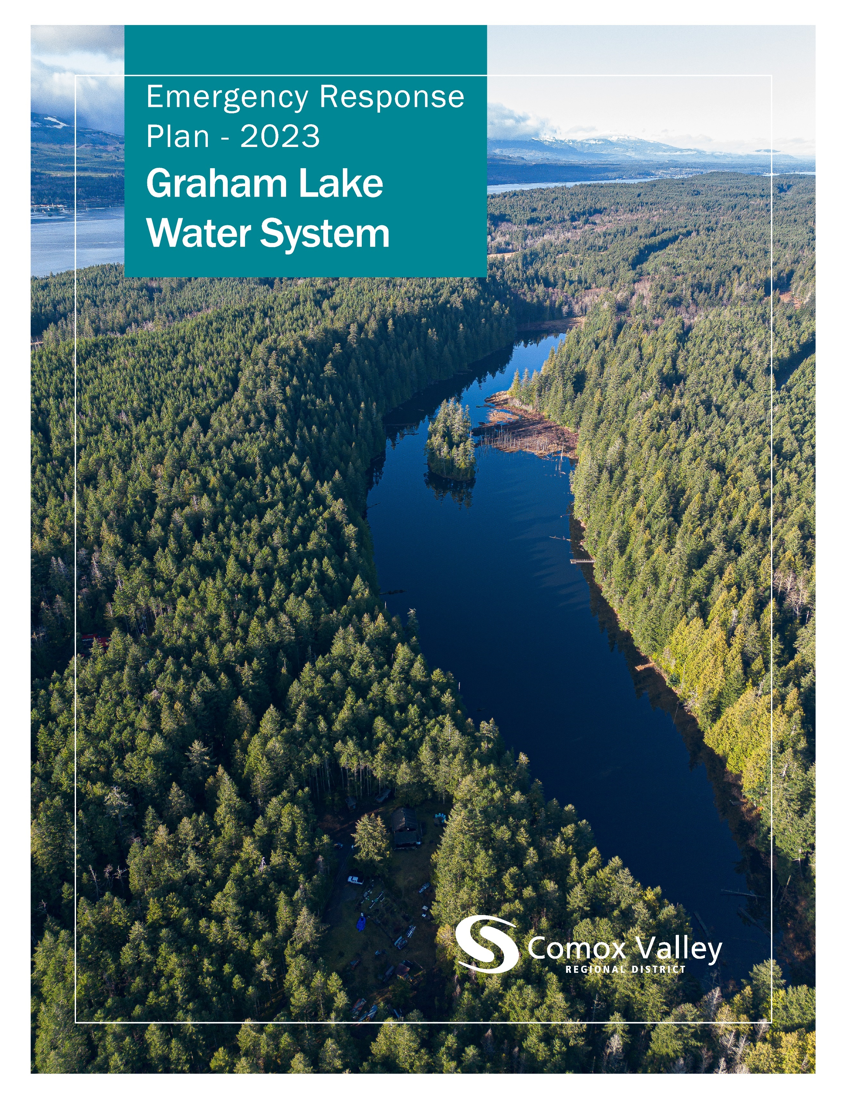

Table of Contents
Introduction 3
Type of Emergency 3
Loss of Power 3
Earthquake 3
Drought 4
Turbidity 4
Contamination 5
Communications 6
Emergency Contacts 8

The CVRD respectfully acknowledges that the land on which it operates is the unceded territory of the K'ómoks First Nation, the traditional keepers of this land.

Introduction
An ‘emergency’, within the scope of this document is defined as anything that could cause illness or injury to a resident within the Graham Lake Water System. The purpose of this plan is to acknowledge potential crises, anticipate potential hazards, and prepare for events in advance.
Generally, the communications component of a response to an emergency will be administered as needed, and whichever means best suits the level of urgency will be used.

Type of Emergency

Loss of Power
The loss of power will activate the standby generator to provide electricity to the Graham Lake treatment facility. The on-call operator will receive an alarm notification advising that the generator is on and will take the following actions:
- Respond to the alarm and assess the situation.
- Contact BC Hydro (1-888-769-3766), notify them, and request an estimate of the duration of the power outage.
- Ensure that the generator is running properly and check fuel levels.
- Ensure that the treatment equipment is operating properly.
- Refuel the generator if the outage is anticipated to last for an extended period. Total capacity of the propane tank is 1813L with an expected run time of 639 hours.
- Once power is restored arrange to have the generator refueled.
Uninterruptible power supplies will maintain data logging and limited control in the event of a power failure.

Earthquake
Earthquake response is dependant on the impacted infrastructure and the severity of the damage. In a scenario involving broken water distribution mains the objective is to preserve as much water as possible by isolating damaged sections or the water system.
Response to the loss of a water supply main is dependant on the cause and extent of damage to the source or supply system, but the course of action will generally resemble the following:
  - Notify the Manager of Water Services, the Supervisor of Water Treatment, and the Supervisor of Distribution/Transmission.
  - Notify the Vancouver Island Health Authority.
  - Assess affected infrastructure, classify the damage, prioritize the work, and coordinate a response plan. If there is washout from a dam breach or transmission main failure, notify the Ministry of Environment.
  - Notify any agencies that would be affected by disruption of service. A boil water or restrictive water use notice may need to be issued.
  - Isolate the affected area, make repairs, and flush.
  - Collect and test samples before reinstitution.
  - Remove water advisories.
  - Replace materials used.

Drought
Drought response is dependent on the severity of the drought. Historically, lake level has not been significantly affected by drought and there are no requirements to maintain creek flow below the dam. Lake level and spillway conditions are monitored weekly by staff, but the Graham Lake Water System does not currently have a conservation bylaw in place to respond to drought conditions. However, residents of the service area are cooperative with conservation efforts, familiar with other notices affecting their water, and it is expected that utilizing existing communication methods with residents to reduce consumption in a drought scenario would be effective.

Turbidity
Turbidity is continuously monitored by instruments at the treatment facility. If turbidity exceeds 1 nephelometric turbidity unit, the on-call operator will receive an alarm notification and will take the following actions:
  - Respond to the alarm, assess the situation, and check equipment for calibration/proper operation.
  - Notify the Manager of Water Services, the Supervisor of Water Treatment, and the Supervisor of Distribution/Transmission.
  - Notify the Vancouver Island Health Authority.
  - If a Boil Water Notice is needed, develop a communications plan and notify customers.
  - Confirm that adequate chlorine levels exist throughout the distribution system.
  - Test turbidity levels throughout the distribution system. If levels are above 1 NTU, flush the distribution mains until NTU is below 1.
  - When turbidity levels in the distribution system have been reduced to less than 1 NTU, rescind the Boil Water Notice.

Contamination
If there is contamination or suspected contamination of the source water, the following steps will be carried out:
  - Notify the Manager of Water Services, the Supervisor of Water Treatment, and the Supervisor of Distribution/Transmission.
  - Close the inlet valve.
  - Assess the source and the extent of the contamination within the water system. If contamination has spread to the distribution system, see below.
If the contamination is determined to be from fuel in the source water, develop and employ a hydrocarbon sampling strategy. Contact the Emergency Management BC Emergency Coordination Centre and advise them of the nature of the emergency. If possible, contain the contamination with absorbent floating booms from the spill response container located at Comox Lake. Once contamination is contained, sample until source water is clean.
  - Flush and sample.
  - Once repeat samples are clean, the isolated area may be brought back online.
If there is contamination or suspected contamination of the water distribution system, the following steps will be carried out:
  - Notify the Manager of Water Services, the Supervisor of Water Treatment, and the Supervisor of Distribution/Transmission.
  - If a Boil Water Notice is needed, develop a communications plan and notify customers. Additional advisories may be required after determining the cause of contamination.
  - Notify the Vancouver Island Health Authority.
  - Sample and assess the extent of the contamination.
  - Isolate affected area.
  - Flush and sample.
  - Once repeat samples are clean, the isolated area may be brought back online.
  - Issue communications to remove the Boil Water Notice.

Communications
The Manager of Water Services will alert the Communications Department about any water emergencies. A decision on the level of response will be made in conjunction with the department and the GM of Engineering and/or the Senior Manager of Water and Wastewater.
The Crisis Communications Plan applies to incidents that occur within the CVRD and for which the CVRD has direct jurisdictional authority. The CVRD will assume lead responsibility for all emergency communications in those jurisdictional areas, and for those components of infrastructure and services for which the CVRD has direct accountability, including the following actions:
  - Messaging citizens through Connect Rocket
  - Posting an emergency banner on the CVRD website
  - Advising the Water Committee and CVRD Board Chair
  - Advising CVRD staff
  - Preparing a press release and distributing to local media outlets
  - Posting updates to social media
  - Posting updates to the website
  - Drafting FAQs and key messages
  - Responding to social media inquiries

Emergency Contacts
External Agency | Contact
Denman Island Fire Department | (250) 335-0345
R.C.M.P. | (250) 338-1321
Brenntag Canada Emergency | (604) 685-5036
North Island Hospital Comox Valley | (250) 331-5900
VIHA Environmental Health Officer – Ella Derby | (250) 331-8607
VIHA Environmental Health Officer – Nancy Clements | (250) 923-1343
VIHA Public Health Engineer – Darrell Belanger | (250) 331-8518
VIHA Medical Health Officer – Dr. Charmaine Enns | (250) 331-8591
VIHA After-Hour Emergency | (800) 204-6166
Emergency Management BC 24/7 Coordination Centre | (800) 663-3456
Ministry of Environment | (800) 663-3456
Center for Disease Control | (604) 661-7033
Bureau Veritas – Analytical Services | (250) 338-7786
BC Hydro Vancouver Island | (250) 701-4611
BC Hydro Report and Outage | (888) 769-3766
WorkSafe BC – Worksite Emergency | (888) 621-7233
Prices Alarms – Emergency Response Centre | (888) 817-8415
City of Courtenay City Hall | (250) 334-4441
City of Courtenay Public Works Yard | (250) 338-1525
Town of Comox City Hall | (250) 339-2202
Town of Comox Public Works Yard | (250) 339-2485
K'ómoks First Nation | (250) 339-4545
Comox Valley Regional District | Contact
Manager of Water Services – Mike Herschmiller | (250) 218-9699
Manager of Emergency Programs – Howie Siemens | (250) 334-2002
Emergency Planning Coordinator – Cari McIntyre | (250) 334-6096
Senior Operator – Water Transmission and Distribution – Steve Prunkle | (250) 218-3207
Senior Operator – Water Treatment – Jarrett Morka | (250) 207-0307
Leadhand – Water Distribution and Transmission – Gavin Waterfield | (250) 207-0294
Leadhand – Water Treatment – Tyler Robertson | (236) 255-3437
Water Utilities Technician – Kaleb Leskiw | (250) 218-4171
Waterworks Operator – Transmission and Distribution – Danny McGill | (250) 207-4300
Waterworks Operator – Transmission and Distribution – Steve Russell | (250) 207-0307
Waterworks Operator – Transmission and Distribution – Eric Cox | (250) 207-0297
Waterworks Operator – Transmission and Distribution – Kerry Bird | (250) 897-6677
Waterworks Operator – Transmission and Distribution – Paul Turney | (250) 207-6700
Waterworks Operator – Transmission and Distribution – Patrick Roesch | (250) 650-5117
Waterworks Operator – Transmission and Distribution – Kyle Jorgensen | (778) 585-4497
Waterworks Operator – Transmission and Distribution – Keith McKay | (250) 207-4600
Waterworks Operator – Transmission and Distribution – Jamie Pratt | (250) 650-1091
Waterworks Operator – Treatment – Kate Norkum | (250) 207-4300
Waterworks Operator – Treatment – Sonya Jenssen | (250) 207-4900

