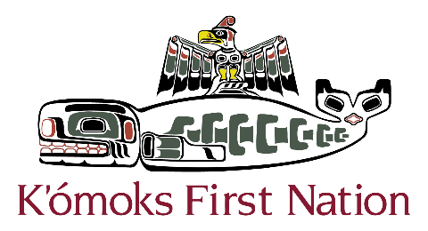

_________________________________________________________________________
3330 Comox Rd., Courtenay BC, V9N 3P8 | Ph: 250.339.4545 ext. 120| F: 250.339.7053 | E: archpermits@komoks.ca
Preliminary Field Reconnaissance of Spike Road Park
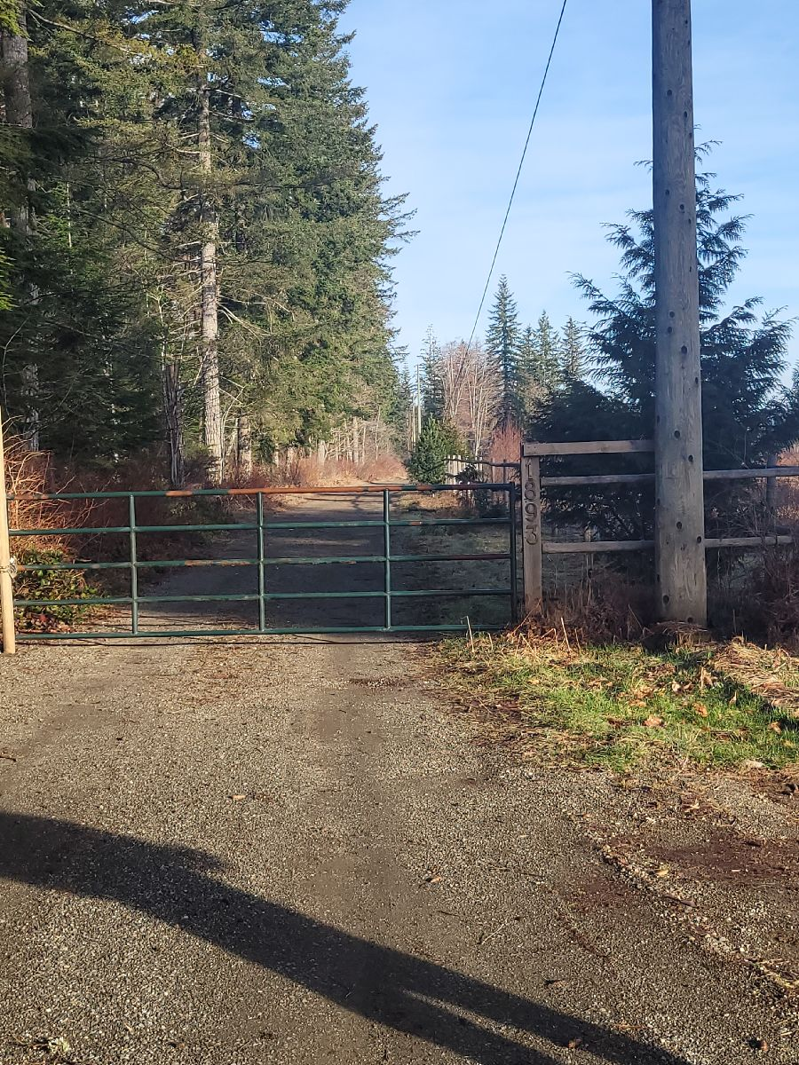
Photo 1. Spike Road Park, photo of gate facing northwest.
Raini Bevilacqua, M.A.
March 28th, 2024
Proponent: Mark Hart – CVRD Parks Department
E: mhart@comoxvalleyrd.ca
P: 250-334-6058
Overview
In 2022, the Comox Valley Regional District (CVRD) acquired Spike Road Park, a 73-acre property located at 1893 Spike Road in Courtenay in the east ½ of the southwest ¼ of section 19, Township 6, Comox District, Plan 552E, PID 008-992-789, PIN 05652 (“the park”) (Photo 1, Figure 1). The property is located at the end of a long driveway that is reached by turning left at the end of Spike Road. Mark Hart of the CVRD Parks Department applied for a K’ómoks First Nation Cultural Heritage Investigation Permit (KFN CHIP 2024-22) to assist in creating a park management plan for the park. The park is located just bordering an area of high archaeological potential as defined by the KFN Cultural Heritage Policy (KFN Area of Potential), and KFN requested that a preliminary field reconnaissance (PFR) of this property was undertaken as part of the park management plan to further assess the archaeological potential of the park and to observe the area for archaeological deposits. There are no specific developments plans for the park, which the CVRD plans use as an ecological conservation area, however, there is potential for the Ministry of Transportation Right of Way (MoTI ROW) to be transformed into a working road.

The 73-acre park is less than 300 m northeast of the Tsolum River. There is an estimated 5 acres of dry land within the park boundary, with most of the property designated as wetland/bog which feeds the Tsolum. Previous environmental studies (Current Environmental 2022; Youth and Ecological Restoration 2023) identified hardhack, common rush, slough sedge, and Nootka rose in the bogs (Figure 2). The park is within Western Toad Habitat which is a factor in designating the park as an ecological conservation area. Bears and cougars are prevalent in the area. Recent records from local birders have also noted the wetland as very important for seasonal migrant birds. There is one mature/old growth Douglas fir that has been identified within the park. Other forest vegetation identified during the Current Environmental study included western white pine, grand fir, red alder, salmonberry, red huckleberry, Nootka rose, Pacific crab-apple, Oregon grape, hardhack, sword fern, and bracken fern, as well as invasive Scotch broom.

The land was granted to Robert Dunsmuir in 1884 for the E&N rail. In the 1890’s the land was sold to the Fraser River Sawmill Company and later the Comox Logging and Railway Company. Construction of the rail line began in 1910 and ran through the property along the modern ROW and operated until 1943. The property was within the path of the 1920’s Merville fire. Burnt cedar trees are visible within the western and eastern bogs and may be remnant of the wildfire. The property was farmed from the 1990’s up until the CVRD purchase of the property and currently includes a dwelling, barns, outbuildings, fields, and fencing. The CVRD was awarded a license to operate a seasonal emergency evacuation route from Spike Road to Endall Road in 2018 and was awarded a license to extend the One Spot Trail along the road in 2022.
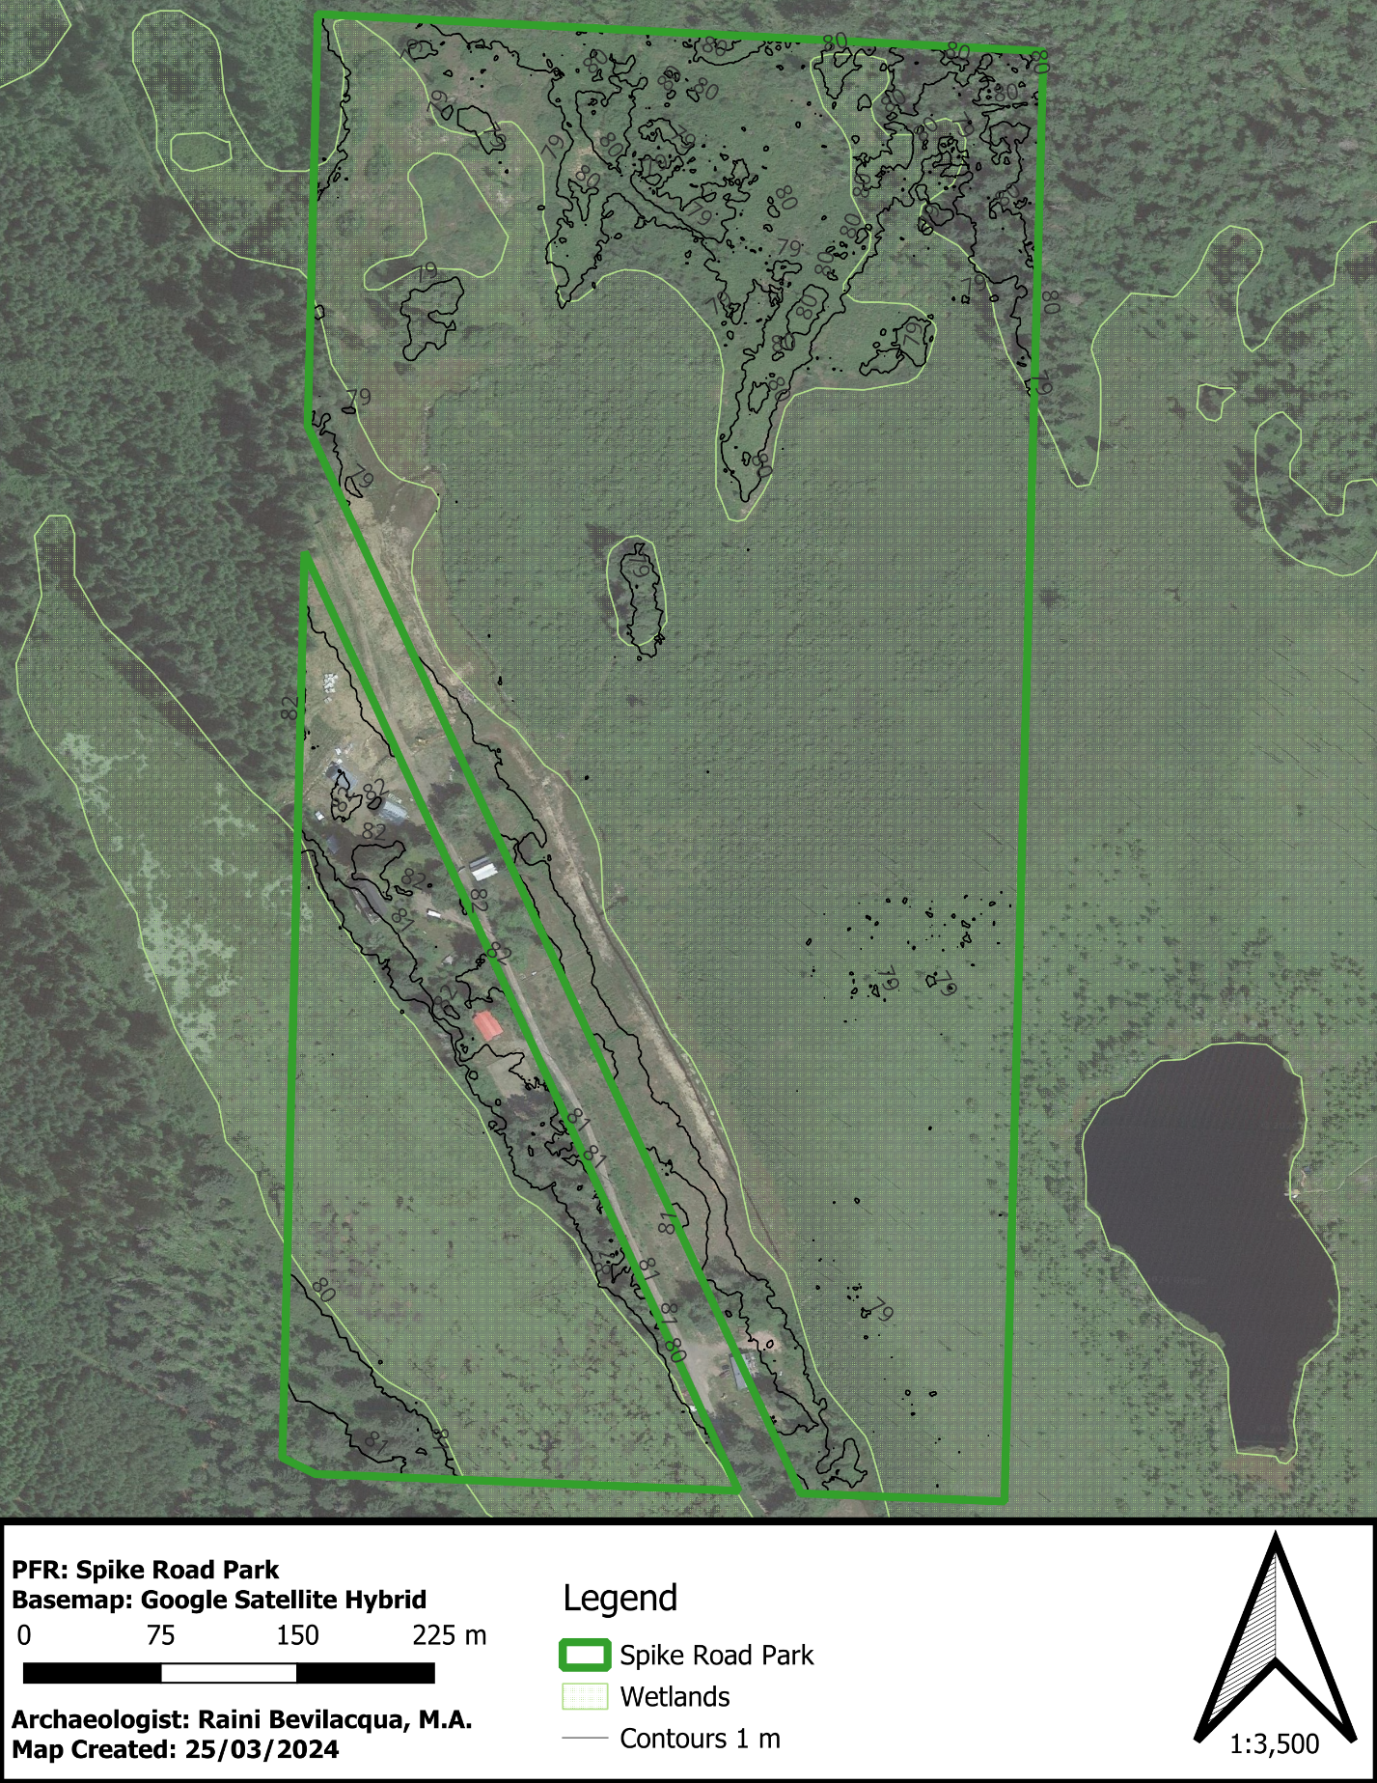
Figure 1. PFR presurvey map, “the property.”

Figure 2. Site map of 1893 Spike Rd, showing the 30 m ARHDPA, the wetland SPEA, the shade zone of sensitivity, proposed site for a parking lot and recommended planting areas (labelled areas 1 and 2) from Current Environmental report BIOPHYSICAL ASSESSMENT – 1893
Ethnographic Background
The Park is situated in the traditional territory of the Island Comox (Sathloot, Sasitla, leeksen, and Xa’xe) and Pentlatch People (Pentlatsch, Saamen, Chuachuatl, and S’oksun,). The Island Comox territory originally spanned from Cape Lazo to Salmon River while the Pentlatch territory spanned from Cape Lazo in Comox to the Englishman River in Parksville, including the Northern Gulf Islands of Hornby and Denman. Both groups fall within the Northern Coast Salish territory along with the Homalco, Klahoose, Sliammon, and Sechelt. Both traditionally spoke dialects of the Coast Salishan language family, with Island Comox speaking Ayajusem and the Pentlatch speaking Pentlatch.
The semi-sedentary hunting-gathering-fishing economy of the Pentlatch and Island Comox included a seasonal round based on terrestrial hunting (predominantly deer and elk), fishing (mainly salmon and herring), and gathering a wide variety of shellfish, berries, roots, tubers, and seaweeds. Western red cedar and yellow cedar were logged and bark-stripped throughout the territory to construct semi-permanent and permanent plank houses, canoes, massive wooden fish weir complexes, ceremonial items, cloths, and tools. Other common tools were made of stones, bone, shell, and antler.
These groups thrived in the territory with villages throughout and rich resources aplenty. Unfortunately, the 1862 smallpox epidemic disseminated the Island Comox and Pentlatch populations leading to an amalgamation of many local groups. The Island Comox were pushed southward into Pentlatch territory in the early 1700’s by the Lekwiltok, a Kwakwaka’wakw group, speaking the Lik’wala dialect of the Wakashan language. By 1850 the Comox Harbour became the main village for the remaining Island Comox population. In 1886, Anthropologist Frans Boas noted that Pentlatch, Island Comox, and Lekwiltok lived in three separate sections of the Comox Harbour village.
The Pentlatch are represented in the modern period by the Qualicum First Nation (QFN) located along the Big Qualicum River at Qualicum I.R. 1 and the K’ómoks First Nation (KFN) located in Comox Harbour at Comox I.R. 1, with two other reserves: Puntledge (I.R. 2) and Goose Spit (I.R. 3). While the QFN remain predominantly Pentlatch, the KFN is made up of an amalgamation of Island Comox and Pentlatch tribes.
Archaeological Background
The property is located in the traditional territory of the K’ómoks and Pentlatch People. There is one recorded archaeological site within 5 km of the park (Figure 3 and Table 1). It is important to note that inland areas within the region are majorly under-surveyed and there are likely many unregistered archaeological sites in the area.
Table 1. Previously recorded sites within the vicinity of the study area.
Borden Number: | Site Type | Location from DjSf-11
DkSg-4 | Cultural Depression/Mound Site | 4.8 km east
There is Traditional Use Study (TUS) data available from this region, identifying the area as a place where K’ómoks and Pentlatch people have and continue to hunt deer, elk, and grouse, gather chanterelle mushrooms, and pick berries (Figure 4). The Tsolum River is also a named place, Ts'uwem.

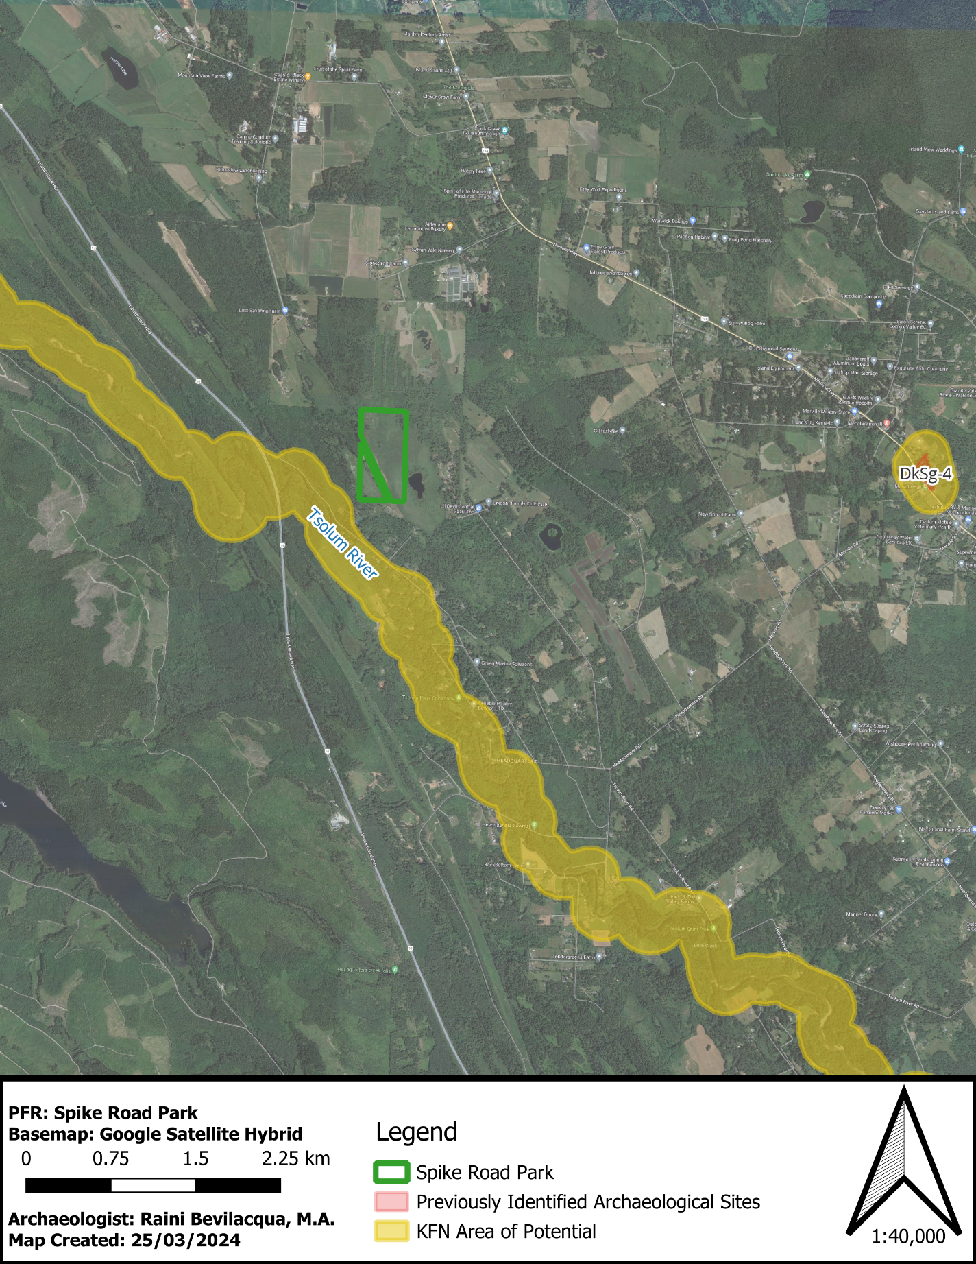
Figure 4. Previously recorded archaeological sites within the vicinity of the property.

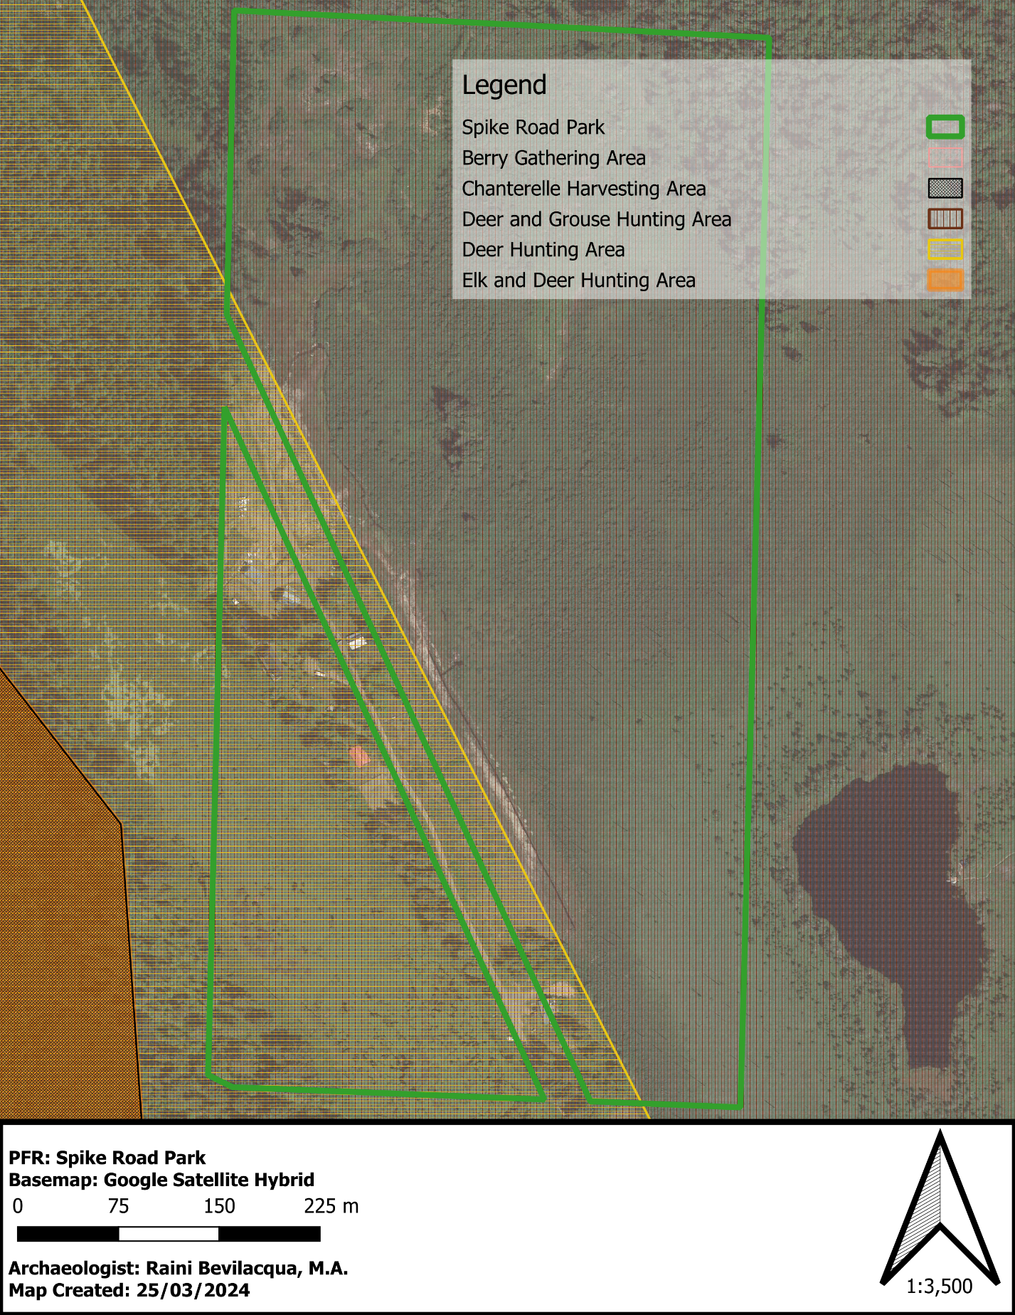
Figure 3. Traditional Use Study data for Spike Road Park.
Preliminary Field Reconnaissance (PFR)
On February 16th, 2024, myself (Raini Bevilacqua) and Bonnie Frank (KFN Representative) visited what we thought was Spike Road Park to conduct the PFR, however upon sending the first draft of the report to mark Hart we were informed that we surveyed the wrong property.
On March 14th, 2024, myself (Raini Bevilacqua) and Kris Ball (QFN/KFN Representative) met with Mark Hart to complete the survey of Spike Road Park. We inspected the dry land portion of the park along the ROW (Figure 2, Photo 2 and Photo 3) for surficial archaeological remains. The dry land portion of the park ranges from 79 to 82 m above sea level. Do to access, we could only survey the developed areas along the ROW along the One Spot Trail. Based on the site history is quite possible that the dry landform that the ROW runs along is partially or fully man-made landscape from the historic rail line. It is likely that the western and eastern bogs were once one large wetland.
We did observe both the eastern and western bogs from the trail (Photo 4 and Photo 5). The eastern bog was visibly drier and densely covered in hardhack and Nootka rose with a few burnt standing trees (assumed cedar). The western bog was much more inundated with water. We noted many species of ducks, redwing blackbird, and heron during our survey.
The forested areas within this section are third growth Douglas fir. We did identify logged western red cedar on the property but did not identify any standing cedars. No culturally modified trees (CMT’s) were identified. We walked into the Timber West block just southwest of the park along the One Spot Trail and noted the Douglas fir forested environment with salal and sword fern (Photo 6).
Multiple soil exposures were observed. Throughout the park, soil exposures were negative for archaeological material (Photo 7 to Photo 9). The soil was predominantly medium brown silts with a large quantity of medium sized cobbled.
The inspection of developed portion of the park along the ROW did not identity any archaeological deposits or artifacts.
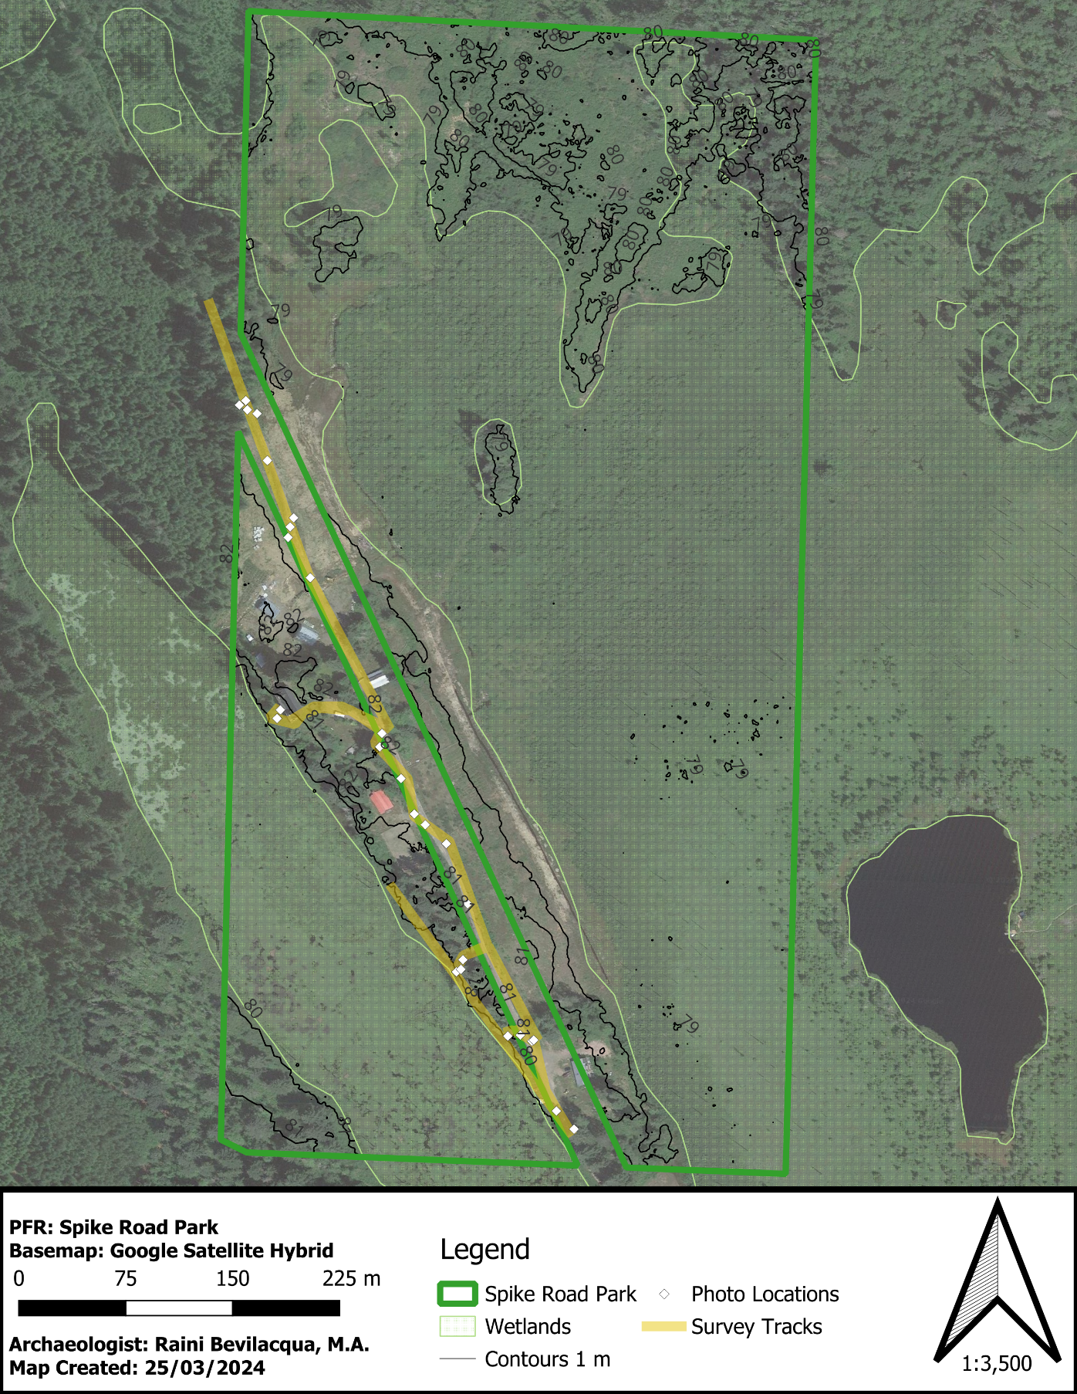
Figure 5. PFR survey map.
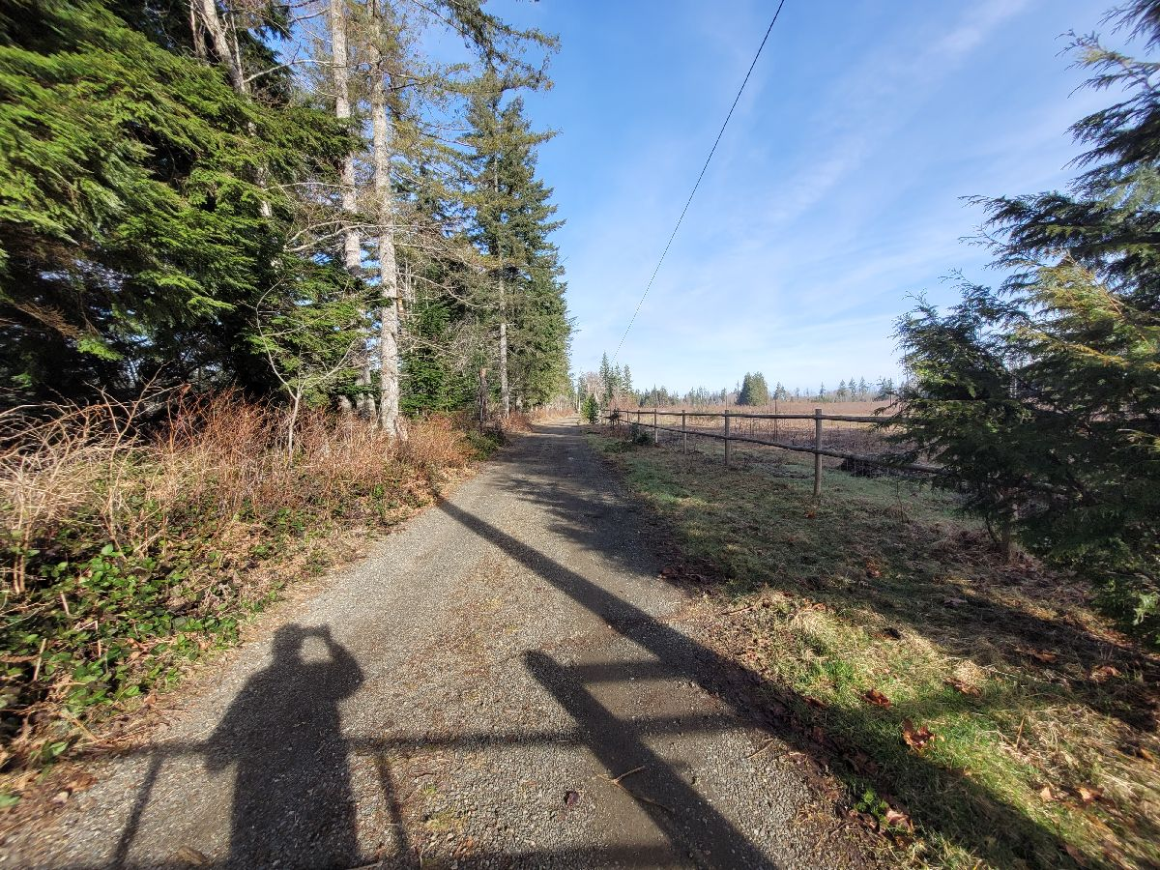
Photo 2. One Spot Trail through Spike Road Park. Photo facing northwest from park gate.

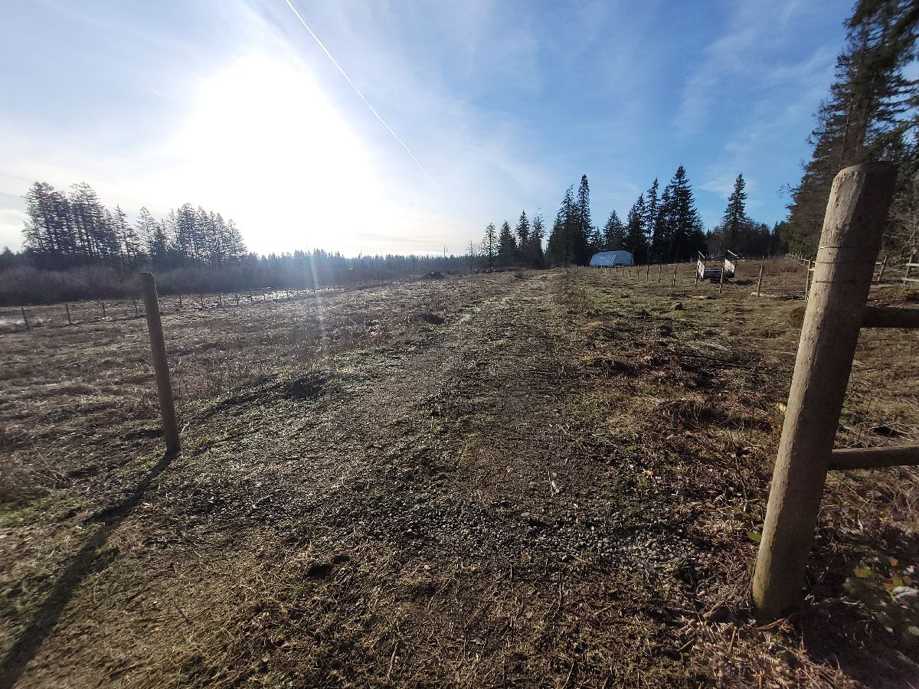
Photo 3. One Spot Trail through Spike Road Park. Photo facing southeast from northwest park boundary.
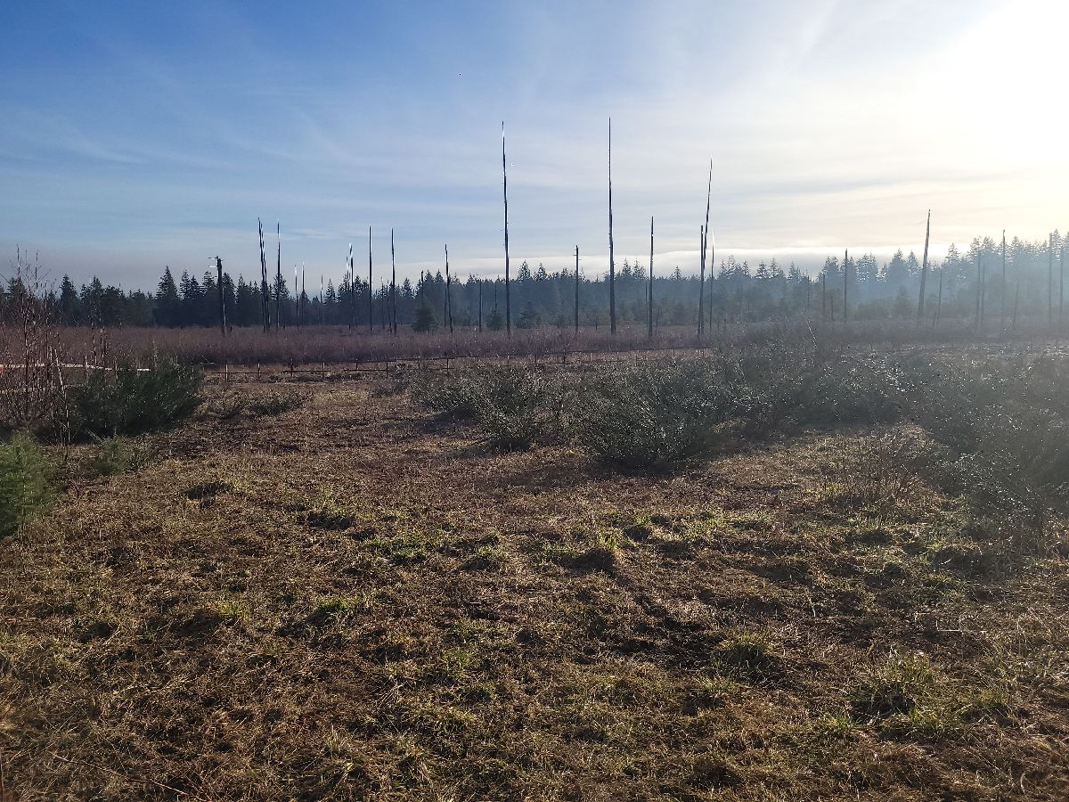
Photo 4. Eastern hardhack Bog with burnt standing trees. Photo facing northeast.
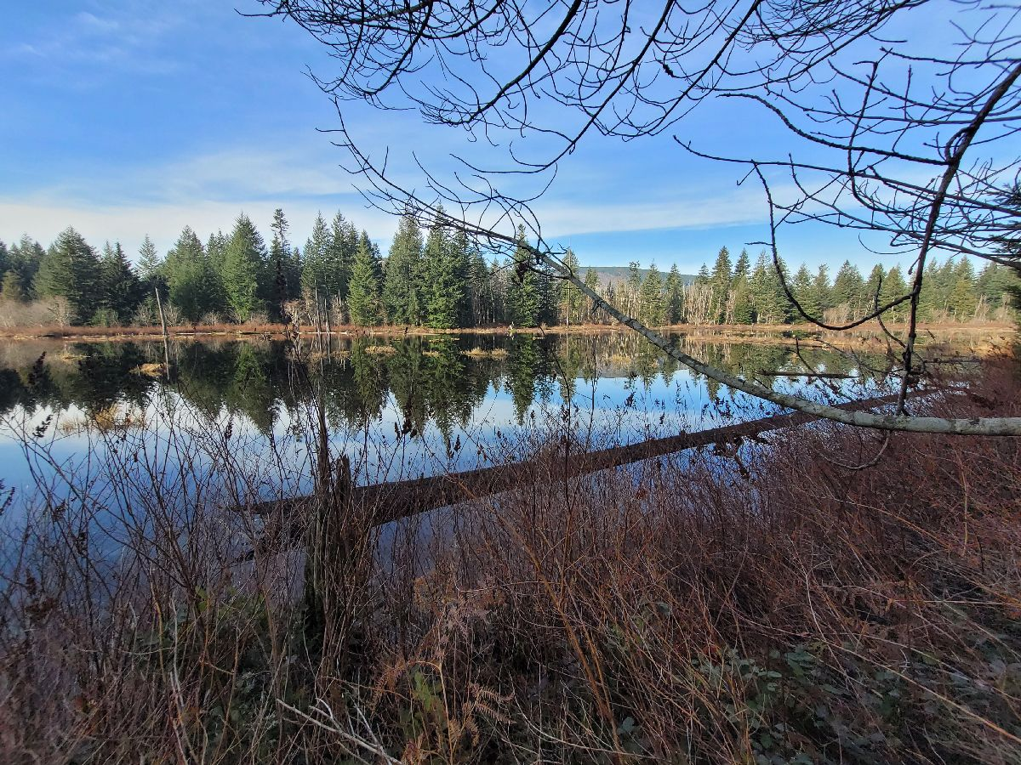
Photo 5. Western bog. photo facing northwest.

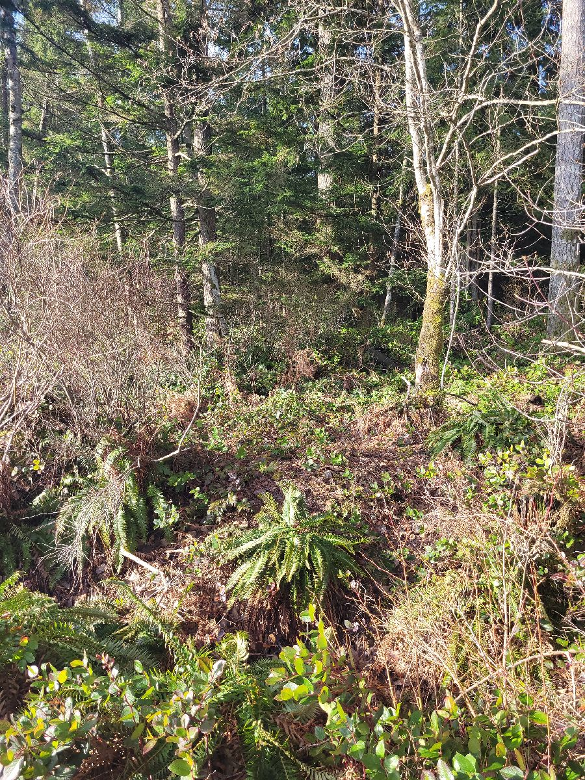
Photo 6. Forest environment. Northwestern boundary of park along One Spot Trail.
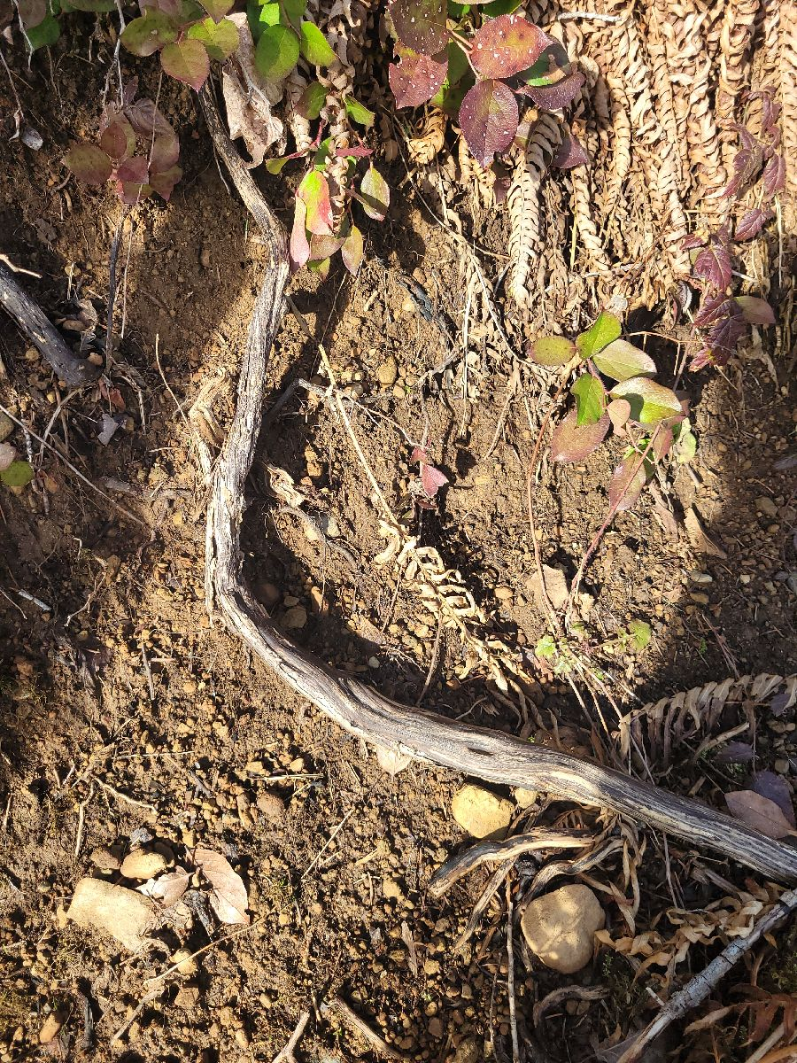
Photo 7. Soil exposure - sterile.
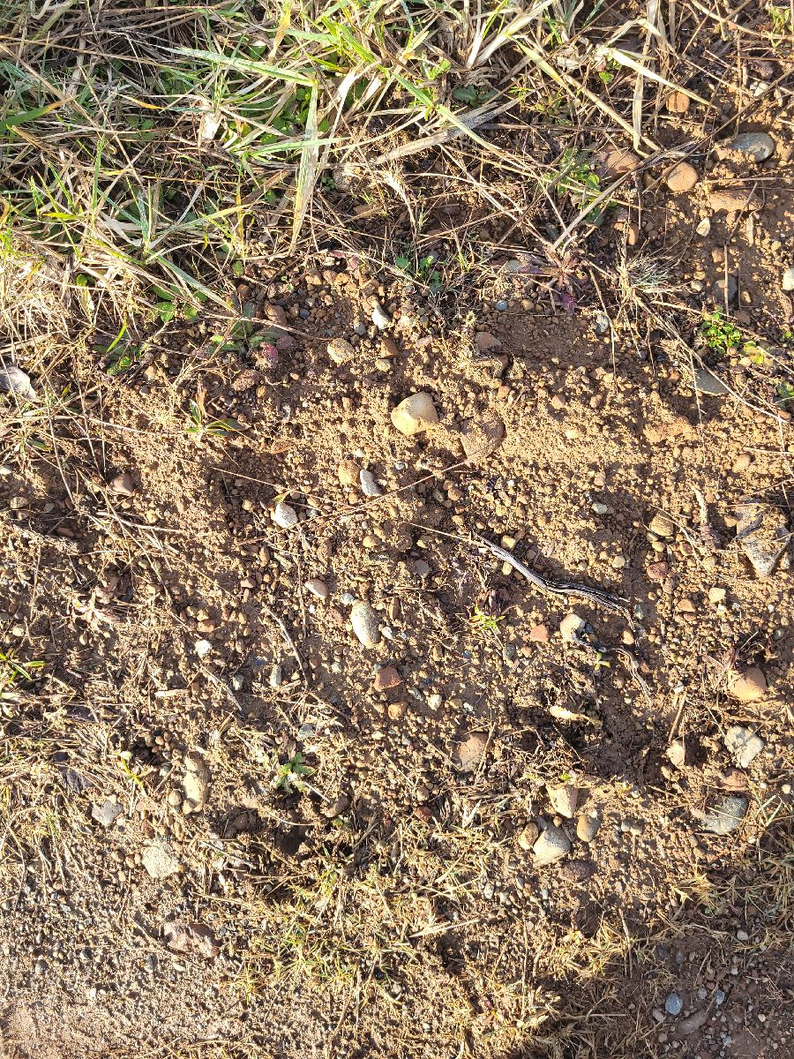
Photo 8. Soil exposure - sterile.
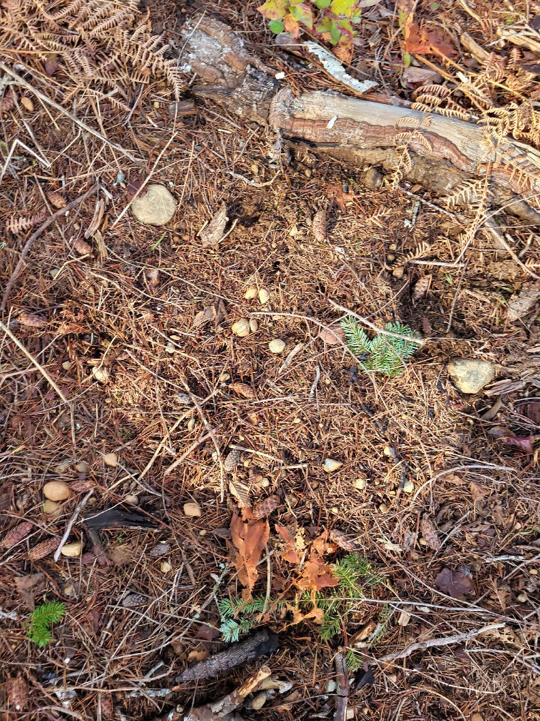
Photo 9. Soil exposure - sterile.

Conclusion and Recommendations
Although no archaeological remains were observed during the PFR, there is still the possibility that such remains exist below the surface. If the entire dry landform along the ROW was man-made the likelihood of archaeological material decreases further. However, a thorough inspection of the park did not identify any archaeological material.
Wetland areas have high usability for Indigenous people for resource gathering (berry picking, freshwater fishing, bird hunting). There is low likelihood of archaeological material within wetlands, however, dry areas near wetlands have a high likelihood of archaeological material (lithics, campsites, CMT’s). It should also be noted that the dry land in the northern portion of the park was not surveyed, this is likely the location of a more natural landform and therefore has higher archaeological potential.
No development is planned at this time as the CVRD has slated the property for an ecological conservation area. Based on the PFR and general wetland environment of Spike Road Park, a future park management plan, or minor developments (trails etc.), should note that there is very little probability of encountering archaeological deposits.
For this reason, I do not recommend further archaeological investigation within the park. Given that no archaeological remains are recorded on this property, and none were observed during this PFR, permits from the Archaeology Branch are not required if future construction occurs.
That being said, all archaeological remains in B.C. are protected under the Heritage Conservation Act, and if such remains are encountered during future construction, work must cease, and appropriate permits must be obtained from the Archaeology Branch. If archaeological remains are identified during future construction, please also notify KFN.
I hope that you find this information sufficient, and feel free to contact me if you have any additional concerns.
Sincerely

Raini Bevilacqua
Raini Bevilacqua, M.A.
KFN Contract Archaeologist

